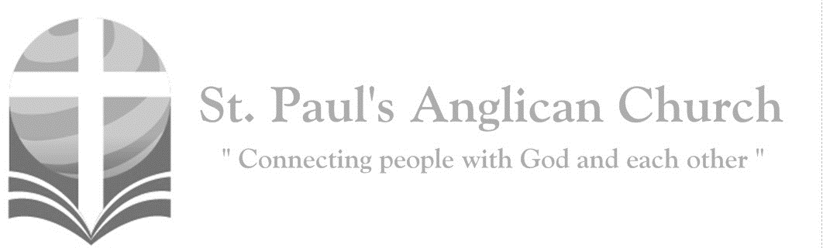
Sunday, November 17, 2019: 23rd Sunday After Pentecost

Look up and raise your heads, because your redemption is drawing near. (Luke 21:28)

Opening Songs: Cornerstone

My hope is built on nothing less
Than Jesus' blood and righteousness
I dare not trust the sweetest frame
But wholly trust in Jesus' Name
(Repeat)
(Chorus)
Christ alone, cornerstone
Weak made strong in the Saviour's love
Through the storm He is Lord
Lord of all

When darkness seems to hide His face
I rest on His unchanging grace
In every high and stormy gale
My anchor holds within the veil
(To Chorus)
When He shall come
With trumpet sound
Oh may I then in Him be found
Dressed in His righteousness alone
Faultless to stand before the throne
(To Chorus)

Morning Prayer
Leader: (BAS pg. 47) Lord, open our lips,
People: And our mouth shall proclaim your praise.
All: Glory to the Father, and to the Son, and to the Holy Spirit: as it was in the beginning, is now, and will be for ever. Amen. Alleluia!
Leader: (pg. 47) God rules over all the earth: O come, let us worship.
(pg. 49) Come, let us sing to the Lord;
People: let us shout for joy to the rock of our salvation.
Leader: Let us come before his presence with thanksgiving
People: and raise a loud shout to him with psalms.
Leader: For the Lord is a great God,
People: and a great king above all gods.
Leader: In his hand are the caverns of the earth,
People: and the heights of the hills are his also.
Leader: The sea is his for he made it,
People: and his hands have moulded the dry land.
Leader: Come, let us bow down, and bend the knee,
People: and kneel before the Lord our maker.
Leader: For he is our God, and we are the people of his pasture and the sheep of his hand.
People: Oh, that today you would hearken to his voice!
Leader: (pg. 47) God rules over all the earth: O come, let us worship.

The Reading of Scripture
First Reading: Isaiah 65:17-25 (pg. 532 in the red pew Bible)
Reader: The Word of the Lord.
People: Thanks be to God.

Psalm (or Canticle): Isaiah 12:2-6
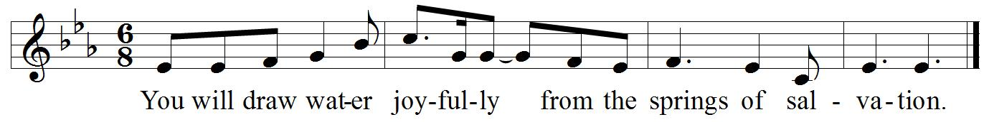
Refrain:

Surely, it is God who saves me; I will trust in him and not be afraid. For the Lord is my stronghold and my sure defence, and he will be my Saviour. Refrain.
Therefore, you shall draw water with rejoicing from the springs of salvation. And on that day you shall say, give thanks to the Lord and call upon his name; make his deeds known among the peoples; see that they remember that his name is exalted. Refrain.
Sing the praises of the Lord, for he has done great things, and this is known in all the world. Cry aloud, inhabitants of Zion, ring out your joy, for the great one in the midst of you is the Holy One of Israel. Refrain.

Second Reading: Hebrews 2 Thessalonians 3:6-13 (pg. 838 in the red pew Bible)
Reader: The Word of the Lord.
People: Thanks be to God.

The Gospel Reading
Reader: The Lord be with you.
People: And also with you.
Reader: The Holy Gospel of our Lord Jesus Christ according to St. Luke.
People: Glory to you, Lord Jesus Christ.
Gospel Reading: Luke 21:5-19 (pg. 745 in the red pew Bible)
Reader: The Gospel of Christ.
People: Praise to you, Lord Jesus Christ.

Worship Through Song

Hosanna
Praise is rising, eyes are turning to You
We turn to You
Hope is stirring
Hearts are yearning for You
We long for You

(Pre-Chorus)
'Cause when we see You
We find strength to face the day
In Your presence
All our fears are washed away
Washed away

(Chorus) Hosanna, hosanna
You are the God who saves us
Worthy of all our praises
Hosanna, hosanna
Come have Your way among us
We welcome You here Lord Jesus

Hear the sound of
Hearts returning to You, we turn to You
In Your Kingdom
Broken lives are made new
You make us new
(To Pre-Chorus)

You’ll Come
I have decided, I have resolved
To wait upon You Lord
My Rock and Redeemer
Shield and reward
I'll wait upon You Lord

As surely as the sun will rise
You'll come to us
Certain as the dawn appears

(Chorus) You'll come
Let Your glory fall
As You respond to us
Spirit rain
Flood into our thirsty hearts again
You'll come, You'll come

We are not shaken, we are not moved
We wait upon You Lord
Mighty deliverer, triumph and truth
We wait upon You Lord

As surely as the sun will rise
You'll come to us
Certain as Your word endures

Chains be broken lives be healed
Eyes be opened Christ is revealed (Repeat)
(To Chorus)

What a Beautiful Name
You were the Word at the beginning
One with God, the Lord Most High
Your hidden glory in creation
Now revealed in You our Christ

What a beautiful Name it is
What a beautiful Name it is
The Name of Jesus Christ my King
What a beautiful Name it is
Nothing compares to this
What a beautiful Name it is
The Name of Jesus

You didn't want heaven without us
So Jesus, You brought heaven down
My sin was great, Your love was greater
What could separate us now

What a wonderful Name it is
What a wonderful Name it is
The Name of Jesus Christ my King
What a wonderful Name it is
Nothing compares to this
What a wonderful Name it is
The Name of Jesus
What a wonderful Name it is
The Name of Jesus

Death could not hold You
The veil tore before You
You silence the boast of sin and grave
The heavens are roaring
The praise of Your glory
For You are raised to life again
You have no rival, You have no equal
Now and forever God You reign
Yours is the kingdom, Yours is the glory
Yours is the Name above all names
(Continued on next page)

What a powerful Name it is
What a powerful Name it is
The Name of Jesus Christ my King
What a powerful Name it is
Nothing can stand against
What a powerful Name it is
The Name of Jesus

Listening Time

Affirmation of Faith – The Apostle’s Creed
All: I believe in God, the Father almighty, Creator of heaven and earth. I believe in Jesus Christ, his only Son, our Lord. He was conceived by the power of the Holy Spirit and born of the Virgin Mary. He suffered under Pontius Pilate, was crucified, died and was buried. He descended to the dead. On the third day, he rose again. He ascended into heaven and is seated at the right hand of the Father. He will come again to judge the living and the dead. I believe in the Holy Spirit, the holy catholic Church, the communion of saints, the forgiveness of sins, the resurrection of the body, and the life everlasting. Amen.

Prayers of the People

Collect
Leader: (pg. 392) Almighty God, you sent your Son Jesus Christ to be the light of the world. Free us from all that darkens and ensnares us, and bring us to eternal light and joy; through the power of him who is alive and reigns with you and the Holy Spirit, one God, now and for ever.
All: Amen.

The Peace
Leader: The peace of the Lord be always with you.
People: And also with you.
Leader: Let us share God’s peace with one another.
All share the peace with one another.

Offertory Song: Great is Thy Faithfulness

Great is Thy faithfulness
O God my Father
There is no shadow
Of turning with Thee
Thou changest not
Thy compassions they fail not
As Thou hast been
Thou forever wilt be

(Chorus) Great is Thy faithfulness
Great is Thy faithfulness
Morning by morning new mercies I see
All I have needed
Thy hand hath provided
Great is Thy faithfulness
Lord unto me

Summer and winter
And springtime and harvest
Sun, moon, and stars
In their courses above
Join with all nature in manifold witness
To Thy great faithfulness
Mercy and love (To Chorus)

Pardon for sin
And a peace that endureth
Thy own dear presence
To cheer and to guide
Strength for today
And bright hope for tomorrow
Blessings all mine
With ten thousand beside (To Chorus)

The Lord’s Prayer
Leader: (pg. 54) Gathering our prayers and praises into one, let us pray as our Saviour taught us,
All: (Sung) Our Father in heaven, hallowed be your name. Your kingdom come, your will be done, on earth as in heaven. Give us today our daily bread. Forgive us our sins as we forgive those who sin against us. Save us from the time of trial, and deliver us from evil. For the kingdom, the power, and the glory are yours, now and for ever. Amen.

Congregational Announcements

Closing Song: Agnus Dei

Alleluia, alleluia
For the Lord God Almighty reigns
Alleluia, alleluia
For the Lord God Almighty reigns
Alleluia
Holy, holy are You Lord God Almighty
Worthy is the Lamb, worthy is the Lamb
You are holy, Holy
Are You Lord God Almighty
Worthy is the Lamb, worthy is the Lamb
Amen

The Dismissal
Leader: Let us bless the Lord.
All: Thanks be to God.
Leader: The grace of our Lord Jesus Christ, and the love of God, and the fellowship of the Holy Spirit, be with us all evermore.
All: Amen.

Thank you for joining us at St. Paul’s today!!
White Elephant Sale/Fundraiser for
Rwanda Mission Trip/Conference
Purpose: To raise funds for a trip to Rwanda in Summer 2020 to re-establish relationships in the Cyangugu diocese, facilitate conferences for youth and pastors and check on progress with microfinance, housing, and youth education projects
When: Saturday November 30 between 11:00AM and 3:00PM in the Hall.

Come, bring your friends. Enjoy tea and refreshments and find special Christmas gifts while supporting a great cause!

Reign of Christ the King Interface Service – Sat. Nov. 23, 7:00-9:00PM
St. Paul's and Interface will celebrate the Reign of Christ the King with a worship service exploring the themes of 'God Rules from the Wood of the Cross' & 'Our Adoption into God's Royal Family.' The service will feature the use of original symbols, rituals, art, and imagery. This liturgy allows worshipers to embody the themes in a sacramental ritual of enduring quality and significance.

Lauren Rudat Update on India Trip
Sunday, Nov. 24 at 8:45AM
Please join us in the John Room at 8:45AM on November 23 as Lauren Rudat will be sharing with the group an account of her recent summer trip to India and the Christian ministries she supports there. Everyone is welcome!

Gingerbread Night – Fri. Nov. 29
Please join us for Supper and Gingerbread making on Friday, November 29 at 6:00PM in the Hall. Please sign up in the foyer if you plan to attend. Cost is:
$25 / family (meal and gingerbread kit)
$15 / person (meal and gingerbread kit)
$5 / person (meal only); $10 for extra kit

Advent Study
Rev. Myron will be leading a study during Advent Sunday mornings before service starting December 1. If you have an interest in participating, please let us know ASAP. Books have already been ordered but we ordered a few extra. The cost to parishioners will be $10.00 for the book with St. Paul’s picking up any additional cost in excess of the $10.00.

@StEdmonton
facebook.com/stpachurchedmonton
St. Paul’s Vestry:
Peter Jackson, Rector’s Warden
Pat Stretch, People’s Warden
David Heritage, Treasurer
Margot Byer, Vestry Member
John Green, Vestry Member
Deanna Kalles, Vestry Member
David Parker, Vestry Member
Carol Rudat, Vestry Member

St. Paul’s Staff:
Rector:
The Reverend Myron Bradley Penner
Office Administrator:
RJ Chambers
Youth Leader: Victoria Eeles
For prayer requests email:
office@stpauls-anglican.ca
For urgent prayer requests call
the church office: (780) 455-0771
For pastoral emergencies call:
(587) 334-2130

Office Hours:
Monday-Thursday: 9:00AM-12:00PM
Closed: Fri/Sat/Sun and Stat Holidays
St. Paul’s Anglican Church
10127 145 Street, Edmonton T5N 2X6
Phone: (780) 455-0771; Email: office@stpauls-anglican.ca
Website: www.stpauls-anglican.ca
This Week’s Readings:
Isaiah 65:17-25 (pg. 532)
Isaiah 12:2-6 (in the bulletin)
2 Thessalonians 3:6-13 (pg. 838)
Luke 21:5-19 (pg. 745)

This Week’s Ministry Teams:
Music/Sound: RJ’s Team/RJ C.
Service Team: Anyone Available
Prayers: Janette C.
Chapel Prayer: Anyone Available
Kid’s Ministry: No Kid’s Ministry

St. Paul’s Cycle of Prayer:
Jim and Diane Brick;
John Green;
Lucy Heath
Anglican Cycle of Prayer:
Diocese of Niagara; the Rt. Rev. Susan Bell, Bishop. St. Augustine Parkland, Spruce Grove: Billy Isenor (s. Dana), Rector; Aaron Parsall-Myler (s. Erika), Associate Priest; Lesley Hand (s. Charles), John Rushton (s. Elizabeth), Honorary Assistants. Buyé Diocese, Bigombo Parish: Simeon Ntirandekura, Rector. Whitefish Lake First Nation.

Next Week’s Ministry Teams
Music/Sound: Andrew’s Team/Jennifer S.
Service Team: B Team
Prayers: Barb M.; Vestry: Carol R.
Chapel Prayer: Dudley B. and Pat H-B.
Kid’s Ministry: Carol G. and Abigail P.

