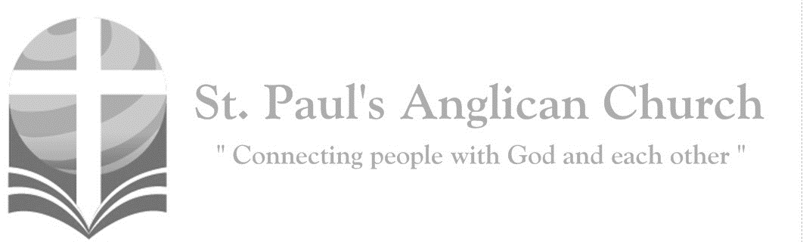

Sunday, December 15, 2019: Advent 3 – Joy

*The Spirit of the Lord God is upon me, because the Lord has anointed me to bring good tidings to the afflicted. (Isaiah 61:1)*

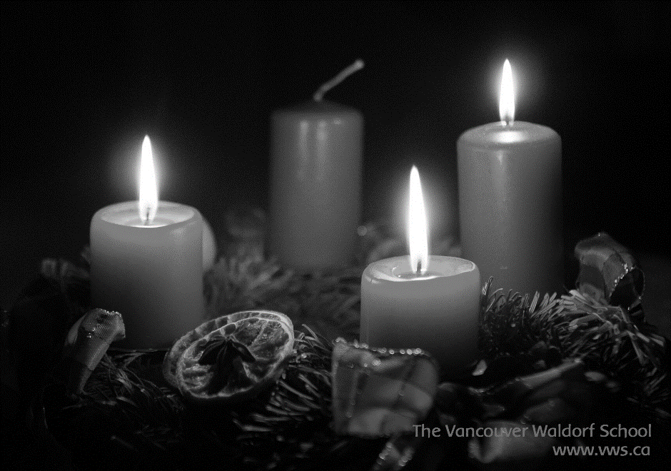

SUNDAYS AT ST. PAUL’S

**REGULAR SERVICES**

* Weekly services held Sundays at 10:00AM
* Interface services - Art based services throughout the year
* Sermons available on our website

**SUNDAY PRAYER**

* Prayer for the service at 9:30AM in the Luke Room
* Individual Prayer in the Chapel during the Sunday service

**SERVING AT ST. PAUL’S**

* Join a Ministry Team (Sunday service team, music team, children’s ministry, Altar guild, or many others)
* Regular or One-Time Giving (cash, cheque, automatic debit, and credit options available)

**LARGE PRINT MATERIALS** Large print Bibles and   
 Books of Alternative   
 Services (BAS) are availableat each Sanctuary door.

Page numbers will not be the same as those listed in the bulletin.

**VISITING TODAY?**

We want to get to know   
 you! Please join us for

in the Hall for coffee and

fellowship following the service. The greeters are also available to help if you have any questions.





**Assisted listening**

**is available. Please**

**ask a greeter**

**for assistance.**



CONNECT

**St. Paul’s CHILDREN’S MINISTRY**

**KIDS** Pre-School-Grade 2 in the hall / Grade 3-5 in the Matthew Room

Sunday School teaching is weekly during the 10:00AM service.

**St. Paul’s YOUTH MINISTRY**

**YOUTH** Youth Grades 6-12 meet weekly during the 10:00AM service.

Youth also meetbi-weekly for fun events and devotionals.

**St. Paul’s ADULT MINISTRY**

**ADULTS** St. Paul’s has a number of small groups where you can connect with others through Christ. If you are interested in joining a small   
group or starting a small group of your own, please speak with Pat Stretch.

**Opening Song: *Come Thou Long Expected Jesus***

Come Thou long expected Jesus  
Born to set Thy people free  
From our fears and sins release us  
Let us find our rest in Thee  
Israel's strength and consolation  
Hope of all the earth Thou art  
Dear desire of every nation  
Joy of every longing heart

Born Thy people to deliver  
Born a child and yet a King  
Born to reign in us forever  
Now Thy gracious Kingdom bring  
By Thine own eternal Spirit  
Rule in all our hearts alone  
By Thine all sufficient merit  
Raise us to Thy glorious throne

**Lighting of the Third Advent Candle: JOY**

Reader 1: We have lit the candles of Hope and Peace, and relight them now to remind us that our hope is in Christ and that he will come again to bring peace to the world.

Reader 2: Today begins the third week in our Advent journey, and so we light the third candle, the candle of Joy. In ancient times, the prophet Isaiah said, “The people who walked in darkness have seen a great light; those who lived in a land of deep darkness—on them light has shined.” Many suffer from despair, anxiety, or holiday blues. Others experience only the dark side of human nature. Christ’s light has power to overcome all dark places in our society and our souls.

Reader 1: The Psalmist tells us to “make a joyful noise to the LORD, for the Lord is God who made us and whose we are, whose steadfast loves endures forever and faithfulness to all generations.”

***(The first three candles are lit.)***

Reader 2: Now we light the third candle, the candle of Joy, as we remember the angel’s words to the shepherds, “Do not be afraid. I am bringing you good news of great joy for all people.” We light it so that all who reap blue harvests from seeds of sadness may know the joy of Jesus Christ. We light it in honor of those who show us the joy of following Christ.

Reader 1: Let us pray:

**All: God of Good News, as we await your coming we give you thanks for the joy we have in Christ Jesus. May all who seek such joy find it. For all who have ceased to believe in its possibility, may you work through us to show your joy already present. Come, God of Joy, come. Amen.**

**The Gathering of the Community**

Celebrant: *(BAS pg. 185)* The grace of our Lord Jesus Christ, and the love of God, and the fellowship of the Holy Spirit, be with you all.

**People: And also with you.**

Celebrant:Almighty God,

**All:to you all hearts are open, all desires known, and from you no secrets are hidden. Cleanse the thoughts of our hearts by the inspiration of your Holy Spirit that we may perfectly love you, and worthily magnify your holy name; through Christ our Lord. Amen.**

Celebrant: *(pg. 270)* God of power and mercy, you call us once again to celebrate the coming of your Son. Remove those things which hinder love of you, that when he come, he may find us waiting in awe and wonder for him who lives and reigns with you and the Holy Spirit, one God, now and for ever.

**People:** **Amen**.

**Children’s Dismissal**

**The Reading of Scripture**

First Reading: Isaiah 35:1-10 (pg. 508 in the red pew Bible)

Reader: The Word of the Lord.

**People:** **Thanks be to God.**

Psalm (or Canticle): Psalm 146:5-10 (see bulletin insert)

Second Reading: James 5:7-10 (pg. 856 in the red pew Bible)

Reader: The Word of the Lord.

**People:** **Thanks be to God.**

**Worship Through Song**

***Joy of the Lord***

Though the tears may fall

My song will rise  
My song will rise to You  
Though my heart may fail

My song will rise  
My song will rise to You  
While there’s breath in my lungs  
I will praise You Lord

In the dead of night I’ll lift my eyes  
I’ll lift my eyes to You  
 (*continued on next page*)

When the waters rise I’ll lift my eyes  
I’ll lift my eyes to You  
While there’s hope in this heart  
I will praise You Lord

(*Chorus*)

The joy of the Lord is my strength  
The joy of the Lord is my strength  
In the darkness I’ll dance  
In the shadows I’ll sing  
The joy of the Lord is my strength

When I cannot see You with my eyes  
Let faith arise to You  
When I cannot feel Your hand in mine  
Let faith arise to You  
God of mercy and love

I will praise You Lord

Oh You shine with glory Lord of light  
I feel alive with You  
In Your presence now I come alive  
I am alive with You  
There is strength when I say  
I will praise You Lord (*To Chorus*)

When sorrow comes my way  
You are the shield around me  
Always You remain  
My courage in the fight  
I hear You call my name Jesus

I am coming  
Walking on the waves

Reaching for Your light (*To Chorus*)

***Your Name***

Humbly to the earth You came  
Born into this world to save  
God with us Emmanuel  
Now we adore Your Name

(*Chorus*)

Your Name is a strong and mighty tower  
Your Name is a shelter like no other  
Your Name let the nations sing it louder  
For nothing has the power to save  
But Your Name

Jesus in Your Name we pray  
Come and fill our hearts today  
Lord give us strength to live for You  
And glorify Your Name (*To Chorus*)

Wonderful Counselor, Prince of Peace

Wonderful Counselor, Prince of Peace

(*To Chorus*)

God with us Emmanuel  
God with us Emmanuel  
God with us Emmanuel  
Now we adore Your Name

**Listening Time**

**The Gospel Reading**

Reader: The Lord be with you.

**People: And also with you.**

Reader: The Holy Gospel of our Lord Jesus Christ according to St. Matthew.

**People: Glory to you, Lord Jesus Christ.**

Gospel Reading: Matthew 11:2-11 (pg. 688 in the red pew Bible)

Reader: The Gospel of Christ.

**People: Praise to you, Lord Jesus Christ.**

**Sermon Notes:** Sermon by the Reverend Dr. Myron Penner

________________________________________________________________________________________________________________________________________________________________________________________________________________________________________________________________________________________________________________________________________________________________________________________________________________________________________________________________________________________________________________________

________________________________________________________________________________________________________________________________________________________________________________________________________________________

________________________________________________________________________________________________________________________________________________________________________________________________________________________________________________________________________________________________

________________________________________________________________________________________________________________________________________________________________________________________________________________________

________________________________________________________________________

________________________________________________________________________________________________________________________________________________

________________________________________________________________________

**Affirmation of Faith – John 14:1-14**

**All: We believe in God, creator of all that is and all that is to come. In God’s house are many rooms, and God prepares a place for us, so that where God is, we may be also. We believe in God; we believe also in Jesus Christ, who is our way, our truth and our life. Through him we have seen God, who lived and worked in him. We believe in the Holy Spirit, who lives and works in us; so that we may do the works that Jesus does, and even greater works; so that the Father may be glorified in the Son. Alleluia.**

**Prayers of the People**

**Confession of Sin**

Celebrant: *(pg. 191)* Dear friends in Christ, God is steadfast in love and infinite in mercy; he welcomes sinners and invites them to his table. Let us confess our sins, confident in God’s forgiveness.

*Silent Confession*

Celebrant:We confess to God,

**All: the Father, the Son, and the Holy Spirit, and before the whole company of heaven, that we have sinned in what we have thought, said, and done, through our own fault, and we pray God to have mercy on us. God, you rule over all, have mercy on us, forgive us all our sins and save us from all evil; make us strong to do good and bring us to everlasting life, through Jesus Christ our Lord. Amen.**

Celebrant: Almighty God have mercy upon you, pardon and deliver you from all your sins, confirm and strengthen you in all goodness and keep you in eternal life through Jesus Christ our Lord.

**People:Amen.**

**The Peace**

Celebrant: The peace of the Lord be always with you.

**People: And also with you.**

**Offertory Song: *Christmas Offering***

Over the skies of Bethlehem

Appeared a star  
While angels sang to lowly shepherds  
Three wise men seeking truth

Traveled from afar  
Hoping to find the child from Heaven  
Falling on their knees  
They bowed before the humble

Prince of Peace

(*continued on next page*)

(*Chorus*) I bring an offering

Of worship to my King  
No one on earth deserves

The praises that I sing  
Jesus may You receive

The honour that You're due  
Oh Lord I bring an offering to You

The sun cannot compare

To the glory of Your love  
There is no shadow in Your presence  
No mortal man would dare

To stand before Your throne  
Before the Holy One of Heaven  
It's only by Your blood

It's only through Your mercy  
Lord, I come (*To Chorus*)

**Prayer Over the Gifts**

Celebrant: *(pg. 271)* God of hope,

**All: renew in us the joy of your salvation and make us a living sacrifice to you, for the sake of Jesus Christ our Lord. Amen.**

Celebrant: *(pg. 196)* The Lord be with you.

**People: And also with you.**

Celebrant: Lift up your hearts.

**People: We lift them to the Lord.**

Celebrant: Let us give thanks to the Lord our God.

**People: It is right to give our thanks and praise.**

Celebrant: *(pg. 219)* Blessed are you, gracious God, creator of heaven and earth; we give you thanks and praise through Jesus Christ our Lord, who in the fullness of time came among us in our flesh, and opened to us the way of salvation. Now we watch for the day when he will come again in power and great triumph to judge this world, that we, without shame or fear, may rejoice to behold his appearing. Therefore, we praise you, joining our voices with angels and archangels, and with all the company of heaven, who for ever sing this hymn to proclaim the glory of your name.

**All:** ***(Sung)*** **Holy, holy, holy is the Lord God Almighty. Holy, holy, holy is the Lord God Almighty.Who was, and is, and is to come. Who was, and is, and is to come. Lift up his name with the sound of singing.   
Lift up his name in all the earth. Lift up your voice and give him glory.   
For he is worthy to be praised. For he is worthy to be praised.   
For he is worthy to be praised.**

Celebrant: *(pg. 197)* Holy and gracious God, accept our praise……. All glory and honour are yours, Father and Son, with the Holy Spirit, in the holy Church, now and for ever.

**All: Amen.**

Celebrant: *(pg. 211)* As our Saviour taught us, let us pray,

**All: *(Sung)* Our Father in heaven, holy is your name. Your kingdom come on earth as in heaven. Our Father in heaven, reveal who you are. Your will be done on earth as in heaven. Feed us today what we need to live. Forgive all our sins as we forgive. And keep us safe. The kingdom is yours, the power is yours, and the glory forever. The kingdom is yours, the power is yours, and the glory forever.**

Celebrant: *(pg. 212)* “I am the bread of life,” says the Lord. “Whoever comes to me will never be hungry; whoever believes in me will never thirst.”

**All: Taste and see that the Lord is good; happy are they who trust in him!**

Celebrant: *(pg. 213)* The gifts of God for the People of God.

**People: Thanks be to God.**

**The Communion**

*You are welcome to receive communion or come forward for a blessing. If you prefer to receive a blessing, please fold your arms over your chest. There is de-alcoholized wine available in the centre and gluten-free wafers available upon request.*

**Lamb of God**

*(Sung)* Lamb of God, you take away the sin of the world.

Lamb of God, you take away the sin of the world.

Lord have mercy, Christ have mercy, Lord have mercy on me.

Lord have mercy, Christ have mercy and grant us thy peace.

**Communion Music**

***Dona Nobis Pacem***

Dona nobis pacem, pacem

Dona nobis pacem

(*English Translation: Grant Us Peace*)

***Ancient of Days***

Though the nations rage  
Kingdoms rise and fall  
There is still one King  
Reigning over all  
So I will not fear  
For this truth remains  
That my God is the Ancient of Days

(*Chorus*)

None above Him, none before Him  
All of time in His hands  
For His throne it shall remain

And ever stand  
All the power, all the glory  
I will trust in His name  
For my God is the Ancient of days

(*Tag last line last time*)

Though the dread of night  
Overwhelms my soul  
He is here with me  
I am not alone  
O His love is sure  
And He knows my name  
For my God is the Ancient of Days

(*To Chorus*)

Though I may not see  
What the future brings  
I will watch and wait  
For the Saviour king  
Then my joy complete  
Standing face to face  
In the presence of the Ancient of Days

(*To Chorus*)

**Prayer After Communion**

Celebrant: *(pg. 271)* Merciful God,

**All: may this Eucharist free us from our sins, fill us with unending joy, and prepare us for the birthday of our Saviour. We ask this in the name of Jesus Christ, who is Lord now and for ever. Amen.**

Celebrant: *(pg. 214)* Glory to God,

**All:whose power, working in us, can do infinitely more than we can ask or imagine. Glory to God from generation to generation, in the Church and in Christ Jesus, for ever and ever. Amen.**

**Blessing**

**Congregational Announcements *(David H.)***

**Closing Song: *Joy to the World/Our God Saves***

Joy to the world the Lord is come  
Let earth receive her King  
Let every heart prepare Him room  
Let heaven and nature sing  
Let heaven and nature sing  
Let heaven and heaven and nature sing

Joy to the world the Savior reigns  
Let men their songs employ  
While fields and floods

Rocks, hills, and plains  
Repeat the sounding joy  
Repeat the sounding joy  
Repeat, repeat the sounding joy

Hear the joyful sound of our offering  
As Your saints bow down

As Your people sing  
We will rise with You

Lifted on Your wings  
And the world will see that

Our God saves, our God saves  
There is hope in Your name

You rule the world with truth and grace  
And make the nations prove  
The glories of Your righteousness  
The wonders of Your love  
The wonders of Your love  
The wonders, wonders of Your love

Mourning turns to songs of praise  
Our God saves, our God saves

Joy to the world the Lord is come  
Joy to the world the Lord is come  
You rule the world with truth and grace  
You rule the world with truth and grace

**The Dismissal**Celebrant: *(pg. 215)* Let us bless the Lord.

**All: Thanks be to God. Amen.**

*Please join us in the hall for coffee following the service.*



@StEdmonton

facebook.com/stpachurchedmonton

**St. Paul’s Vestry:**

Peter Jackson, *Rector’s Warden*

Pat Stretch, *People’s Warden*

David Heritage, *Treasurer*

Margot Byer, *Vestry Member*

John Green, *Vestry Member*

Deanna Kalles, *Vestry Member*

David Parker, *Vestry Member*

Carol Rudat, *Vestry Member*

**St. Paul’s Staff:**

*Rector:*

The Reverend Myron Bradley Penner  
*Office Administrator:*

RJ Chambers

*Youth Leader:* Victoria Eeles

**For prayer requests** **email**:

office@stpauls-anglican.ca

**For urgent prayer requests call**

the church office: (780) 455-0771

**For pastoral emergencies call:**

(587) 334-2130

**Office Hours:**

Monday-Thursday: 9:00AM-12:00PM

Closed: Fri/Sat/Sun and Stat Holidays

**St. Paul’s Anglican Church**

10127 145 Street, Edmonton T5N 2X6

Phone: (780) 455-0771; Email: office@stpauls-anglican.ca

Website: www.stpauls-anglican.ca

**This Week’s Readings:**

Isaiah 35:1-10 (pg. 508)

Psalm 146:5-10 (see bulletin insert)

James 5:7-10 (pg. 856)

Matthew 11:2-11 (pg. 688)

**This Week’s Ministry Teams:**

Music/Sound: Adele’s Team/Scott M.

Service Team: Tilburn Team

Prayers: Deanna K.; Vestry: David H.

Chapel Prayer: Kjeryn A. and Barb M.

Kid’s Ministry: Gay G. and Carol R.

**St. Paul’s Cycle of Prayer:**

Dudley Baker and Pat Halligan-Baker; Kathy Paterson;

Val Tilburn

**Anglican Cycle of Prayer:**

Diocese of Qu’Appelle; the Rt. Rev. Robert Hardwick, Bishop. Immanuel, Wetaskiwin: Hugh Matheson (s. Fiona Brownlee), Rector. Buyé Diocese, Ngozi (St. John) Parish: Damascene Bagirubwira Rector and Deo Nkunzimana Deputy Rector. Alexis Nakota Sioux Nation.

**Next Week’s Ministry Teams**

Music/Sound: RJ’s Team/RJ C.

Service Team: Jackson Team

Prayers: Gay G.; Vestry: Peter J.

Chapel Prayer: Dudley B. and Pat H-B.

Kid’s Ministry: Abigail P. and Renee J.

(*Kids in service for Lessons and Carols)*