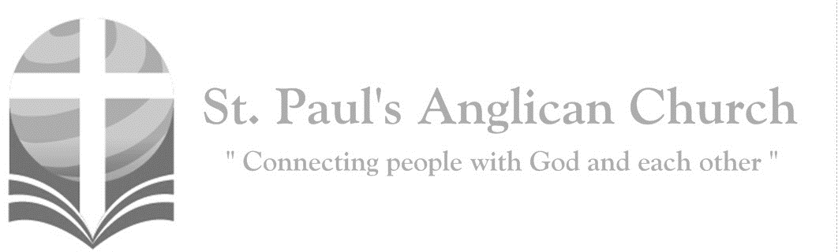

Sunday, February 2, 2020: 4th Sunday After Epiphany

*Rejoice and be glad, for your reward is great in heaven.   
(Matthew 5:12)*



SUNDAYS AT ST. PAUL’S

**REGULAR SERVICES**

* Weekly services held Sundays at 10:00AM
* Interface services - Art based services throughout the year
* Sermons available on our website

**SUNDAY PRAYER**

* Prayer for the service at 9:30AM in the Luke Room
* Individual Prayer in the Chapel during the Sunday service

**SERVING AT ST. PAUL’S**

* Join a Ministry Team (Sunday service team, music team, children’s ministry, Altar guild, or many others)
* Regular or One-Time Giving (cash, cheque, automatic debit, and credit options available)

**LARGE PRINT MATERIALS** Large print Bibles and   
 Books of Alternative   
 Services (BAS) are availableat each Sanctuary door.

Page numbers will not be the same as those listed in the bulletin.

**VISITING TODAY?**

We want to get to know   
 you! Please join us for

in the Hall for coffee and

fellowship following the service. The greeters are also available to help if you have any questions.





**Assisted listening**

**is available. Please**

**ask a greeter**

**for assistance.**



CONNECT

**St. Paul’s CHILDREN’S MINISTRY**

**KIDS** Pre-School-Grade 2 in the hall / Grade 3-5 in the Matthew Room

Sunday School teaching is weekly during the 10:00AM service.

**St. Paul’s YOUTH MINISTRY**

**YOUTH** Youth Grades 6-12 meet weekly during the 10:00AM service.

Youth also meetbi-weekly for fun events and devotionals.

**St. Paul’s ADULT MINISTRY**

**ADULTS** St. Paul’s has a number of small groups where you can connect with others through Christ. If you are interested in joining a small   
group or starting a small group of your own, please speak with Pat Stretch.

**Opening Song: *Come People of the Risen King***

Come people of the risen King  
Who delight to bring Him praise  
Come all and tune your hearts to sing  
To the Morning Star of grace  
From the shifting shadows of the earth  
We will lift our eyes to Him  
Where steady arms of mercy reach  
To gather children in

(*Chorus*) Rejoice, rejoice

Let every tongue rejoice  
One heart, one voice  
O Church of Christ rejoice

Come those whose joy is morning sun  
And those weeping through the night  
Come those who tell of battles won  
And those struggling in the fight  
For His perfect love will never change  
And His mercies never cease  
But follow us through all our days  
With the certain hope of peace

(*To Chorus*)

Come young and old from every land  
Men and women of the faith  
Come those with full or empty hands  
Find the riches of His grace  
Over all the world His people sing  
Shore to shore we hear them call  
The truth that cries through every age  
Our God is all in all (*To Chorus*)

**The Gathering of the Community**

Celebrant: *(BAS pg. 185)* The grace of our Lord Jesus Christ, and the love of God, and the fellowship of the Holy Spirit, be with you all.

**People: And also with you.**

Celebrant:Almighty God,

**All:to you all hearts are open, all desires known, and from you no secrets are hidden. Cleanse the thoughts of our hearts by the inspiration of your Holy Spirit that we may perfectly love you, and worthily magnify your holy name; through Christ our Lord. Amen.**

Celebrant: *(pg. 352)* Living God, in Christ you make all things new. Transform the poverty of our nature by the riches of your grace, and in renewal of our lives make known your glory; through Jesus Christ our Lord, who is alive and reigns with you and the Holy Spirit, one God, now and for ever.

**People:** **Amen**.

**Children’s Dismissal**

**The Reading of Scripture**

First Reading: Micah 6:1-8 (pg. 659 in the red pew Bible)

Reader: The Word of the Lord.

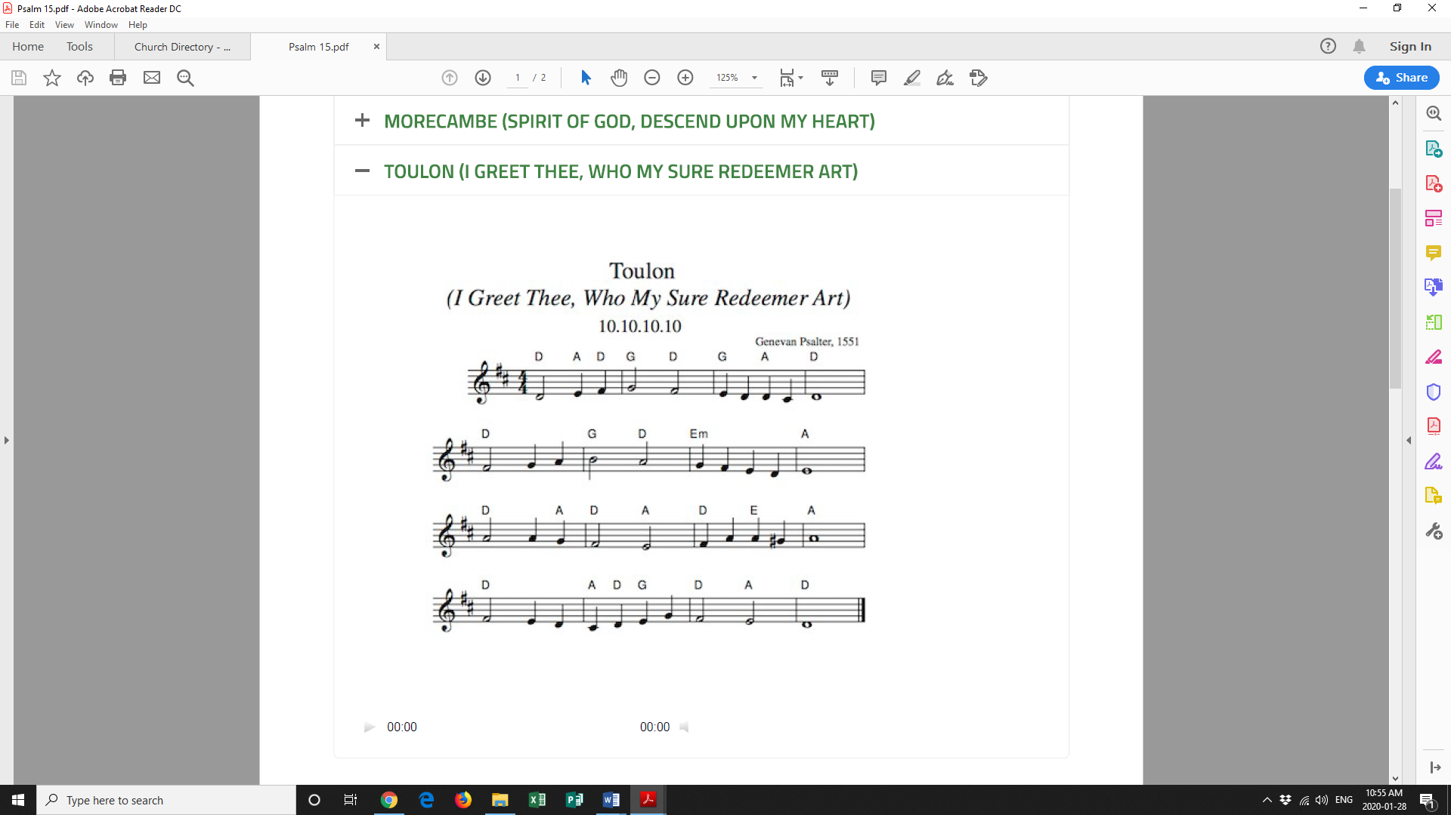**People:** **Thanks be to God.**

Canticle: Psalm 15 (see below)

Who, LORD, may dwell within   
 Your holy place,

And live upon Your holy, righteous   
 hill?

Those who walk blamelessly, and   
 do what’s right,

And speak the truth from their   
 heart ever still.

Who never slander with an evil   
 tongue,

Nor do their neighbor any wrongful   
 deed;

Who cast no slur on either friend or foe,

Rejecting those who walk by sinful   
 creed.

The righteous honor those who fear the   
 LORD;

They keep their oath, despite the hurt   
 or pain.

No wicked bribe they take for a reward.  
Money is lent without dishonest gain.

Who, LORD, may dwell within Your holy   
 place?

Who live upon Your holy, righteous hill?

Those who walk in this path and do   
 these things,

Will not be moved or shaken from Your   
 will.

Second Reading: 1 Corinthians 1:18-31 (pg. 807 in the red pew Bible)

Reader: The Word of the Lord.

**People:** **Thanks be to God.**

**Processional Chorus – *Enough***

All of You

Is more than enough for all of me  
For every thirst and every need  
You satisfy me with Your love  
And all I have in You

Is more than enough

**The Gospel Reading**

Reader: The Lord be with you.

**People: And also with you.**

Reader: The Holy Gospel of our Lord Jesus Christ according to St. Matthew.

**People: Glory to you, Lord Jesus Christ.**

Gospel Reading: Matthew 5:1-12 (pg. 683 in the red pew Bible)

Reader: The Gospel of Christ.

**People: Praise to you, Lord Jesus Christ.**

**Worship Through Song**

***Enough***

(*Chorus*) (And) All of You

Is more than enough for all of me  
For every thirst and every need  
You satisfy me with Your love  
And all I have in You

Is more than enough

You're my supply, my breath of life  
Still more awesome than I know  
You're my reward, worth living for  
Still more awesome than I know  
(To Chorus)

You're my sacrifice of greatest price  
Still more awesome than I know  
You're my coming King

You are everything  
Still more awesome than I know

(To Chorus)

More than all I want

More than all I need  
You are more than enough for me  
More than all I know

More than all I can say  
You are more than enough (To Chorus)

***Blessed Be Your Name***

Blessed be Your name  
In the land that is plentiful  
Where Your streams of abundance flow  
Blessed be Your name

Blessed be Your name  
When I'm found in the desert place  
Though I walk through the wilderness  
Blessed be Your name

(*Pre-Chorus*)

Every blessing You pour out

I’ll turn back to praise  
When the darkness closes in

Lord, still I will say

(*Chorus*)

Blessed be the name of the Lord  
Blessed be Your name  
Blessed be the name of the Lord  
Blessed be Your glorious name

Blessed be Your name  
When the sun's shining down on me  
When the world's all as it should be  
Blessed be Your name (*cont. next page*)

Blessed be Your name  
On the road marked with suffering  
Though there's pain in the offering  
Blessed be Your name (*To Pre-Chorus*)

You give and take away  
You give and take away  
My heart will choose to say  
Lord blessed be Your name (*repeat*)

(*To Chorus*)

**Listening Time**

**Sermon by the Reverend Dr. Myron Penner – Sermon Notes:**

________________________________________________________________________________________________________________________________________________________________________________________________________________________________________________________________________________________________________________________________________________________________________________________________________________________________________________________________________________________________________________________

________________________________________________________________________________________________________________________________________________________________________________________________________________________

________________________________________________________________________________________________________________________________________________________________________________________________________________________________________________________________________________________________

________________________________________________________________________________________________________________________________________________________________________________________________________________________________________________________________________________________________________________________________________________________________________

**Affirmation of Faith – Radical Creed**

**All: We believe and trust in God the Father Almighty.**

**We believe and trust in Jesus Christ, his Son.**

**We believe and trust in the Holy Spirit.**

**We believe and trust in the Three in One.**

**Prayers of the People**

**Confession of Sin**

Celebrant: *(pg. 191)* Dear friends in Christ, God is steadfast in love and infinite in mercy; he welcomes sinners and invites them to his table. Let us confess our sins, confident in God’s forgiveness.

*Silent Confession*

Celebrant:Most merciful God,

**All: we confess that we have sinned against you in thought, word, and deed, by what we have done and by what we have left undone. We have not loved you with our whole heart; we have not loved our neighbours as ourselves. We are truly sorry and we humbly repent. For the sake of your Son Jesus Christ, have mercy on us and forgive us, that we may delight in your will, and walk in your ways, to the glory of your name. Amen.**

Celebrant: Almighty God have mercy upon you, pardon and deliver you from all your sins, confirm and strengthen you in all goodness and keep you in eternal life through Jesus Christ our Lord.

**People:Amen.**

**The Peace**

Celebrant: The peace of the Lord be always with you.

**People: And also with you.**

**Offertory Song: *Hope of the Nations***

Jesus, hope of the nations  
Jesus, comfort for all who mourn  
You are the source

Of heaven's hope on earth  
Jesus, light in the darkness  
Jesus, truth in each circumstance  
You are the source

Of heaven's light on earth

In history You lived and died  
You broke the chains, You rose to life

You are the hope living in us  
You are the Rock in whom we trust  
You are the light shining

For all the world to see  
You rose from the dead conquering fear  
Our Prince of Peace drawing us near  
Jesus our hope

Living for all who will receive  
Lord, we believe (*repeat all*)

Lord, we believe  
Lord, we believe

**Prayer Over the Gifts**

Celebrant: *(pg. 353)* God of steadfast love,

**All: may our offering this day, by the power of your Holy Spirit, renew us for your service. We ask this in the name of Jesus Christ the Lord. Amen.**

Celebrant: *(pg. 196)* The Lord be with you.

**People: And also with you.**

Celebrant: Lift up your hearts.

**People: We lift them to the Lord.**

Celebrant: Let us give thanks to the Lord our God.

**People: It is right to give our thanks and praise.**

Celebrant: We give you thanks and praise, almighty God……. Now with all creation we raise our voices to proclaim the glory of your name.

**All:** ***(Sung)*** **Holy, holy, holy Lord, God of power and might, heaven and earth of Your glory are full. Hosanna, hosanna, hosanna in the highest. Blessed is he who comes in the name of the Lord.   
Blessed is he who comes in the name of the Lord.   
Holy, holy, holy Lord, God of power and might, heaven and earth of Your glory are full. Hosanna, hosanna, hosanna in the highest.**

Celebrant: *(pg. 197)* Holy and gracious God, accept our praise……. All glory and honour are yours, Father and Son, with the Holy Spirit, in the holy Church, now and for ever.

**All: Amen.**

Celebrant: *(pg. 211)* As our Saviour taught us, let us pray,

**All: *(Sung)* Our Father in heaven, holy is your name. Your kingdom come on earth as in heaven. Our Father in heaven, reveal who you are. Your will be done on earth as in heaven. Feed us today what we need to live. Forgive all our sins as we forgive and keep us safe. The kingdom is yours, the power is yours, and the glory forever. The kingdom is yours, the power is yours, and the glory forever.**

Celebrant: *(pg. 212)* We break this bread to share in the body of Christ.

**All: We, being many, are one body, for we all share in the one bread.**

Celebrant: *(pg. 213)* The gifts of God for the People of God.

**People: Thanks be to God.**

**The Communion**

*You are welcome to receive communion or come forward for a blessing. If you prefer to receive a blessing, please fold your arms over your chest. There is an intinction cup available on the left side and de-alcoholized wine available on the right side. Gluten-free wafers are available upon request.*

**Lamb of God**

*(Sung)* Lamb of God, you take away the sin of the world, have mercy on us.

Lamb of God, you take away the sin of the world, have mercy on us.

Lamb of God, you take away the sin of the world, grant us your peace.

**Communion Music**

***When I Survey the Wondrous Cross***

When I survey the wondrous cross  
On which the Prince of glory died  
My richest gain I count but loss  
And pour contempt on all my pride

Forbid it Lord that I should boast  
Save in the death of Christ my God  
All the vain things that charm me most  
I sacrifice them to His blood

See from His head, His hands, His feet  
Sorrow and love flow mingled down  
Did ever such love and sorrow meet  
Or thorns compose so rich a crown

Were the whole realm of nature mine  
That were a present far too small  
Love so amazing, so divine  
Demands my soul, my life, my all

***My Heart is Filled with Thankfulness***

My heart is filled with thankfulness  
To Him who bore my pain  
Who plumbed the depths

Of my disgrace and gave me life again  
Who crushed my curse of sinfulness  
And clothed me with His light  
And wrote His law of righteousness  
With power upon my heart

My heart is filled with thankfulness  
To Him who walks beside  
Who floods my weaknesses

With strength and causes fears to fly  
Whose every promise is enough  
For every step I take  
Sustaining me with arms of love  
And crowning me with grace

(*continued on next page*)

My heart is filled with thankfulness  
To Him who reigns above  
Whose wisdom is my perfect peace  
Whose every thought is love  
For every day I have on earth  
Is given by the King  
So I will give my life my all  
To love and follow Him

**Prayer After Communion**

Celebrant: *(pg. 353)* Source of all goodness,

**All: in this eucharist we are nourished by the bread of heaven and invigorated with new wine. May these gifts renew our lives, that we may show your glory to all the world, in the name of Jesus Christ the Lord.** **Amen.**

Celebrant: *(pg. 214)* Glory to God,

**All:whose power, working in us, can do infinitely more than we can ask or imagine. Glory to God from generation to generation, in the Church and in Christ Jesus, for ever and ever. Amen.**

**Blessing**

**Congregational Announcements *(David H.)***

**Closing Song: *Do Something Beautiful***

We are a shining light  
City on a hill that can't be hidden  
A shining light  
And this shining light

Is the life of Jesus in us  
Oh what a light  
The fire of His Spirit burns  
With justice joy and peace  
And works through our hands and feet

(*Chorus*) Go do something beautiful

In the Name of Jesus  
Do something beautiful  
Go do something Jesus would  
Do something beautiful  
Do something beautiful

We are the salt of the earth  
Here to purify and flavour  
Salt of the earth  
Sent through all the earth  
To love God and love our neighbour  
Salt of the earth

As freely as we received  
So freely we must give  
And we are His hands and feet

(*To Chorus*)

(*continued on next page*)

Let your light so shine before the world  
That all may see the good you do  
And give their praise to God our Father

(*To Chorus*)

Do something beautiful

**The Dismissal**Celebrant: *(pg. 215)* Go forth in the name of Christ.

**All: Thanks be to God. Amen.**

*Please join us in the hall for coffee following the service.*

**AGM and Sandwiches – February 9**

Please join us for the St. Paul’s Annual General Meeting following the service on February 9. We will also be having a Sandwich Sunday that day so please plan to join us for lunch!! If you are able to help with setup and clean up that day, please email RJ in the office.

**Team Tomorrow**

Team Tomorrow is a (renewed) ministry that seeks to encourage just and responsible living with future generations in mind. Watch for more information at our AGM. In the meantime, please plan to join us at 7:00PM on Feb. 8 for part 2 of a speaker series at Bethel Community Church (14204 25 Street) to learn about practical solutions for environmental challenges. Please contact Margot at margot.byer@gmail.com if you are interested in car-pooling together.

**Wholeness Through Christ**

Wholeness Through Christ (WTC) is a scripturally-based, Spirit-led ministry to

the whole person. WTC is offering a Prayer Ministry Course in Calgary May 19-24. If you register by April 19, you save

$100.00! To register or to find out more information, please visit wholenessthroughchrist.com.

**Games Night – February 14, 6:00PM**

Join us for board games in the Hall!! Come learn a new game, bring your favourite game to teach others, or play a classic with new friends. We also have a Puzzlers Corner for those who want to build puzzles together. We sometimes even have goodies to snack on!

**Confirmation/Baptism Interest?**

**There will be a service of Confirmation on March 1. If you are interested in Confirmation or Baptism, please speak with Rev. Myron or contact the office.**

**Are You Interested in Joining the Chapel Prayer Team?**

**Chapel Prayer training will be held on Thursday evenings at 7:00PM in February in the John Room. If you are interested in joining this important ministry at St. Paul’s, please plan to join us!**



@StEdmonton

facebook.com/stpachurchedmonton

**St. Paul’s Vestry:**

Peter Jackson, *Rector’s Warden*

Pat Stretch, *People’s Warden*

David Heritage, *Treasurer*

Margot Byer, *Vestry Member*

John Green, *Vestry Member*

Deanna Kalles, *Vestry Member*

David Parker, *Vestry Member*

Carol Rudat, *Vestry Member*

**St. Paul’s Staff:**

*Rector:*

The Reverend Myron Bradley Penner  
*Office Administrator:*

RJ Chambers

*Youth Leader:* Victoria Eeles

**For prayer requests** **email**:

office@stpauls-anglican.ca

**For urgent prayer requests call**

the church office: (780) 455-0771

**For pastoral emergencies call:**

(587) 334-2130

**Office Hours:**

Monday-Thursday: 9:00AM-12:00PM

Closed: Fri/Sat/Sun and Stat Holidays

**St. Paul’s Anglican Church**

10127 145 Street, Edmonton T5N 2X6

Phone: (780) 455-0771; Email: office@stpauls-anglican.ca

Website: www.stpauls-anglican.ca

**This Week’s Readings:**

Micah 6:1-8 (pg. 659)

Psalm 15 (in bulletin)

1 Corinthians 1:18-31 (pg. 807)

Matthew 5:1-12 (pg. 683)

**This Week’s Ministry Teams:**

Music/Sound: Adele’s Team/Scott M.

Service Team: Jackson Team

Prayers: Gay G.; Vestry: David H.

Chapel Prayer: Wendell and Nora J.

Kid’s Ministry: Renee J. and Abigail P.

**St. Paul’s Cycle of Prayer:**

Gene and Kay Wannamaker;   
Amanda Wannamaker;

Nathan and Deanna Kalles

**Anglican Cycle of Prayer:**

Diocese of Western Newfoundland; the Rt. Rev. John Organ, Bishop. Diocese of Edmonton Examining Chaplains, theological students, and postulants for ordination. Buyé Diocese, Gakana Parish: Gregoire Ntirenganya, Rector. Montana First Nation.

**Next Week’s Ministry Teams**

Music/Sound: Jodi and Youth/Asher H.

Service Team: Heritage Team

Prayers: David H.; Vestry: Pat S.

Chapel Prayer: Kjeryn A. and Barb M.

Kid’s Ministry: Creative Engagement Service

(All kids remain in the service)