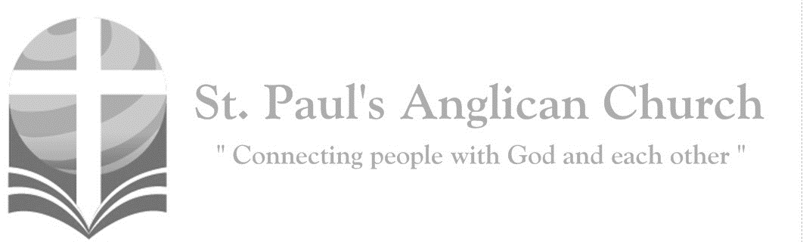
Monday, April 6, 2020, 7:00PM – Holy Week: Monday
Live Streamed Evening Prayer
God sent his Son to be the expiation for our sins.
(1 John 4:10)

Light your candle if you are using one and take a moment of silence to pay attention to the presence of God.

Evening Prayer
Rev. Myron: O Lord, I call to you; come to me quickly;
All: Hear my voice when I cry to you.
Rev. Myron: Let my prayer be set forth in your sight as incense,
All: The lifting up of my hands as the evening sacrifice. Glory to the Father, and to the Son, and to the Holy Spirit: as it was in the beginning, is now, and will be for ever. Amen.

The Invitatory
Rev. Myron: (O Gracious Light by Phos Hilaron) O gracious Light, pure brightness of the everliving Father in heaven, O Jesus Christ, holy and blessed! Now as we come to the setting of the sun, and our eyes behold the vesper light, we sing your praises, O God: Father, Son, and Holy Spirit. You are worthy at all times to be praised by happy voices, O Son of God, O Giver of life, and to be glorified through all the worlds.

The Psalm
Psalm 36:5-11
Your steadfast love, O LORD, extends to the heavens, your faithfulness to the clouds. Your righteousness is like the mighty mountains, your judgments are like the great deep; you save humans and animals alike, O LORD. How precious is your steadfast love, O God! All people may take refuge in the shadow of your wings. They feast on the abundance of your house, and you give them drink from the river of your delights. For with you is the fountain of life; in your light we see light. O continue your steadfast love to those who know you, and your salvation to the upright of heart! Do not let the foot of the arrogant tread on me, or the hand of the wicked drive me away.

The Gospel Reading
Rev. Myron: The Lord be with you.
People: And also with you.
Rev. Myron: The Holy Gospel of our Lord Jesus Christ according to St. John.
People: Glory to you, Lord Jesus Christ.
Gospel Reading: John 12:1-11
Six days before the Passover Jesus came to Bethany, the home of Lazarus, whom he had raised from the dead. There they gave a dinner for him. Martha served, and Lazarus was one of those at the table with him. Mary took a pound of costly perfume made of pure nard, anointed Jesus' feet, and wiped them with her hair. The house was filled with the fragrance of the perfume. But Judas Iscariot, one of his disciples (the one who was about to betray him), said, "Why was this perfume not sold for three hundred denarii and the money given to the poor?" (He said this not because he cared about the poor, but because he was a thief; he kept the common purse and used to steal what was put into it.) Jesus said, "Leave her alone. She bought it so that she might keep it for the day of my burial. You always have the poor with you, but you do not always have me." When the great crowd of the Jews learned that he was there, they came not only because of Jesus but also to see Lazarus, whom he had raised from the dead. So the chief priests planned to put Lazarus to death as well, since it was on account of him that many of the Jews were deserting and were believing in Jesus.
Rev. Myron: The Gospel of Christ.
People: Praise to you, Lord Jesus Christ.

Affirmation of Faith – Hear, O Israel
All: Hear, O Israel, the Lord our God, the Lord is one. Love the Lord your God with all your heart, with all your soul, with all your mind, and with all your strength. This is the first and the great commandment. The second is like it: Love your neighbour as yourself. There is no commandment greater than these.

Prayers of the People
Rev. Myron: In peace let us pray to the Lord, saying, “We pray to you, Lord.”
That this evening may be holy, good, and peaceful,
All: We pray to you, Lord.
Rev. Myron: That the work we have done this day and the people we have met may bring us closer to you,
All: We pray to you, Lord.
Rev. Myron: That we may be forgiven our sins and offences,
All: We pray to you, Lord.
Rev. Myron: That we may hear and respond to your call to peace and justice,
All: We pray to you, Lord.
Rev. Myron: That you will sustain the faith and hope of the weary, the lonely, and the oppressed,
All: We pray to you, Lord.
Rev. Myron: That you will strengthen us in your service, and fill our hearts with longing for your kingdom,
All: We pray to you, Lord.

The Collect
Rev. Myron: Almighty God, whose Son was crucified yet entered into glory, may we, walking in the way of the cross, find it is for us the way of life; through Jesus Christ our Lord, who is alive and reigns with you and the Holy Spirit, one God, now and for ever.
All: Amen.

The Lord’s Prayer
Rev. Myron: And now, as our Saviour Christ has taught us, we are bold to say,
All: Our Father, who art in heaven, hallowed be thy name, thy kingdom come, thy will be done, on earth as it is in heaven. Give us this day our daily bread. And forgive us our trespasses, as we forgive those who trespass against us. And lead us not into temptation, but deliver us from evil. For thine is the kingdom, the power, and the glory, for ever and ever. Amen.

The Dismissal
Rev. Myron: Let us bless the Lord.
All: Thanks be to God.
Rev. Myron: The Lord almighty grant us a quiet night and peace at the last.
All: Amen.

