**Ash Wednesday Supper – 5:45PM on Wednesday, February 26**

The *Wednesday Night before Sunday Bible Study Group* would like to invite the congregation to join us for a soup / bread / salad supper before the Ash Wednesday evening service on February 26th. Supper would be available 5:45- 6:30PM. Gluten free alternatives will be provided as requested. Please confirm attendance by Sunday, February 23 to Peter or John in person or Peter at [pjackson@sjsa.ab.ca](mailto:pjackson@sjsa.ab.ca).

**A Night with the Persecuted Church – Monday,   
February 24, 7:00PM**

Please join Open Doors and St. Paul's as we host this event. This is an opportunity to hear stories of how people have sacrificed everything to follow Christ. You’ll be challenged to follow the examples of faith lived by those who follow Jesus no matter the cost. You’ll also have the opportunity to connect through letter writing and prayer.

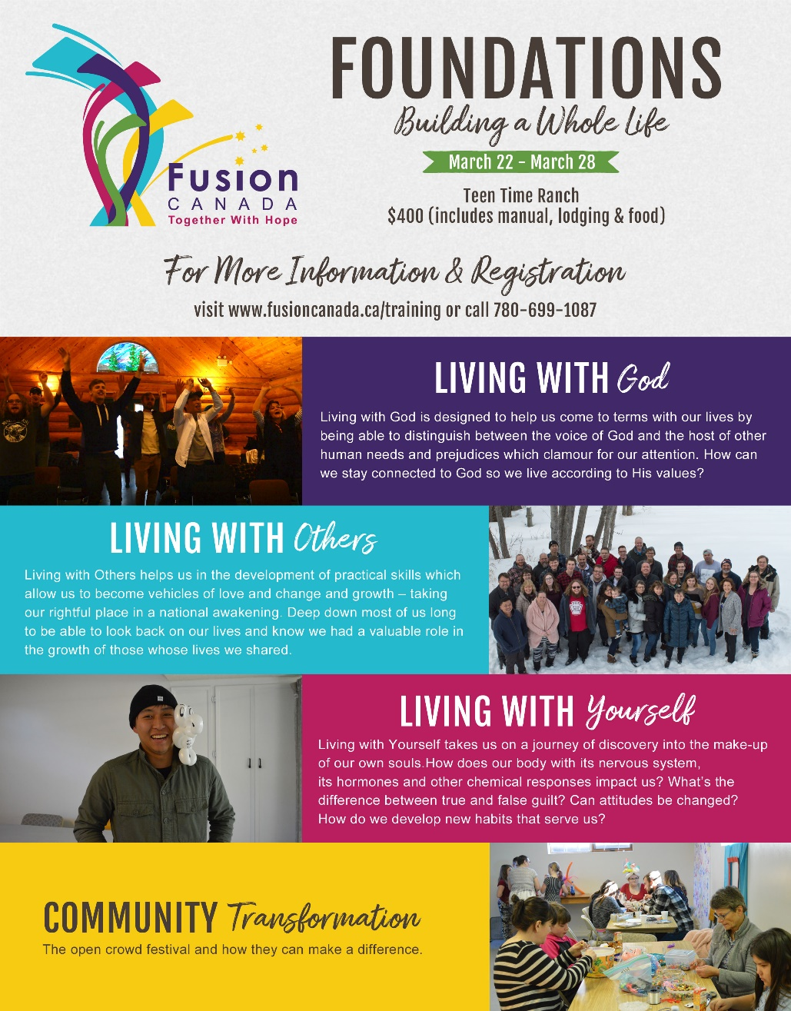

**Shrove Tuesday Supper – 6:00PM on Tuesday, February 25**

**Please join us for pancakes on Shrove Tuesday!**

**Ash Wednesday Service – 7:00PM on Wednesday, February 26**

**Please join us on Ash Wednesday at 7:00PM in the Sanctuary.**

**Lent Study – 8:45AM on Sundays in Lent**

During Lent (March 1-April 10), Rev. Myron will be leading a Lent study series called “A Gospel-Shaped World.” It will be an excellent companion to his sermon series at that time. Please plan to join us!!

**Team Tomorrow Meeting**

Team Tomorrow welcomes you to our next meeting this Sunday, February 23 after the service (downstairs in one of the meeting rooms).  Please share your ideas for a responsible and just response towards climate change.

**Confirmation/Baptism**

**There will be a service of Confirmation on March 1. If you are interested in Confirmation or Baptism, please speak with Rev. Myron or contact the office.**

**For more information about Fusion and the Foundations course (see reverse side), please speak with Terry Berard.**

**Lenten Embers 2020**

This spiritual formation exercise is designed to serve worshippers devotionally while encouraging the development of the gifts of simplicity, discernment, awareness and prayer. Lenten Embers kits will be available for pick-up at the Church office commencing Ash Wednesday. Please email Jim Robertson indicating your intention to participate so Jim can better estimate the number of kits required – [interfaceworship@gmail.com](mailto:interfaceworship@gmail.com).

**Ash Wednesday Supper – 5:45PM on Wednesday, February 26**

The *Wednesday Night before Sunday Bible Study Group* would like to invite the congregation to join us for a soup / bread / salad supper before the Ash Wednesday evening service on February 26th. Supper would be available 5:45- 6:30PM. Gluten free alternatives will be provided as requested. Please confirm attendance by Sunday, February 23 to Peter or John in person or Peter at [pjackson@sjsa.ab.ca](mailto:pjackson@sjsa.ab.ca).

**A Night with the Persecuted Church – Monday,   
February 24, 7:00PM**

Please join Open Doors and St. Paul's as we host this event. This is an opportunity to hear stories of how people have sacrificed everything to follow Christ. You’ll be challenged to follow the examples of faith lived by those who follow Jesus no matter the cost. You’ll also have the opportunity to connect through letter writing and prayer.



**Shrove Tuesday Supper – 6:00PM on Tuesday, February 25**

**Please join us for pancakes on Shrove Tuesday!**

**Ash Wednesday Service – 7:00PM on Wednesday, February 26**

**Please join us on Ash Wednesday at 7:00PM in the Sanctuary.**

**Lent Study – 8:45AM on Sundays in Lent**

During Lent (March 1-April 10), Rev. Myron will be leading a Lent study series called “A Gospel-Shaped World.” It will be an excellent companion to his sermon series at that time. Please plan to join us!!

**Team Tomorrow Meeting**

Team Tomorrow welcomes you to our next meeting this Sunday, February 23 after the service (downstairs in one of the meeting rooms).  Please share your ideas for a responsible and just response towards climate change.

**Confirmation/Baptism**

**There will be a service of Confirmation on March 1. If you are interested in Confirmation or Baptism, please speak with Rev. Myron or contact the office.**

**For more information about Fusion and the Foundations course (see reverse side), please speak with Terry Berard.**

**Lenten Embers 2020**

This spiritual formation exercise is designed to serve worshippers devotionally while encouraging the development of the gifts of simplicity, discernment, awareness and prayer. Lenten Embers kits will be available for pick-up at the Church office commencing Ash Wednesday. Please email Jim Robertson indicating your intention to participate so Jim can better estimate the number of kits required – [interfaceworship@gmail.com](mailto:interfaceworship@gmail.com).