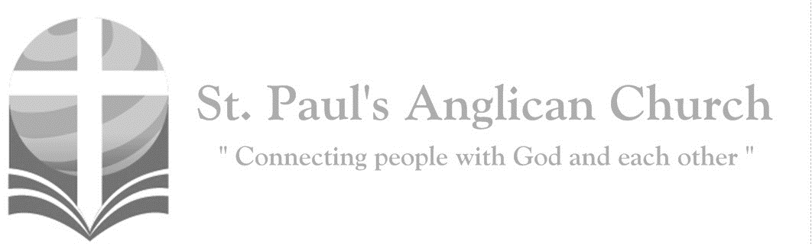

Sunday, April 28, 2019: 2nd Sunday of Easter

*Have you believed, Thomas, because you have seen me? Blessed are those who have not seen and yet believe. (John 20:29)*

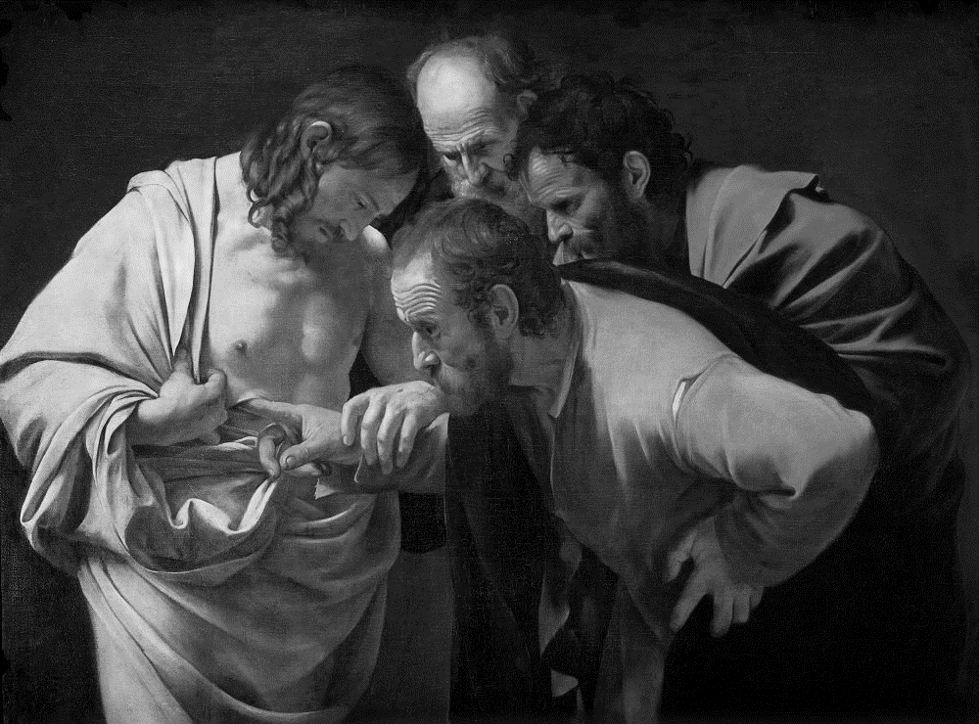

SUNDAYS AT ST. PAUL’S

**REGULAR SERVICES**

* Weekly services held Sundays at 10:00AM
* Interface services - Art based services throughout the year
* Sermons available on our website

**SUNDAY PRAYER**

* Prayer for the service at 9:30AM in the Luke Room
* Individual Prayer in the Chapel during the Sunday service

**SERVING AT ST. PAUL’S**

* Join a Ministry Team (Sunday service team, music team, children’s ministry, Altar guild, or many others)
* Regular or One-Time Giving (cash, cheque, automatic debit, and credit options available)

**LARGE PRINT MATERIALS** Large print Bibles and   
 Books of Alternative   
 Services (BAS) are availableat each Sanctuary door.

Page numbers will not be the same as those listed in the bulletin.

**VISITING TODAY?**

We want to get to know   
 you! Please join us for

in the Hall for coffee and

fellowship following the service. The greeters are also available to help if you have any questions.

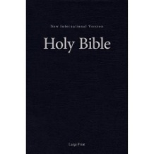



**Assisted listening**

**is available. Please**

**ask a greeter**

**for assistance.**



CONNECT

**St. Paul’s CHILDREN’S MINISTRY**

**KIDS** Chickadees Ages 2-4 / Peacocks Grade K-2 / Falcons Grade 3-5

Sunday School teaching is weekly during the 10:00AM service.

**St. Paul’s YOUTH MINISTRY**

**YOUTH** Youth Grades 6-12 meet weekly during the 10:00AM service.

Youth also meetbi-weekly for fun events and devotionals.

**St. Paul’s ADULT MINISTRY**

**ADULTS** St. Paul’s has a number of small groups where you can connect with others through Christ. If you are interested in joining a small   
group or starting a small group of your own, please speak with Pat Stretch.

**Opening Song: *Praise, My Soul, the King of Heaven***

Praise my soul, the King of heaven

To His feet your tribute bring

Ransomed, healed, restored, forgiven

Who like me His praise should sing?

Praise Him! Praise Him!

Praise Him! Praise Him!

Praise the everlasting King

Praise Him for His grace and favour

To our fathers in distress

Praise Him still the same as ever

Slow to blame, and swift to bless

Praise Him! Praise Him!

Praise Him! Praise Him!

Glorious in His faithfulness

Father-like, he tends and spares us

All our hopes and fears He knows

In His hands He gently bears us

Rescues us from all our foes

Praise Him! Praise Him!

Praise Him! Praise Him!

Widely as His mercy flows

Angels help us to adore Him

You behold Him face to face

Sun and moon, bow down before Him

All that is in time and space

Praise Him! Praise Him!

Praise Him! Praise Him!

Praise with us the God of grace

**The Gathering of the Community**

Celebrant: *(BAS pg. 185)* Alleluia! Christ is risen.

**People: The Lord is risen indeed. Alleluia!**

Celebrant: May his grace and peace be with you.

**People: May he fill our hearts with joy.**

Celebrant:Almighty God,

**All:to you all hearts are open, all desires known, and from you no secrets are hidden. Cleanse the thoughts of our hearts by the inspiration of your Holy Spirit that we may perfectly love you, and worthily magnify your holy name; through Christ our Lord. Amen.**

Celebrant: *(pg. 336)* Almighty and eternal God, the strength of those who believe and the hope of those who doubt, may we, who have not seen, have faith and receive the fullness of Christ’s blessing, who is alive and reigns with you and the Holy Spirit, one God, now and for ever.

**People:** **Amen**.

**Children and Youth Dismissal**

**The Reading of Scripture**

First Reading: Acts 5:27-32 (pg. 774 in the red pew Bible)

Reader: The Word of the Lord.

**People:** **Thanks be to God.**

Psalm Reading: Psalm 118:14-29 (pg. 867 in the BAS)

Second Reading: Revelation 1:4-8 (pg. 867 in the red pew Bible)

Reader: The Word of the Lord.

**People:** **Thanks be to God.**

**Worship Through Song**

***I Believe***

Bethlehem, He was born there

I believe, I believe

Galilee, Jesus walked there

I believe, I believe

Gethsemane, Jesus prayed there

Calvary He bled and died there

He rose again, and lives forever

I believe, I believe

***Alleluia, Alleluia***

(*Chorus*) Alleluia, alleluia

Give thanks to the risen Lord

Alleluia, alleluia, give praise to his name

Jesus is Lord of all the earth

He is the King of creation (*To Chorus*)

Spread the good news o’er all the earth

Jesus has died and has risen (*To Chorus*)

We have been crucified with Christ

Now we shall live forever (*To Chorus*)

God has proclaimed the just reward

Life for all men, alleluia (*To Chorus*)

Come let us praise the living God

Joyfully sing to our Saviour (*To Chorus*)

**Listening Time**

**The Gospel Reading**

Gospel Reading: John 20:19-31 (pg. 769 in the red pew Bible)

Reader: The Lord be with you.

**People: And also with you.**

Reader: The Holy Gospel of our Lord Jesus Christ according to St. John.

**People: Glory to you, Lord Jesus Christ.**

*The Gospel Reading*

Reader: The Gospel of Christ.

**People: Praise to you, Lord Jesus Christ.**

Sermon: The Reverend Dr. Myron Penner

**Sermon Notes**

________________________________________________________________________________________________________________________________________________________________________________________________________________________________________________________________________________________________________________________________________________________________________________________________________________________________________________________________________________________________________________________________________________________________________________________________________________________________________________________________________________________________________________________________________________________________________________________________________________________________________________________________________________________________________________________________________________________________________________________________________________________________________________________________________________________________________________________________________________________________________________________________________________________________________________________________________________________________________________________________________________

**The Apostle’s Creed**

Celebrant: *(pg. 189)* Let us confess the faith of our baptism, as we say,

**All: I believe in God, the Father almighty, Creator of heaven and earth. I believe in Jesus Christ, his only Son, our Lord. He was conceived by the power of the Holy Spirit and born of the Virgin Mary. He suffered under Pontius Pilate, was crucified, died and was buried. He descended to the dead. On the third day, he rose again. He ascended into heaven and is seated at the right hand of the Father. He will come again to judge the living and the dead. I believe in the Holy Spirit, the holy catholic Church, the communion of saints, the forgiveness of sins, the resurrection of the body, and the life everlasting. Amen.**

**Prayers of the People**

**Confession of Sin**

Celebrant: *(pg. 191)* Dear friends in Christ, God is steadfast in love and infinite in mercy; he welcomes sinners and invites them to his table. Let us confess our sins, confident in God’s forgiveness.

*Silent Confession*

**All: Have mercy upon us, most merciful Father; in your compassion, forgive us our sins, known and unknown, things done and left undone; and so uphold us by your Spirit that we may live and serve you in newness of life to the honour and glory of your name; through Jesus Christ our Lord. Amen.**

Celebrant: Almighty God have mercy upon you, pardon and deliver you from all your sins, confirm and strengthen you in all goodness and keep you in eternal life through Jesus Christ our Lord.

**People:Amen.**

**The Peace**

Celebrant: The peace of the Lord be always with you.

**People: And also with you.**

**Offertory Song: *Give Thanks***

Give thanks with a grateful heart

Give thanks to the Holy One

Give thanks because He’s given

Jesus Christ His Son (*Repeat All*)

And now let the weak say “I am strong”

Let the poor say “I am rich”

Because of what

The Lord has done for us (*Repeat*)

Give thanks, give thanks

**Prayer Over the Gifts**

Celebrant: *(pg. 337)* God of grace,

**All: you have freed us from our sins and made us a kingdom in your Son Jesus Christ our Lord. Accept all we offer you this day, and strengthen us in the new life you have given us, through Jesus Christ our Lord. Amen.**

Celebrant: *(pg. 198)* The Lord be with you.

**People: And also with you.**

Celebrant: Lift up your hearts.

**People: We lift them to the Lord.**

Celebrant: Let us give thanks to the Lord our God.

**People: It is right to give our thanks and praise.**

Celebrant: *(pg. 222)* Blessed are you, gracious God, creator of heaven and earth; we give you thanks and praise for the glorious resurrection of your Son Jesus Christ our Lord; for he is the true paschal lamb who has taken away the sin of the world. By his death he destroyed death, and by his rising to life again he has won for us eternal life. Therefore, joining our voices with the whole company of heaven, we sing our joyful hymn of praise to proclaim the glory of your name.

**All:** ***(Sung)*** **Holy, holy, holy Lord, God of power and might, heaven and earth of Your glory are full. Hosanna, hosanna, hosanna in the highest. Blessed is he who comes in the name of the Lord.   
Blessed is he who comes in the name of the Lord.   
Holy, holy, holy Lord, God of power and might, heaven and earth of Your glory are full. Hosanna, hosanna, hosanna in the highest.**

Celebrant: *(pg. 198)* We give thanks to you, Lord our God……. Therefore, Father, according to his command,

**All: we remember his death, we proclaim his resurrection, we await his coming in glory;**

Celebrant: and we offer our sacrifice of praise and thanksgiving to you…… by whom, and with whom, and in whom, in the unity of the Holy Spirit, all honour and glory are yours, almighty Father, now and for ever.

**All: Amen.**

Celebrant: *(pg. 211)* As our Saviour taught us, let us pray,

**All: *(Sung)* Our Father in heaven, hallowed be your name. Your kingdom come, your will be done, on earth as in heaven. Give us today our daily bread. Forgive us our sins as we forgive those who sin against us. Save us from the time of trial, and deliver us from evil. For the kingdom, the power, and the glory are yours, now and for ever. Amen.**

Celebrant: *(pg. 213)* Lord, we died with you on the cross.

**All: Now we are raised to new life.**

Celebrant: We were buried in your tomb.

**All: Now we share in your resurrection.**

Celebrant: Live in us, that we may live in you.

Celebrant: *(pg. 213)* The gifts of God for the People of God.

**People: Thanks be to God.**

**The Communion**

*You are welcome to receive communion or come forward for a blessing. If you prefer to receive a blessing, please fold your arms over your chest. There is de-alcoholized wine available in the centre and gluten-free wafers available upon request.*

**Lamb of God**

*(Sung)* Lamb of God, you take away the sin of the world.

Lamb of God, you take away the sin of the world.

Lord have mercy, Christ have mercy, Lord have mercy on me.

Lord have mercy, Christ have mercy and grant us thy peace.

**Communion Music**

***Behold the Lamb***

Behold the Lamb

Who bears our sins away

Slain for us and we remember

The promise made

That all who come in faith

Find forgiveness at the cross

So we share in this bread of life

And we drink of His sacrifice

As a sign of our bonds of peace

Around the table of the King

The body of our Saviour Jesus Christ Torn for you, eat and remember

The wounds that heal

The death that brings us life

Paid the price to make us one

So we share in this bread of life

And we drink of His sacrifice

As a sign of our bonds of love

Around the table of the King

The blood that cleanses

Every stain of sin, shed for you

Drink and remember

He drained death’s cup

That all may enter in

To receive the life of God

(*continued on next page*)

So we share in this bread of life

And we drink of His sacrifice

As a sign of our bonds of grace

Around the table of the King

And so with thankfulness

And faith we rise to respond

And to remember

Our call to follow in the steps of Christ

As His body here on earth

As we share in His suffering

We proclaim Christ will come again!

And we’ll join in the feast of heaven Around the table of the King

**Prayer After Communion**

Celebrant: *(pg. 337)* Father,

**All: we have seen with our eyes and touched with our hands the bread of life. Strengthen our faith that we may grow in love for you and for each other; through Jesus Christ the risen Lord. Amen.**

Celebrant: *(pg. 214)* Glory to God,

**All:whose power, working in us, can do infinitely more than we can ask or imagine. Glory to God from generation to generation, in the Church and in Christ Jesus, for ever and ever. Amen.**

**Blessing**

**Congregational Announcements *(Peter Jackson)***

**Closing Song: *See, What a Morning***

See, what a morning, gloriously bright

With the dawning of hope in Jerusalem

Folded the grave clothes

Tomb filled with light

As the angels announce “Christ is risen!”

See God’s salvation plan

Wrought in love, borne in pain

Paid in sacrifice

Fulfilled in Christ the Man, for He lives

Christ is risen from the dead

See, Mary weeping, “Where is He laid?”

As in sorrow she turns

From the empty tomb

Hears a voice speaking

Calling her name

It’s the Master, the Lord

Raised to life again

The voice that spans the years

Speaking life, stirring hope

Bringing peace to us

Will sound till He appears, for He lives

Christ is risen from the dead

(*continued on next page*)

One with the Father, Ancient of Days

Through the Spirit

Who clothes faith with certainty

Honour and blessing, glory and praise

To the King crowned

With power and authority

And we are raised with Him

Death is dead, life has won

Christ has conquered

And we shall reign with Him

For He lives

Christ is risen from the dead

**The Dismissal**Celebrant: *(pg. 215)* Go in peace to love and serve the Lord.

**All: Thanks be to God. Alleluia.**

*Please join us in the Hall for coffee following the service.*

**Spring Clean – June 1 at St. Paul’s**

Please plan to join us for our annual Spring Clean at St. Paul’s on Saturday, June 1 from 10:00AM-3:00PM. This is an opportunity to do deal with some of the larger cleaning and organizing projects at St. Paul’s as well as do some special cleaning (kid’s toys, windows, etc.). There will also be delicious treats for those who come. Please keep your eyes open for a sign-up sheet that will appear in the foyer in the next couple of weeks.

**Canon Andrew White at St. Paul’s**

Please join us on Tuesday, May 7 from 7:00-9:00PM as the Rev. Canon Andrew White speaks about persecution, reconciliation, and the church in the Middle East. This event will begin with a short time of Worship, followed by a presentation by Canon White, and will end with a Q&A. The event will be followed by a short reception in the Hall. It is a privilege for St. Paul’s to be able to host Canon White and we hope you will plan to join us. Please invite anyone you think may be interested. To RSVP, please register on Eventbrite (a link will be sent out to the congregation) or contact RJ at the office.

For this event, we expect a large turnout so we will need some volunteers to help with the reception as well as to assist as parking attendants. If you are able to help in any way, please contact the office.

**St. Paul’s Youth Games League**

Please join us every 2nd and 4th Tuesday

from 7:00-9:00PM in the Hall for Games League. This is an event for the youth

(and young at heart) and is open for

anyone to attend**.**We will be focusing

on some fun competitive games.

**Community Games Night – May 3**

Please join us on Friday, May from 6:00-10:00PM (drop-in) in the Hall. This is an event for all ages and open for anyone to attend. Please invite your family, friends, and neighbours to this community event. There will be lots of games to choose from or you can bring some of your own.

There may also be munchies!!

**Wholeness Through Christ**

Wholeness Through Christ (WTC) is a scripturally-based, Spirit-led ministry to

the whole person. WTC is offering a Prayer Ministry Course in Calgary on May 22-26. Please pick up a brochure for more.

**Praying for the Muslim World**

Learn more about the Muslim World by picking up a copy of the Muslim World Prayer Guide (both adult and children versions available) at either door. Please pray for Muslims May 6 – June 4.

**Youth Variety Show – TONIGHT!**

Please join us tonight, April 28 at 7:00PM in the Sanctuary for a Variety Show presented by our youth!



@StEdmonton

facebook.com/stpachurchedmonton

**St. Paul’s Vestry:**

Peter Jackson, *Rector’s Warden*

Pat Stretch, *People’s Warden*

David Heritage, *Treasurer*

Margot Byer, *Vestry Member*

John Green, *Vestry Member*

Deanna Kalles, *Vestry Member*

David Parker, *Vestry Member*

Carol Rudat, *Vestry Member*

**St. Paul’s Staff:**

*Interim Rector:*

The Reverend Myron Bradley Penner  
*Office Administrator:*

RJ Chambers

*Youth Leader:* Victoria Eeles

**For prayer requests** **email**:

stpaulsprayerchain@gmail.com

**For urgent prayer requests call**

the church office: (780) 455-0771

**For pastoral emergencies call:**

(587) 334-2130

**Office Hours:**

Monday-Thursday: 9:00AM-12:00PM

Closed: Fri/Sat/Sun and Stat Holidays

**St. Paul’s Anglican Church**

10127 145 Street, Edmonton T5N 2X6

Phone: (780) 455-0771; Email: office@stpauls-anglican.ca

Website: www.stpauls-anglican.ca

**This Week’s Readings:**

Acts 5:27-32 (pg. 774)

Psalm 118:14-29 (BAS pg. 867)

Revelation 1:4-8 (pg. 867)

John 20:19-31 (pg. 769)

**This Week’s Ministry Teams:**

Music/Sound: Pat’s Team/Chandra S.

Service Team: B Team

Prayers of the People: Barb M.

Chapel Prayer: Wendell and Nora J.

Vestry on Duty: Peter J.

**St. Paul’s Cycle of Prayer:**

Laurier and Margot Byer;

Victoria Bellmore and Colton;

Angela Sutton

**Anglican Cycle of Prayer:**

Diocese of Qu’Appelle; the **Rt. Rev. Robert Hardwick, Bishop.** St. Augustine of Canterbury, Edmonton: Jonathan Crane (s. Megan), Rector. Buyé Diocese, Gakana Parish: Gregoire Ntirenganya, Rector. All First Nations people of Treaty 6.

**Next Week’s Ministry Teams**

Music/Sound: RJ’s Team/RJ C.

Service Team: Green and Friends Team

Prayers of the People: Nancy W-S.

Chapel Prayer: Kjeryn A. and Barb M.

Vestry on Duty: David H.