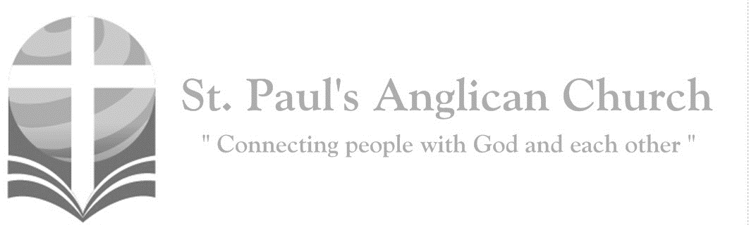
Sunday, May 10, 2020: 5th Sunday of Easter

I am the way, the truth, and the life, says the Lord; no one comes to the Father, but by me. (John 14:6)

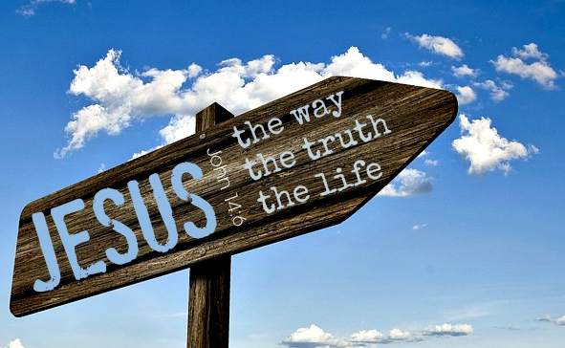

Opening Song: I Know that My Redeemer Lives
I know that my Redeemer lives
What joy the blest assurance gives
He lives, He lives, Who once was dead
He lives, my everlasting Head

He lives to bless me with His love
He lives to plead for me above
He lives, my hungry soul to feed
He lives to help in time of need
He lives and grants me daily breath
He lives and I shall conquer death
He lives, my future to prepare
He lives to bring me safely there

He lives, all glory to His name
He lives, my Saviour still the same
What joy the blest assurance gives
I know that my Redeemer lives

Morning Prayer
Leader: Lord, open our lips,
All: And our mouth shall proclaim your praise.
Leader: O God, make speed to save us.
All: O Lord, make haste to help us. Glory to the Father, and to the Son, and to the Holy Spirit: as it was in the beginning, is now, and will be for ever. Amen. Alleluia!

Leader: Alleluia! The Lord is risen indeed: O come, let us worship.
All: Alleluia! Christ our Passover has been sacrificed for us; therefore, let us keep the feast, not with the old leaven, the leaven of malice and evil, but with the unleavened bread of sincerity and truth. Alleluia! Christ being raised from the dead will never die again; death no longer has dominion over him. The death that he died, he died to sin, once for all; but the life he lives, he lives to God. So also consider yourselves dead to sin, and alive to God in Jesus Christ our Lord. Alleluia! Christ has been raised from the dead, the first fruits of those who have fallen asleep. For since by a man came death, by a man has come also the resurrection of the dead. For as in Adam all die, so also in Christ shall all be made alive. Alleluia!

The Reading of Scripture
First Reading: Acts 7:55-60
But filled with the Holy Spirit, he gazed into heaven and saw the glory of God and Jesus standing at the right hand of God. "Look," he said, "I see the heavens opened and the Son of Man standing at the right hand of God!" But they covered their ears, and with a loud shout all rushed together against him. Then they dragged him out of the city and began to stone him; and the witnesses laid their coats at the feet of a young man named Saul. While they were stoning Stephen, he prayed, "Lord Jesus, receive my spirit." Then he knelt down and cried out in a loud voice, "Lord, do not hold this sin against them." When he had said this, he died.
Reader: The Word of the Lord.
People: Thanks be to God.

Canticle: Psalm 31:1-5, 15-16
Refrain:

In You, O Lord, I take refuge, let me be never put to shame; and in Your righteousness, O Lord, deliver me—I trust Your name. O come and turn Your ear to me; come quickly and my rescue be; and be my Rock of refuge sure, a fortress strong to rescue me. Ref.

Since You’re my fortress and my Rock, for Your name’s sake, lead me and guide; free me from traps they set for me, for You’re the strength where I abide. For I commit my spirit, Lord, into Your sovereign, steadfast hands; redeem me, Lord, O God of truth; my life before You ever stands. Refrain

My times are in Your hands for sure; deliver me from enemies. Let Your face shine upon Your child; in Your unfailing love, save me. Refrain

Second Reading: 1 Peter 2:2-10
Like newborn infants, long for the pure, spiritual milk, so that by it you may grow into salvation-if indeed you have tasted that the Lord is good. Come to him, a living stone, though rejected by mortals yet chosen and precious in God's sight, and like living stones, let yourselves be built into a spiritual house, to be a holy priesthood, to offer spiritual sacrifices acceptable to God through Jesus Christ. For it stands in scripture: "See, I am laying in Zion a stone, a cornerstone chosen and precious; and whoever believes in him will not be put to shame." To you then who believe, he is precious; but for those who do not believe, "The stone that the builders rejected has become the very head of the corner," and "A stone that makes them stumble, and a rock that makes them fall." They stumble because they disobey the word, as they were destined to do. But you are a chosen race, a royal priesthood, a holy nation, God's own people, in order that you may proclaim the mighty acts of him who called you out of darkness into his marvelous light. Once you were not a people, but now you are God's people; once you had not received mercy, but now you have received mercy.
Reader: The Word of the Lord.
People: Thanks be to God.

The Gospel Reading
Leader: The Lord be with you.
People: And also with you.
Leader: The Holy Gospel of our Lord Jesus Christ according to St. John.
People: Glory to you, Lord Jesus Christ.
Gospel Reading: John 14:1-14
"Do not let your hearts be troubled. Believe in God, believe also in me. In my Father's house there are many dwelling places. If it were not so, would I have told you that I go to prepare a place for you? And if I go and prepare a place for you, I will come again and will take you to myself, so that where I am, there you may be also. And you know the way to the place where I am going." Thomas said to him, "Lord, we do not know where you are going. How can we know the way?" Jesus said to him, "I am the way, and the truth, and the life. No one comes to the Father except through me. If you know me, you will know my Father also. From now on you do know him and have seen him." Philip said to him, "Lord, show us the Father, and we will be satisfied." Jesus said to him, "Have I been with you all this time, Philip, and you still do not know me? Whoever has seen me has seen the Father. How can you say, 'Show us the Father'? Do you not believe that I am in the Father and the Father is in me? The words that I say to you I do not speak on my own; but the Father who dwells in me does his works. Believe me that I am in the Father and the Father is in me; but if you do not, then believe me because of the works themselves. Very truly, I tell you, the one who believes in me will also do the works that I do and, in fact, will do greater works than these, because I am going to the Father. I will do whatever you ask in my name, so that the Father may be glorified in the Son. If in my name you ask me for anything, I will do it.”
Leader: The Gospel of Christ.
People: Praise to you, Lord Jesus Christ.

Message from Rev. Myron Penner

Affirmation of Faith – Hear, O Israel
All: Hear, O Israel, the Lord our God, the Lord is one. Love the Lord your God with all your heart, with all your soul, with all your mind, and with all your strength. This is the first and the great commandment. The second is like it: Love your neighbour as yourself. There is no commandment greater than these.

Prayers of the People
Reader: Let us offer our prayers to the source of all love and all life, saying, “Lord, hear our prayer.” Merciful Lord, we pray for all who call themselves Christians: that we may become a royal priesthood, a holy nation, to the praise of Christ Jesus our Saviour.
All: Lord, hear our prayer.
Reader: We pray for Jane our bishop, and for all bishops and other ministers, including all of those listed in this week’s Anglican Cycle of Prayer: that they may remain faithful to their calling and rightly proclaim the word of truth. Lord, hear our prayer. We pray for Elizabeth our Queen, for the leaders of the nations, and all in authority: that your people may lead quiet and peaceable lives.
All: Lord, hear our prayer.
Reader: We pray for this city and those who live here, the poor and the rich, the elderly and the young, men and women. Remembering also those in our St. Paul’s Cycle of Prayer: Dan and Natalie Lowe and their children Joelle, Maara, and Abigail; Marcel and Terry Berard; Dee Cartledge; and Betty Kavuma: that you will show your goodwill to all.
All: Lord, hear our prayer.
Reader: We pray for the victims of our society and those who minister to them: that you will be their help and defence.
All: Lord, hear our prayer.
Reader: We pray for those preparing for baptism and confirmation and for those recently baptized or confirmed: that they may be strengthened in the faith.
All: Lord, hear our prayer.
Reader: We give thanks for all the saints who have found favour in your sight from earliest times, prophets, apostles, martyrs, and those whose names are known to you alone: and we pray that we too may be counted among your faithful witnesses.
All: Lord, hear our prayer. Amen.

The Collect
Leader: Almighty God, your Son Jesus Christ is the way, the truth, and the life. Give us grace to love one another and walk in the way of his commandments, who lives and reigns with you and the Holy Spirit, one God, now and for ever.
All: Amen.

The Lord’s Prayer
Leader: And now, as our Saviour Christ has taught us, we are bold to say,
All: Our Father, who art in heaven, hallowed be thy name, thy kingdom come, thy will be done, on earth as it is in heaven. Give us this day our daily bread. And forgive us our trespasses, as we forgive those who trespass against us. And lead us not into temptation, but deliver us from evil. For thine is the kingdom, the power, and the glory, for ever and ever. Amen.

Closing Song: This is Amazing Grace

Who breaks the power
Of sin and darkness
Whose love is mighty
And so much stronger
The King of Glory
The King above all kings
Who shakes the whole earth
With holy thunder
And leaves us breathless
In awe and wonder
The King of Glory
The King above all kings

(Chorus) This is amazing grace
This is unfailing love
That You would take my place
That You would bear my cross
You laid down Your life
That I would be set free
Oh Jesus I sing
For all that You've done for me

Who brings our chaos back into order
Who makes the orphan
A son and daughter
The King of Glory (cont. on next page)
The King of Glory
Who rules the nations
With truth and justice
Shines like the sun in all of its brilliance
The King of Glory
The King above all kings

(Chorus) This is amazing grace
This is unfailing love
That You would take my place
That You would bear my cross
You laid down Your life
That I would be set free
Oh Jesus I sing
For all that You've done for me

Worthy is the Lamb who was slain
Worthy is the King
Who conquered the grave (sing 3x)
Worthy is the Lamb who was slain
Worthy, worthy, worthy (To Chorus)

The Dismissal
Leader: Let us bless the Lord.
All: Thanks be to God.
Leader: May the God of peace enable us to do his will in every kind of goodness, working in us what pleases him, through Jesus Christ, to whom be the glory for ever and ever.
All: Amen.

St. Paul's Open Hours - Please Call Ahead
Starting in May, if you plan to come into St. Paul's for prayer or to drop off food or other items, please call ahead before you come. Myron will try to be onsite during the open prayer hours but sometimes has pastoral emergencies that take him offsite and RJ will be working from home until gathering restrictions are lifted.

Not Receiving Email Announcements from St. Paul’s?
If you have not been receiving email updates from St. Paul’s (which we have been sending every week since gatherings restrictions went into effect), it means you are not on our email list or we have an incorrect email address for you. If you are not receiving our emails and would like to, please email office@stpauls-angican.ca and ask to be added to the announcement contact list. We want to be sure we are remain connected – especially at this difficult time.

St. Paul’s Cycle of Prayer:
Dan and Natalie Lowe and Joelle, Maara, and Abigail;
Marcel and Terry Berard;
Dee Cartledge;
Betty Kavuma

Anglican Cycle of Prayer:
Diocese of Edmonton; the Rt. Rev. Jane Alexander, Bishop. Clergy widows and widowers of the Diocese of Edmonton: Dona Armstrong; Audrey Aylard; Norma Beaver; Pat Bergstrom; Beth-Anne Exham; Kathleen Gale; Peggy Gibbons; Shirley Hanes; Diane Howes; Audrey Irving; Alisa Ketchum-Walker; Ted McClung; Ivy McKnight; Gillian Melbourne; Cynthia Morris; Betty Myles; Janice Roderick; Roberta Shell; Ruth Starr; Pauline Tiffen, Dorothy Wilson. Chaplain at Buyé High School: Audace Kwizera. Kehewin Cree Nation.

St. Paul’s Anglican Church
10127 145 Street, Edmonton T5N 2X6
Phone: (780) 455-0771; Email: office@stpauls-anglican.ca
Website: www.stpauls-anglican.ca
Office Hours:
Monday-Thursday: 9:00AM-12:00PM
Closed: Fri/Sat/Sun and Stat Holidays
St. Paul’s Vestry:
Peter Jackson, Rector’s Warden
Margot Byer, People’s Warden
David Heritage, Treasurer
Barb Dixon, Vestry Member
John Green, Vestry Member
Deanna Kalles, Vestry Member
David Parker, Vestry Member
Carol Rudat, Vestry Member

facebook.com/stpachurchedmonton
@StEdmonton
For Care/Concern Team
or other prayer requests, email:
office@stpauls-anglican.ca
For urgent prayer requests call
the church office: (780) 455-0771
For pastoral emergencies call:
(587) 334-2130

St. Paul’s Staff:
Rector: The Rev. Myron B. Penner
Office Administrator: RJ Chambers
Youth Leader: Victoria Eeles

