For the folk doing prayers of the people

https://www.churchofengland.org/prayer-and-worship/topical-prayers/leading-prayer-through-intercessions
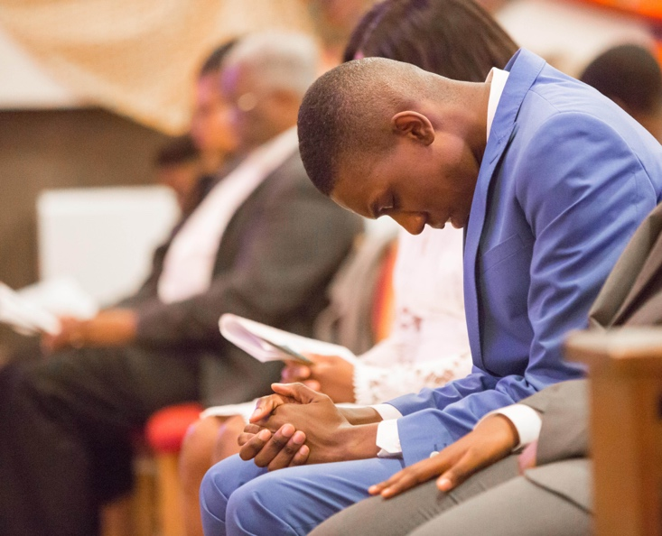 | Leading prayer through intercessions | The Church of England  Often in our worship, we are led in prayer by others. In practice, this is often in the gathered community of Christians who are asked to join their prayers together in petition for the needs of the Church and the world, and for all who are in need. All Christians are called to share in the ministry ...  www.churchofengland.org

This is where you find the weekly intercessions from the diocese.
https://bc.anglican.ca/resources/worship-resources/pages/prayers--204
Prayers | Worship Resources | Anglican Diocese of British Columbia
With Gratitude. The Diocese of British Columbia acknowledges that for thousands of years the Coast Salish, Nuu-chah-nulth, and Kwakwaka’wakw peoples have walked gently on the unceded territories where we now live, work, worship, and play.
bc.anglican.ca
We have online versions of the feasting on the word worship companion so folk can email me if they want those ones.

Other sites that have prayers of the people templates

http://www.textweek.com/yeara/propera19.htm - OnLine Worship and Liturgy Resources

http://worldinprayer.org/
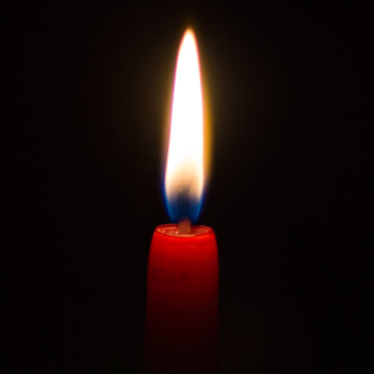 | World in Prayer  Holy One, As we center ourselves for prayer, remind us that you are as close to us as our very breath, even in these times when you may feel so far away to so many of us; in these times when many of us find it so hard to breathe.  worldinprayer.org
https://re-worship.blogspot.com/2012/06/prayers-of-people-topical-index.html

https://liturgy.co.nz/resources/Celebrating-Eucharist/24.pdf

https://seasonofcreation.org/resources/

https://www.churchofengland.org/prayer-and-worship/topical-prayers/leading-prayer-through-intercessions
Leading prayer through intercessions | The Church of England
Often in our worship, we are led in prayer by others. In practice, this is often in the gathered community of Christians who are asked to join their prayers together in petition for the needs of the Church and the world, and for all who are in need. All Christians are called to share in the ministry ...
www.churchofengland.org
https://www.churchofengland.org/prayer-and-worship/topical-prayers
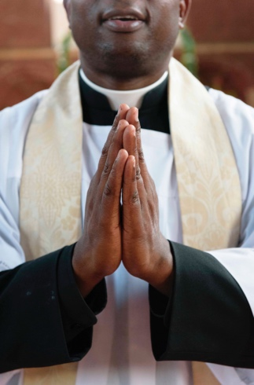 | Topical Prayers | The Church of England  You are invited to use these texts in your own worship and private prayer. You don't have to know any particular prayers if you want to pray - in fact, fixed texts can sometimes get in the way - but the ones listed here may help you to think about ideas, images, and forms of words you can use ...  www.churchofengland.org  See More from mdenton@stmatthiasvictoria.ca

