 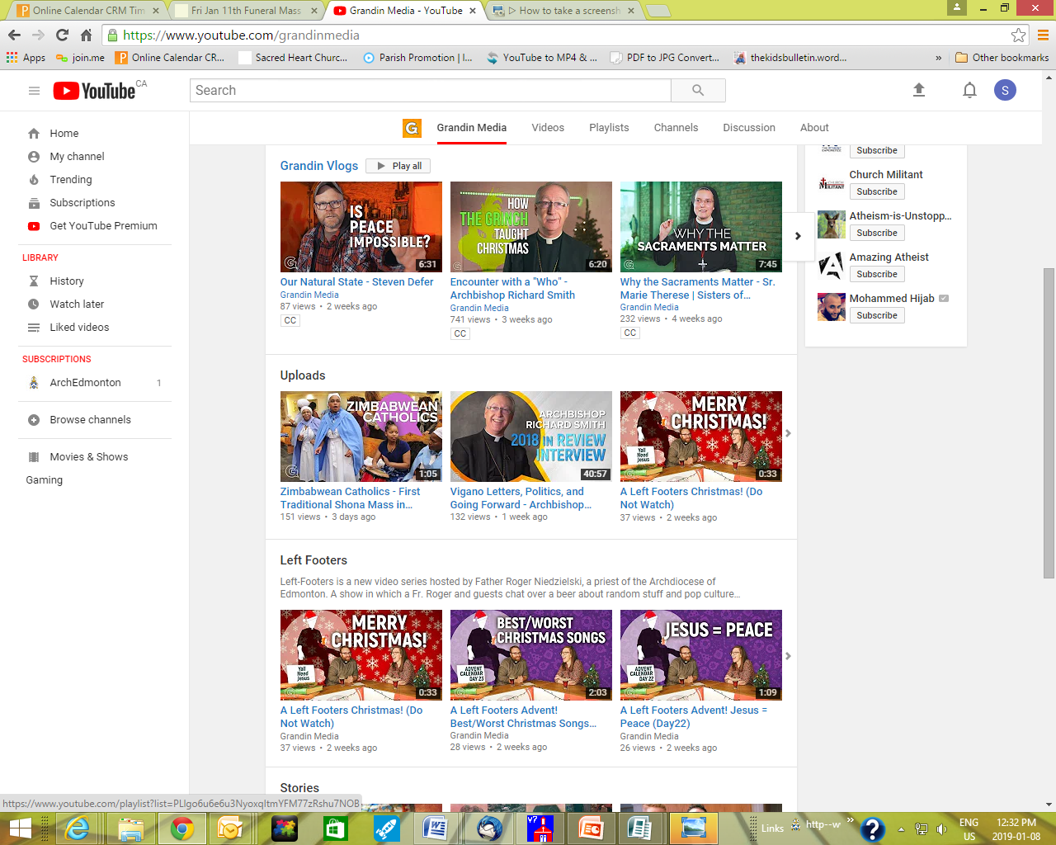 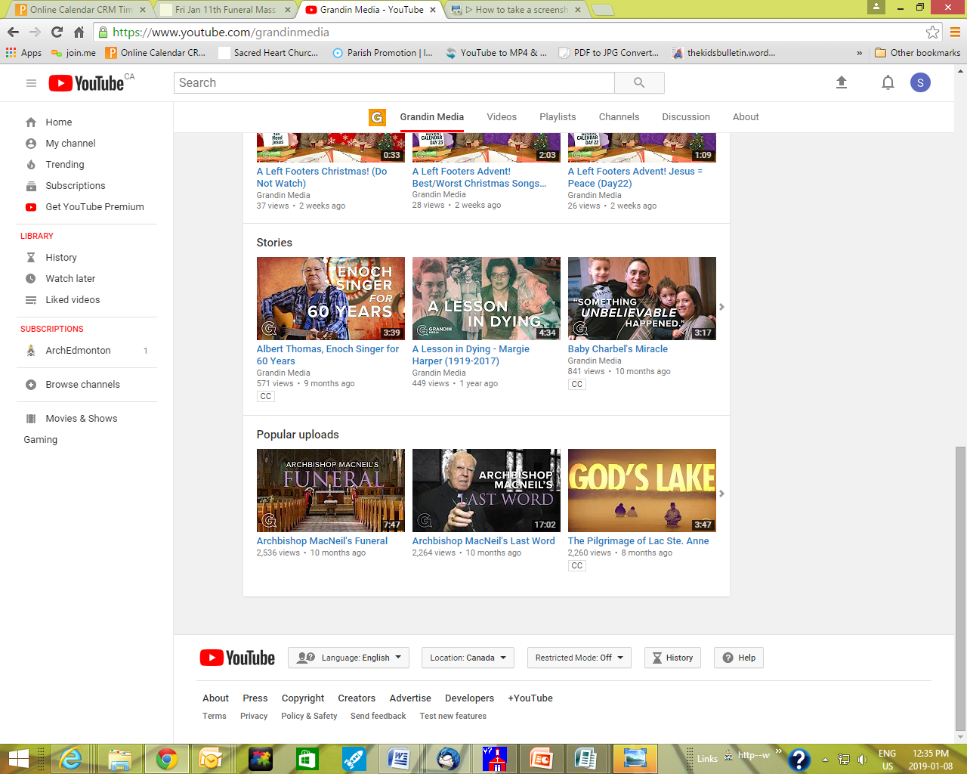

**Sr Marie Therese, Sisters of Merciful Jesus, from Our Lady of Seven Sorrows in Maskwacis!**

**Edmonton Archdiocese Website Survey**

We’re redeveloping the Archdiocese of Edmonton website. It’s part of Archbishop Smith’s larger plan for modernizing diocesan and parish communications. As more and more people seek out church information online, it is vital that the new site be as inviting and useful as possible. So we are conducting a survey of stakeholders to find out how best we can serve our various audiences. It’s an online survey that will take 10 minutes or less to fill out. There is also room for offering opinions about your parish website. Please share your thoughts with us at [**https://caedm.ca/survey**](http://r20.rs6.net/tn.jsp?f=001lk2ZmrOb3uad5ih9_dnkNBCThc0FRqV8Jj_V7gJXoqx8N2ypBBK8ousZFBqpNn2nixYLXGjW6cn2nMJ7VqExjMLK267GONKE1GeHozjGYPdq3CCxM6TGpcDNUr-e1RFqfiovEg3UrreuIgEADgme3g==&c=aP_2v40WabpzfkLBlpQYVmzhPBOhkY8mS8hiJ1cV3HkX1IqoJHpAbw==&ch=dYWKhRiI_uzkIR-bvWkTnzgtK-T8oYT4o_piC4cqoFpP_rUYy3yq4Q==), The survey closes on **Monday, Jan 28**, at 11:59 p.m.



If you haven't yet checked out the Archdiocese of Edmonton's Multi Media source, "Grandin Media", **why not check it out today!**

To the left is a sampling of vlogs and videos you can find, both local and international.

The links can be find on the Archdiocese webpage: **www.caedm.ca** or go directly to Grandin media on You tube: **www.youtube.com/ Grandinmedia** or **https://www.youtube.com/ user/EdmontonArchdiocese**

Videos and other news items are also highlighted on their Facebook page, such as the following new video : **What is a Permanent Deacon?** Check it out at: [**https://www.facebook.com/ archedmonton/**](https://www.facebook.com/archedmonton/)

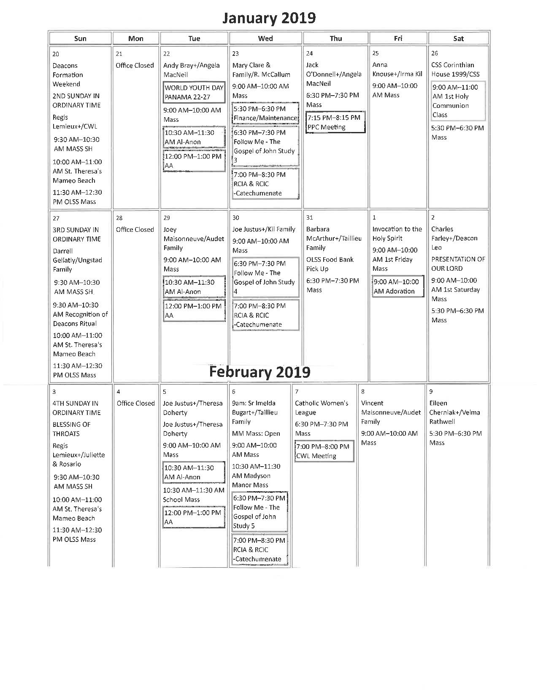

**Points to Ponder: Church & Politics**

January is a month when Christians around the world pray for unity among the followers of Jesus Christ. This year’s Week of Prayer for Christian Unity is celebrated in Canada from January 18-25, 2019. The theme for the 2019 Week is **“Justice, and only justice, you shall pursue”** (Deuteronomy 16:18-20), calling us to move from shared prayer to shared action. . The thematic introduction to the 2019 materials comes from Churches in Indonesia. Drawing on the traditional values of *Bhineka Tunggal Ika (Unity in Diversity)* and *gotong royong* *(living in solidarity and by collaboration)*, Indonesian Christians invite us to be a united witness, and an agent of Christ’s healing grace in a broken world, by making specific commitments to justice, equality, and unity.For more information on how you can celebrate the Week of Prayer, visit [**https://caedm.ca/wpcu**](https://caedm.ca/wpcu)



**Living in the Word**  ̶ ̶  The commandment to love our neighbour moves us to evangelize the social **and political** order, bearing always in mind the dignity of the human person and concern for the common good in accord with Catholic social teaching. Particular outreach must be directed to the impoverished and marginalized. Addressing the plight of the poor, the Holy Father says:

*“We are called to find Christ in them, to lend our voice to their causes, but also to be their friends, to listen to them, to speak for them and to embrace the mysterious wisdom which God wishes to share with us through them.”* (*Evangelii Gaudium*, 198).

(Archbishop Smith, *Pastoral Letter,* September 14, 2017) [**caedm.ca/letter**](http://r20.rs6.net/tn.jsp?f=001lk2ZmrOb3uad5ih9_dnkNBCThc0FRqV8Jj_V7gJXoqx8N2ypBBK8ojGAYdXfBmba8AhOhLqvh1o__1uCTeyblpItqAaPP2c0me21hglMWMLkAXBc2Hd94vQU64ixeCemYfhTXtHbZSAlrZUVAKfAHQ==&c=aP_2v40WabpzfkLBlpQYVmzhPBOhkY8mS8hiJ1cV3HkX1IqoJHpAbw==&ch=dYWKhRiI_uzkIR-bvWkTnzgtK-T8oYT4o_piC4cqoFpP_rUYy3yq4Q==).

January 1st [was] ... marked as World Peace Day, and Pope Francis chose as the theme for this year:

***“Good politics is at the service of peace.”***

*“We must not think politics is reserved to those who govern,”* the pope said. *“We are all responsible for the life of the community, of the common good, and politics is good to the degree that everyone does his or her part in the service of peace.”*

As we look forward to provincial and federal elections this year, that might be worth remembering!

God bless, Lorraine

**Lorraine Turchansky,** *Chief Communications Officer* Jan 8, 2019 Edition, Quid Novum



**Sr Marie Therese from Our Lady of Seven Sorrows in Maskwacis!**



**If you haven't yet checked out the Archdiocese of Edmonton's Multi Media source, "Grandin Media", why not check it out today!** These are a sampling of vlogs and videos you can find, both local and international. The links can be find on the Archdiocese webpage: **www.caedm.ca** or go directly to Grandin media on You tube: **www.youtube.com/Grandinmedia**  or **https://www.youtube.com/ user/EdmontonArchdiocese**

Videos and other news items are also highlighted on their Facebook page, such as the following new video : Check it out at: [**https://www.facebook.com/archedmonton/**](https://www.facebook.com/archedmonton/)

[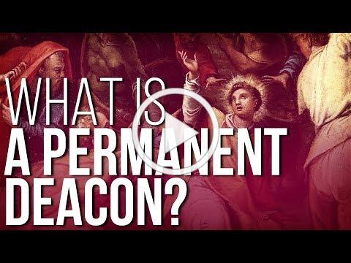](http://r20.rs6.net/tn.jsp?f=001x9_qmpAIiXMB3cUUotHNZEIYmD0bKZ10i4vuFWy1q5-6tTUVFGr6iyJFvUtV6ExlpY92S_jrZNecJZUKQAHa0CY-wuPYM_Xoz3ZZXdRT9Zf6-YwhWcA0pCFqv3fdrZ4O-IJNa7MRPUa4L0twdFK0-Q==&c=GgOlSg2kga6OLCVI5rlXUMnFOB1GY9_2OsKpMWB6iA7sr7MESTrbkg==&ch=KW-ooKEp8Xt5OVhcoIDiIbLWaU7Qq0EXSR4NQAjRNlVm9x2q7dpgWg==)

Don't forget to check out the ***Quid Novum,*** the weekly electronic bulletin of our Archdiocese. Find it and other news from our *Catholic Archdiocese of Edmonton at* ***www.caedm.ca***

We are blessed to have Deacon Leo Farley serving his community here at Sacred Heart Parish Wetaskiwin!

Have you ever wondered about the ministry of permanent deacons? Who are these men and how are they called? Check out this new video, released on the Feast of St. Stephen. It features some of the 33 permanent deacons here in the Archdiocese of Edmonton -- maybe some you know! (runs 21 min.)

