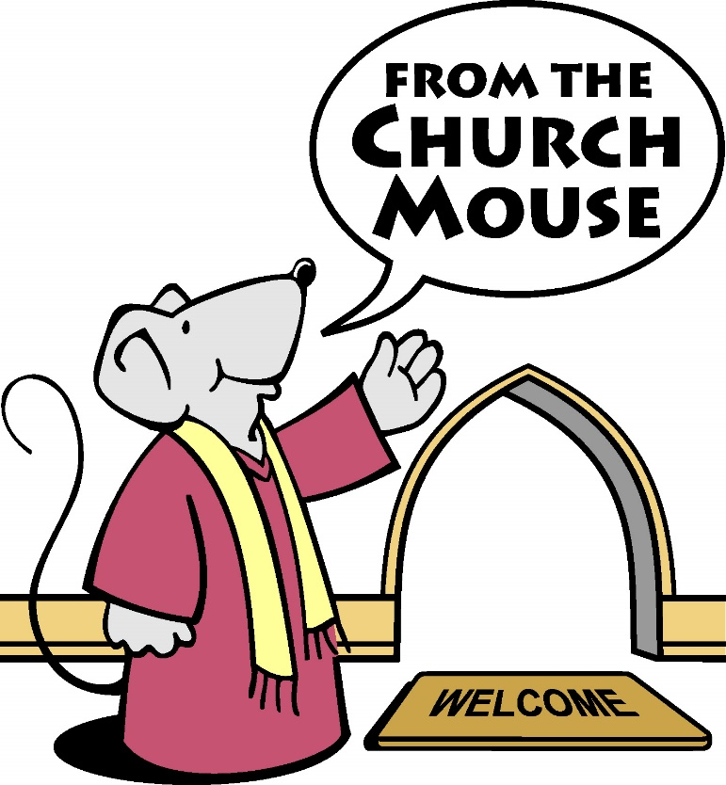
Cycle of Prayer
Please note the Prayer Cycle is subject to Change.

OCTOBER – DECEMBER 2020

For the Diocese of
NOVA SC0TIA AND PRINCE EDWARD ISLAND
SOUTH SHORE REGION

October 04

Bridgewater and the Conqueralls, Nova Scotia
The Reverend Simon Davies and Frances
Holy Trinity, Bridgewater
St. James’, Conquerall Mills

Blandford, Nova Scotia
The Reverend Louis Quennelle Rector, and Robert MacMillan
St. Barnabas, Blandford
All Saints, Bayswater
St. Cuthbert’s, North West Cove

October 11

Blue Rocks, Nova Scotia
The Very Rev John Wright and Mary
St. Barnabas, Blue Rocks

St. John’s, Lunenburg, Nova Scotia
The Reverend Laura Marie Piotrowicz

October 18

Mahone Bay, Nova Scotia
The Reverend Janet Hatt, Priest-in-Charge
St. James’, Mahone Bay
Christ Church, Maitland

New Dublin with Petite Riviere, Nova Scotia
The Reverend Oliver Osmond, Priest-in-Charge, and Rosalie
St. Peter’s, West LaHave
St. James’, LaHave
St. John’s, West Dublin
St. Michael’s, Petite Riviere
St. Mary’s, Crousetown
St. Alban’s, Vogler’s Cove
St. Mark’s, Broad Cove
St. John’s, LaHave Island

October 25

New Germany, Nova Scotia
The Reverend Mellanie Cohoon and Jeff
The Reverend Catherine Robar, Associate Parish Priest

St. John’s, New Germany
Transfiguration, Newburne
St. Paul’s, Union Square
St. Andrew’s, Northfield

Western Shore, Nova Scotia
The Reverend Shirley Carrass, Priest-in-Charge, and Andy
Grace Anglican, Chester Basin

November 1

Chester, Nova Scotia
The Archdeacon Ian Wissler and Chris
St. Stephen’s, Chester
St. George’s, East River
All Saints, Canaan

Lockeport-Barrington, Nova Scotia
The Reverend Doug Chard, Priest-in-Charge
Holy Cross, Lockeport
Holy Trinity, Jordan Falls
Church of the Resurrection, Churchover

November 08

PRAY FOR VETERANS OF THE CANADIAN ARMED FORCES AND THE MINISTRY OF ARMED FORCES CHAPLAINS.

We remember this day the Anglican Priests who serve their country for our Diocese. :
Capt. the Rev’d Leonard Bednar
LCDR Rev’d Charlie Black and Shirlie
LCol. (Retired) the Rev’d Andrew Cooke and Valerie
Capt. the Rev’d Kent Greer
Comm. The Rev’d Jennifer Gosse
Capt. the Rev’d Jim McCorriston
LCol. the Rev’d Canon Todd Meaker and Theresa
Lt.(N) the Rev’d Robert Parker and Rachael
Capt the Rev’d Mark Sceviour
LCol. (Retired) the Rev’d Canon Dr. Gary Thorne and Sandra
Capt. the Rev’d Maya Bevan
Capt. the Rev’d Robin Major and Lisa Dennis

REMEMBRANCE DAY - November 11

PRAY FOR Campus Ministers and Campus Ministry in the Diocese of NS & PEI

The Reverend Sandra Fyfe - Parish of Horton / Acadia University
The Reverend Dr. Renall Ingalls – Dalhousie University/University of King’s College
Archdeacon Sue Channen – St. Xavier University
The Reverend Brenda Drake – Cape Breton University

Charles Simeon, 1836 - November 12
Charles Simeon, a priest at Cambridge in England raised awareness of and began the notion of Campus Ministry.

November 15

Shelburne, Nova Scotia
The Reverend Ed Trevors and Naniya
Christ Church, Shelburne
Union Church, Lower Ohio

South Queens, Nova Scotia
The Reverend Cherry Workman
The Reverend Judy Cross, Associate Parish Priest, and Glenn
St. John’s the Evangelist, Eagle Head
Holy Redeemer, Port Medway
St. Andrew’s, Brooklyn
Trinity, Liverpool
St. James’, Hunt’s Point

November 22

Yarmouth and Tusket, Nova Scotia
The Reverend Patrick Bright, Priest-in-Charge, and Rhea
Holy Trinity, Yarmouth

Retired Clergy of the South Shore Region:
The Reverend Frances Boutilier
The Reverend Linda Macdonald
The Reverend Barbara Minard
The Reverend Gillian Neville-Ball and John Ball
The Reverend Oliver Osmond and Rosalie
The Reverend Alvin Westgate and Cathy Ramey
The Very Reverend John Wright and Mary
The Reverend Gordon Druggett and Donna
The Reverend Ronald Barkhouse, and Peggy

Widows:
Mrs. June Coote
Mrs. Catherine Rigby
Mrs. Holly Mitchell
Mrs. Barb Tuck
CHIGNECTO REGION

November 29

Amherst, Nova Scotia
The Reverend William Ferrey and Allie
The Reverend Charlotte Ross, Associate Parish Priest
Christ Church, Amherst
Church of the Good Shepherd, Tignish

Parrsboro Shore, Nova Scotia
The Rev. Dr. Brian Spence
St. George’s, Parrsboro
St. Mark’s, Moose River
Christ Church, Parrsboro Road
Holy Trinity, Fox River

December 6

Springhill, Nova Scotia
The Reverend Dr. Brian Spence

Lantz, Nova Scotia

The Reverend Canon David Fletcher and Kathy
Christ Church, Lantz
St. George’s, Dutch Settlement

December 13

Maitland, Nova Scotia
Archdeacon Glenn Eason, Priest-in-Charge, and Terry Lea
Holy Trinity, Maitland
St. Peter’s, Upper Kennetcook
St. Paul’s, Northfield

Stewiacke and Shubenacadie, Nova Scotia
Archdeacon Glenn Eason, Priest-in-Charge, and Terry Lea
St. James’, Shubenacadie

December 20

Northumberland, Nova Scotia

The Reverend John Morrell, Priest-in-Charge, and Kathy
The Reverend Kathryn Cook, Deacon

St. Andrew’s, Wallace
All Souls, Oxford
Holy Trinity, Denmark
St. John the Baptist, River John

St. John’s, Truro, Nova Scotia

The Reverend Lori Ramsay and Robert Cullen
The Reverend Dorothy Tay, Associate Parish Priest, and Warren

December 29

Retired Clergy of the Chignecto Region:
The Reverend Frank Likely and Paula
The Reverend David Myles and Margaret
The Reverend Lloyd Ripley
The Reverend Patti McKenna and Kenny
The Reverend Beverly DeVouge
The Reverend Bill Cook and Katherine
The Reverend Gary Yetman, Associate Parish Priest, and Diane

Widows:
Mrs. Marie Eaton
Mrs. Kay Lane
Mrs. Sheila Leddicote
Mrs. Elinor Mullen
Mrs. Faye Porrior

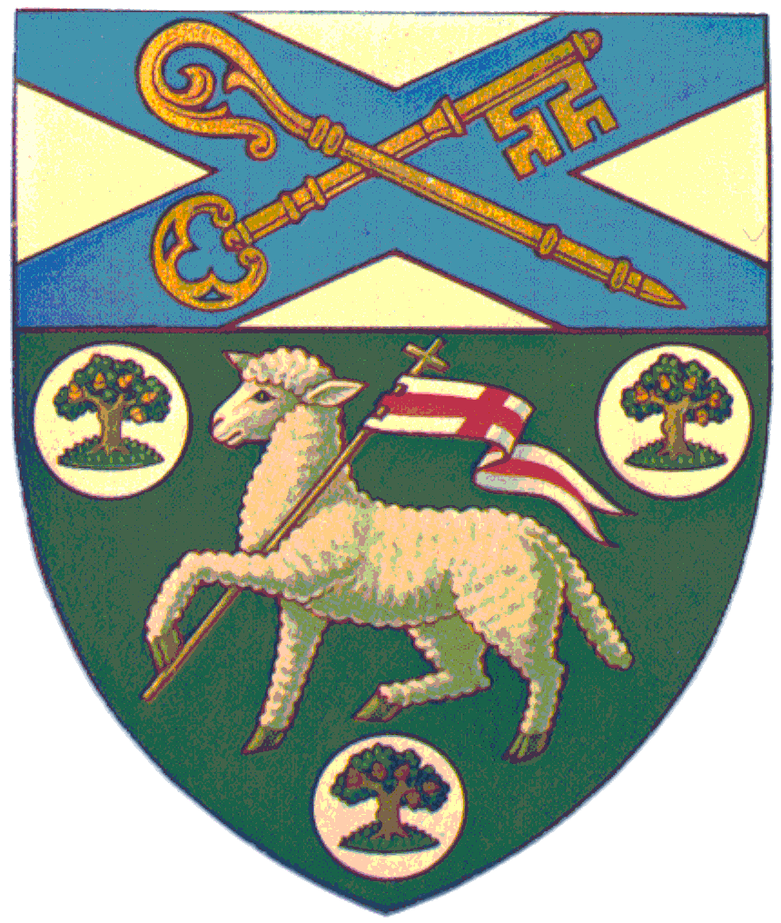

As we commit to pray for one another…

