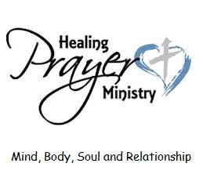
HEALING PRAYER
God calls us to be a healing and reconciling community. Healing and reconciling happen in many different ways and we can be assured that God is always the Healer and Reconciler among us. We can also be instruments of God's grace and can facilitate an atmosphere where compassion and care are paramount, where those in need can find a safe place to cast their cares, and where we can be together strengthened in faith and united in love. At our worship services during communion, there is opportunity for people to be prayed for individually if they desire. A time to bring to God our prayers for healing for ourselves, for those know to us, and for our world. A prayer for wholeness of mind, body, soul and relationship. It is a time where you may desire to give thanks for blessings.
In this type of healing prayer, two team members are stationed near the pulpit during communion. If you would like prayer, come up to the team and briefly say what or who you would like prayer for and the team prays a short, quiet prayer. You may be anointed with oil if you desire. You then return to your seat. Prayers are kept confidential. If you wish private prayer please let the prayer team know and after the service they will pray with you in the sacred prayer room. (To be set up in the Mother’s Room)
Our team at the moment is the Reverend Paul, the Reverend Connie, the Reverend Glen, Gilli McLaren, Sam Green, Jim Wilson, Susan Truman, Donna Kennedy, and Leanne La Chapelle. We would be delighted to have more people join us. We are working on guidelines and Paul will be doing a training session. If you are new to this type of prayer you would pray with an experienced team member in the beginning. If this is a calling for you, please speak with Paul or Susan.
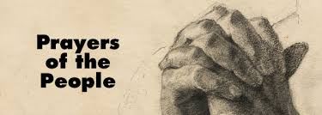
PRAYERS OF THE PEOPLE
There are many ways to love one’s neighbor, but intercessory prayer—praying on behalf of other people—has got to be one of the most powerful. In the narthex we have a sign – up sheet where you may add a person’s name that you wish to hold up in prayer. Please do this before the Worship Service. The intercessor will add the name to the intercession list during the Prayers of the People.

EMAIL PRAYER CHAIN
If you have a prayer request during the week, either for yourself or someone else, please email or phone the Reverend Glen Nicholson (deacon retired) gnicholson839@gmail.com or 604-820-9480. He will then email the members of the prayer chain and they will pray for that specific prayer request. The prayer requests are private and confidential and only known to the members of the prayer chain. The prayer chain members do not meet to discuss your prayer requests or approach you with reference to the prayer. If your need is more than prayer please call Pastor Paul or The Wardens so appropriate actions can be taken to resolve your need. If you have any concerns regarding this matter please speak to retired Deacon Glen, Pastor Paul, Deacon Connie or The Wardens.

