In this first episode of Vital Word, Archbishop Smith addresses the sexual abuse crisis through the lens of Scripture:
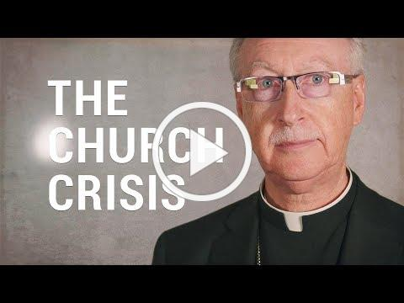
Eyes Open with Archbishop Smith
Vital Word: A new video series from Grandin Media
Can Scripture tell us anything relevant to modern life? That's the challenge being taken up by Vital Word, a new series of video blogs ('vlogs') that aim to support viewers in reading and following Scripture by linking passages to current issues or events affecting Catholics and the Church as whole. The series is being published weekly on Grandin Media's Youtube channel.

"Facing abuse means asking tough questions, investigating, involving lay experts" Archbishop Smith
By Andrew Ehrkamp, Grandin Media September 17, 2018
Betrayal. Hopelessness. Outrage. These are some of the sentiments as Catholics read and hear about the growing sex abuse scandal — and allegations of cover-ups — in the U.S. and around the world.
To that, Edmonton Archbishop Richard Smith says the Church must embrace reform and do whatever it takes to help and heal victims. At the same time, the Church should not be defined by individual actions of some its leaders.
“This perfect storm leaves us all reeling, as we deal with shock, anger, shame and confusion,” Archbishop Smith said in a video message published Sept. 16. “With eyes wide open to Christ, we see clearly the need for reform and our call to face it resolutely, yes; yet we also see that the Church is simply not to be defined by the sins and crimes of some of her leaders, however egregious.”
“Here is the particular grace for which we need to pray right now: to remain with the Church and to do so with our eyes opened; opened wide. They need to be opened wide by Christ first of all so that we continue to recognize his presence with us and to retain that as our principal focus.”
The Archbishop made the comments in the first of a new series of video blogs aimed at providing support in reading and following Scripture by linking passages to current events affecting Catholics and the Church as whole. The series, titled Vital Word, is being published weekly on the Grandin Media Youtube channel.
Archbishop Smith and his brother bishops from Alberta and Northwest Territories had issued a pastoral letter in August pledging to listen to victims and to renew diocesan abuse prevention efforts. But this was the first time he specifically addressed the growing abuse scandal in the U.S. and its tentacles to the Vatican. It came just days after the president of the U.S. Conference of Catholic Bishops, Cardinal Daniel DiNardo, met with Pope Francis to discuss the crisis.
A Pennsylvania grand jury report last month detailed sexual abuse cases in six dioceses and the announcement of credible allegations of child sexual abuse committed by Archbishop Theodore McCarrick, the disgraced former cardinal-archbishop of Washington.
Other reports and investigations of abuse are ongoing in the U.S. and in other countries including Australia and Germany.
“Right now, we are seeing the presence of evil in our midst,” Archbishop Smith said in his video message. “And the evil we see is very great indeed. How are we to look at it? First of all, we need to see and face squarely the immeasurable harm that this evil has done to victims of abuse.”
The Pennsylvania report detailed claims of abuse of minors by clergy going back 70 years. Though the report identified more than 1,000 sex abuse claims, only two cases resulted in prosecutions because the statute of limitations had expired in the majority of cases.
To which, the Archbishop noted that the cases may be old but the harm is still fresh.
“Yes, we know that the accounts brought to our attention by the grand jury report are decades old; yes, we know that the way these things were understood and handled in the past is not the way they are dealt with now; but for the victim, the harm that was caused, even if it was a long while ago, has effects that are lifelong,” Smith said. “So, the gaze we direct toward them must be with eyes filled with compassion, and expressive of a readiness to do whatever needs to be done to help and heal.”
At the same time, Archbishop Smith said the Church must be held accountable.
“We also have to have eyes wide open to the causes of all this. This will mean a readiness to ask direct and tough questions; it will mean launching investigations where needed, and these inquiries will need to involve laypersons with the expertise to do these sorts of things,” Archbishop Smith said.
“These questions and investigations will enable our eyes to be wide open to the truth, to the facts, and this in turn will help us to see clearly the way ahead.”
Pope Francis himself has been accused of ignoring sanctions against Archbishop McCarrick imposed by Francis’ predecessor, Pope Emeritus Benedict. The allegations were made by Archbishop Carlo Maria Vigano, a former papal representative in the U.S.
In his video message, Archbishop Smith said sentiments of betrayal and hopelessness are relatable in Scripture to the two disciples who — unbeknownst to them at first — encountered Jesus on the road to Emmaus after His crucifixion and death.
“We are experiencing the same thing right now. The Church is established by Christ himself as the place, the agent, of hope. Yet, for many it has been experienced as the place of betrayal, precisely by some of our ‘chief priests and leaders,’” Smith said. “This betrayal has been felt most keenly and painfully by abuse victims and by their families.”
Archbishop Smith said there is the need to focus on the good done by religious men and women, Catholic schools, social services and hospitals and the clergy “who haven’t done any of the terrible things we’ve heard about, who are just as rocked as everyone else by this news.”
The actions of a few should not define the Church, he said.
“The Church is the people formed by the encounter with the Risen Christ, who remains with us, who heals us, reforms us, and strengthens us as we walk along the road that leads not away from him but towards any one in need and, ultimately toward the heavenly Jerusalem, our eternal home.”
-With files from Catholic News Service

