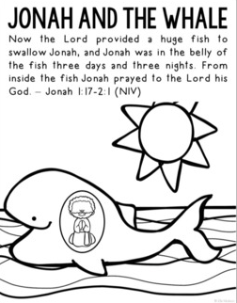
Why was Jonah in the belly of the huge fish?

