PRE-AUTHORIZED
DEBIT FORM
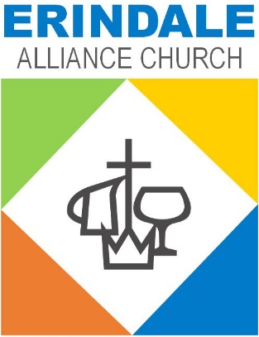

A Gospel and
Community
Church
Please fill out the enclosed form and return it with a voided cheque to the church office.
When your request is processed, you will receive a letter in the mail indicating the date of your first automatic debit. Please watch your bank account to ensure that it is being debited appropriately.

ERINDALE ALLIANCE CHURCH
OFFICE USE ONLY
DLB EXC LET
PRE AUTHORIZED DEBIT (PAD) FORM
(Please Print)
Name(s):
Address:
Postal Code: Telephone:
Email Address:
Giving Number:

I/We authorize my/our bank or financial institution to debit my/our bank account using the terms below.
I/We will ensure that funds are available to cover the amount of the withdrawal.
I/We understand that this authorization may be changed or cancelled at any time with written notice.

Please choose only one of the following options:
☐ On the first day of each month
☐ On the sixteenth day of each month

Please debit my/our bank account for this fund (or funds) in the amount(s) of:
General Fund: $
Global Advance: $
Other: $
TOTAL: $

Signature: Date:
*
* For joint accounts, both account holders must sign if more than one signature is required on cheques.
Please return this completed form with a blank cheque marked “VOID” to:
Accounting Office
Erindale Alliance Church
310 Perehudoff Crescent
Saskatoon, SK S7N 4H1

