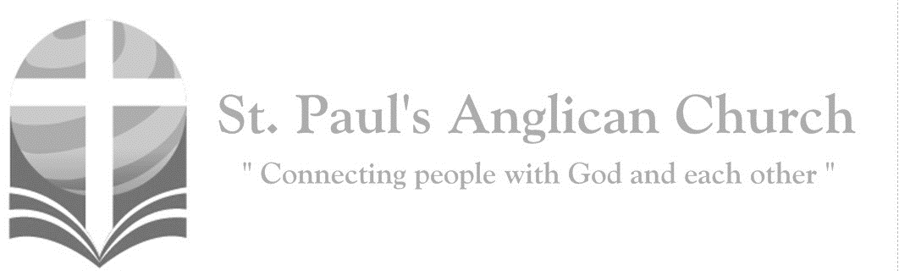

Sunday, April 21, 2019: Easter Sunday

*Christ our Passover has been sacrificed for us;*

*therefore, let us keep the feast. (1 Corinthians 5:7-8)*

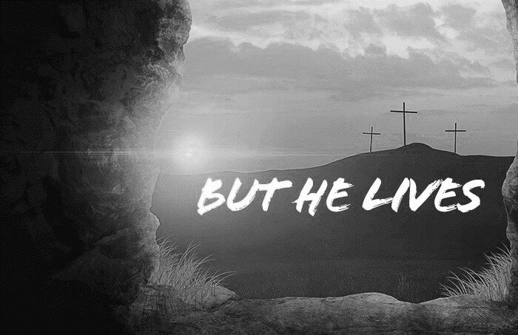

SUNDAYS AT ST. PAUL’S

**REGULAR SERVICES**

* Weekly services held Sundays at 10:00AM
* Interface services - Art based services throughout the year
* Sermons available on our website

**SUNDAY PRAYER**

* Prayer for the service at 9:30AM in the Luke Room
* Individual Prayer in the Chapel during the Sunday service

**SERVING AT ST. PAUL’S**

* Join a Ministry Team (Sunday service team, music team, children’s ministry, Altar guild, or many others)
* Regular or One-Time Giving (cash, cheque, automatic debit, and credit options available)

**LARGE PRINT MATERIALS** Large print Bibles and   
 Books of Alternative   
 Services (BAS) are availableat each Sanctuary door.

Page numbers will not be the same as those listed in the bulletin.

**VISITING TODAY?**

We want to get to know   
 you! Please join us for

in the Hall for coffee and

fellowship following the service. The greeters are also available to help if you have any questions.

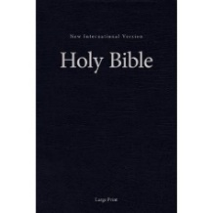



**Assisted listening**

**is available. Please**

**ask a greeter**

**for assistance.**



CONNECT

**St. Paul’s CHILDREN’S MINISTRY**

**KIDS** Chickadees Ages 2-4 / Peacocks Grade K-2 / Falcons Grade 3-5

Sunday School teaching is weekly during the 10:00AM service.

**St. Paul’s YOUTH MINISTRY**

**YOUTH** Youth Grades 6-12 meet weekly during the 10:00AM service.

Youth also meetbi-weekly for fun events and devotionals.

**St. Paul’s ADULT MINISTRY**

**ADULTS** St. Paul’s has a number of small groups where you can connect with others through Christ. If you are interested in joining a small   
group or starting a small group of your own, please speak with Pat Stretch.

**Opening Song: *Jesus Christ is Risen Today***

Jesus Christ is risen today  
Hallelujah  
Our triumphant holy day  
Hallelujah  
Who did once upon the cross  
Hallelujah  
Suffer to redeem our loss  
Hallelujah

Hymns of praise then let us sing  
Hallelujah  
Unto Christ our heavenly King  
Hallelujah  
Who endured the cross and grave  
Hallelujah  
Sinners to redeem and save  
Hallelujah

But the pains which He endured  
Hallelujah  
Our salvation have procured  
Hallelujah  
Now above the sky He's King  
Hallelujah  
Where the angels ever sing  
Hallelujah

**The Gathering of the Community**

Celebrant: *(BAS pg. 185)* Alleluia! Christ is risen.

**People: The Lord is risen indeed. Alleluia!**

Celebrant: May his grace and peace be with you.

**People: May he fill our hearts with joy.**

Celebrant:Almighty God,

**All:to you all hearts are open, all desires known, and from you no secrets are hidden. Cleanse the thoughts of our hearts by the inspiration of your Holy Spirit that we may perfectly love you, and worthily magnify your holy name; through Christ our Lord. Amen.**

Celebrant: *(pg. 335)* Lord of life and power, through the mighty resurrection of your Son, you have overcome the old order of sin and death and have made all things new in him. May we, being dead to sin and alive to you in Jesus Christ, reign with him in glory, who with you and the Holy Spirit is alive, one God, now and for ever.

**People:** **Amen**.

**Children and Youth Dismissal**

**The Reading of Scripture**

First Reading: Acts 10:34-43 (pg. 779 in the red pew Bible)

Reader: The Word of the Lord.

**People:** **Thanks be to God.**

Psalm Reading: Psalm 118:1-2, 14-24 (pg. 866 in the BAS)

Second Reading: 1 Corinthians 15:19-26 (pg. 815 in the red pew Bible)

Reader: The Word of the Lord.

**People:** **Thanks be to God.**

**Worship Through Song**

***Glorious***

Look inside the myst'ry  
See the empty cross  
See the risen Savior  
Victorious and strong  
No one else above Him  
None as strong to save  
He alone has conquered  
The power of the grave

(*Chorus*) Glorious  
My eyes have seen the glory of the Lord  
Glorious  
He stands above the rulers of the earth  
Glorious, glorious  
Lord You are glorious

Look beyond the tombstone  
See the living God  
See the resurrected  
Ruler of my heart  
No one else above Him  
None to match His worth  
The hope of His returning  
Fills the universe

(*To Chorus*)

***The Wonder of Your Cross***

The wonder of Your cross  
Shall be our meditation  
To gather in that shadow  
As the sun went down  
To weep with those  
Who thought that You were leaving  
You were leaving, Jesus  
The humble King  
Who never wore an earthly crown

To steal away at night  
When they took down Your body  
With love and tears  
To leave You in a borrowed grave  
To go with Mary to that place

They laid You  
Where they laid You, Jesus  
And in the morning find the stone

Was rolled away

(*Chorus*)

The cross, O the wonderful cross  
What glory, what vict'ry I've found  
I'll come to the wonderful cross  
And my whole life I lay down

Were heaven's praises  
Silent in those hours of darkness  
Your Holy Spirit brooding  
'Round that empty throne  
Until the declaration He is risen  
You are risen, Jesus; He is not dead  
Behold He lives forevermore

(*To Chorus*)

**Listening Time**

**The Gospel Reading**

Gospel Reading: John 20:1-18 (pg. 768 in the red pew Bible)

Reader: The Lord be with you.

**People: And also with you.**

Reader: The Holy Gospel of our Lord Jesus Christ according to St. John.

**People: Glory to you, Lord Jesus Christ.**

*The Gospel Reading*

Reader: The Gospel of Christ.

**People: Praise to you, Lord Jesus Christ.**

Sermon: The Reverend Dr. Myron Penner

**Sermon Notes**

_____________________________________________________________________________________________________________________________________________________________________________________________________________________________________________________________________________________________________________________________________________________________________________________________________________________________________________________________________________________________________________________________________________________________________________________________________________________________________________________________________________________________________________________________________________________________________________________________________________________________________________________________________________________________________________________________________________________________________________________________________________________________________________________________________________________________________________________________________________________________________________________________________________________________________________________________________________________________________________________________________________________________________________________________________________________________________________________________________________________________________________________________________________________________________________________________________________________________________________________________________________________________________________________________________________________________________________________________

**The Nicene Creed**

Celebrant: (*pg. 188*) Let us confess our faith, as we say,

**All: We believe in one God, the Father, the Almighty, maker of heaven and earth, of all that is, seen and unseen. We believe in one Lord, Jesus Christ, the only Son of God, eternally begotten of the Father, God from God, Light from Light, true God from true God, begotten, not made, of one being with the Father. Through him all things were made. For us and for our salvation he came down from heaven: by the power of the Holy Spirit he became incarnate from the Virgin Mary, and was made man. For our sake he was crucified under Pontius Pilate; he suffered death and was buried. On the third day he rose again in accordance with the scriptures; he ascended into heaven and is seated at the right hand of the Father. He will come again in glory to judge the living and the dead, and his kingdom will have no end. We believe in the Holy Spirit, the Lord, the giver of life, who proceeds from the Father. With the Father and the Son he is worshipped and glorified. He has spoken through the prophets. We believe in one holy catholic and apostolic Church. We acknowledge one baptism for the forgiveness of sins. We look for the resurrection of the dead, and the life of the world to come. Amen.**

**Prayers of the People**

**Confession of Sin**

Celebrant: *(pg. 191)* Dear friends in Christ, God is steadfast in love and infinite in mercy; he welcomes sinners and invites them to his table. Let us confess our sins, confident in God’s forgiveness.

*Silent Confession*

Celebrant:Most merciful God,

**All: we confess that we have sinned against you in thought, word, and deed, by what we have done and by what we have left undone. We have not loved you with our whole heart; we have not loved our neighbours as ourselves. We are truly sorry and we humbly repent. For the sake of your Son Jesus Christ, have mercy on us and forgive us, that we may delight in your will, and walk in your ways, to the glory of your name. Amen.**

Celebrant: Almighty God have mercy upon you, pardon and deliver you from all your sins, confirm and strengthen you in all goodness and keep you in eternal life through Jesus Christ our Lord.

**People:Amen.**

**The Peace**

Celebrant: The peace of the Lord be always with you.

**People: And also with you.**

**Offertory Song: *Thine Be the Glory***

(*Chorus*) Thine be the glory  
Risen conquering Son  
Endless is the victory  
Thou o'er death hast won

Thine be the glory  
Risen conquering Son  
Endless is the victory  
Thou o'er death hast won  
Angels in bright raiment  
Rolled the stone away  
Kept the folded grave clothes  
Where Thy body lay (*To Chorus*)

Lo, Jesus meets us  
Risen from the tomb  
Lovingly He greets us  
Scatters fear and gloom  
Let the church with gladness  
Hymns of triumph sing  
For her Lord now liveth  
Death hath lost its sting (*To Chorus*)

No more we doubt Thee  
Glorious Prince of life  
Life is nought without Thee  
Aid us in our strife  
Make us more than conquerors  
Through Thy deathless love  
Lead us in Thy triumph  
To Thy home above (*To Chorus*)

**Prayer Over the Gifts**

Celebrant: *(pg. 336)* God our strength and salvation,

**All: receive all we offer you this day, and grant that we who have confessed your name, and received new life in baptism, may live in the joy of the resurrection, through Jesus Christ the Lord. Amen.**

Celebrant: *(pg. 198)* The Lord be with you.

**People: And also with you.**

Celebrant: Lift up your hearts.

**People: We lift them to the Lord.**

Celebrant: Let us give thanks to the Lord our God.

**People: It is right to give our thanks and praise.**

Celebrant: *(pg. 222)* Blessed are you, gracious God, creator of heaven and earth; we give you thanks and praise for the glorious resurrection of your Son Jesus Christ our Lord; for he is the true paschal lamb who has taken away the sin of the world. By his death he destroyed death, and by his rising to life again he has won for us eternal life. Therefore, joining our voices with the whole company of heaven, we sing our joyful hymn of praise to proclaim the glory of your name.

**All:** ***(Sung)*** **Holy, holy, holy is the Lord God Almighty. Holy, holy, holy is the Lord God Almighty.Who was, and is, and is to come. Who was, and is, and is to come. Lift up his name with the sound of singing.   
Lift up his name in all the earth. Lift up your voice and give him glory.   
For he is worthy to be praised. For he is worthy to be praised.   
For he is worthy to be praised.**

Celebrant: *(pg. 198)* We give thanks to you, Lord our God……. Therefore, Father, according to his command,

**All: we remember his death, we proclaim his resurrection, we await his coming in glory;**

Celebrant: and we offer our sacrifice of praise and thanksgiving to you…… by whom, and with whom, and in whom, in the unity of the Holy Spirit, all honour and glory are yours, almighty Father, now and for ever.

**All: Amen.**

Celebrant: *(pg. 211)* As our Saviour taught us, let us pray,

**All: *(Sung)* Our Father in heaven, hallowed be your name. Your kingdom come, your will be done, on earth as in heaven. Give us today our daily bread. Forgive us our sins as we forgive those who sin against us. Save us from the time of trial, and deliver us from evil. For the kingdom, the power, and the glory are yours, now and for ever. Amen.**

Celebrant: *(pg. 213)* Lord, we died with you on the cross.

**All: Now we are raised to new life.**

Celebrant: We were buried in your tomb.

**All: Now we share in your resurrection.**

Celebrant: Live in us, that we may live in you.

Celebrant: *(pg. 213)* The gifts of God for the People of God.

**People: Thanks be to God.**

**The Communion**

*You are welcome to receive communion or come forward for a blessing. If you prefer to receive a blessing, please fold your arms over your chest. There is de-alcoholized wine available in the centre and gluten-free wafers available upon request.*

**Lamb of God**

*(Sung)* Lamb of God, you take away the sin of the world.

Lamb of God, you take away the sin of the world.

Lord have mercy, Christ have mercy, Lord have mercy on me.

Lord have mercy, Christ have mercy and grant us thy peace.

**Communion Music**

***All Heaven Declares***

All heaven declares  
The glory of the risen Lord  
Who can compare with  
The beauty of the Lord

Forever He will be  
The Lamb upon the throne  
I gladly bow the knee  
And worship Him alone

I will proclaim  
The glory of the risen Lord  
Who once was slain  
To reconcile man to God

Forever You will be  
The Lamb upon the throne  
I gladly bow the knee  
And worship You alone

***The Power of the Cross***

Oh to see the dawn of the darkest day  
Christ on the road to Calvary  
Tried by sinful men

Torn and beaten then  
Nailed to a cross of wood

(*Chorus*) This the power of the cross  
Christ became sin for us  
Took the blame, bore the wrath  
We stand forgiven at the cross

Oh to see the pain written on Your face  
Bearing the awesome weight of sin  
Every bitter thought, every evil deed  
Crowning Your bloodstained brow

(*To Chorus*)

Now the daylight flees

Now the ground beneath  
Quakes as its Maker bows His head  
Curtain torn in two

Dead are raised to life  
Finished the vict'ry cry (*To Chorus*)

Oh to see my name

Written in the wounds  
For through Your suffering I am free  
Death is crushed to death

Life is mine to live  
Won through Your selfless love

(*continued on next page*)

This the power of the cross  
Son of God slain for us

What a love, what a cost  
We stand forgiven at the cross

**Prayer After Communion**

Celebrant: *(pg. 336)* God of life,

**All: bring us to the glory of the resurrection promised in this Easter sacrament. We ask this in the name of Jesus Christ the risen Lord. Amen.**

Celebrant: *(pg. 214)* Glory to God,

**All:whose power, working in us, can do infinitely more than we can ask or imagine. Glory to God from generation to generation, in the Church and in Christ Jesus, for ever and ever. Amen.**

**Blessing**

**Congregational Announcements *(Deanna Kalles)***

**Closing Song: *He Is Risen***

He is risen, he is risen

Tell it with a joyful voice

He has burst his three days’ prison

Let the whole wide earth rejoice

Death is conquered, man is free

Christ has won the victory

Come, ye sad and fearful-hearted

With glad smile and radiant brow

Lent’s long shadows have departed

All his woes are over now

And the Passion that he bore

Sin and pain can vex no more

He is risen, he is risen

He hath opened heaven’s gate

We are free from sin’s dark prison

Risen to a holier state

And a brighter Easter beam

On our longing eyes shall stream

**The Dismissal**Celebrant: *(pg. 215)* Go in peace to love and serve the Lord.

**All: Thanks be to God. Alleluia.**

*Please join us in the hall for coffee and Hot Cross buns following the service.*

**Spring Clean – June 1 at St. Paul’s**

Please plan to join us for our annual Spring Clean at St. Paul’s on Saturday, June 1. This is an opportunity to do deal with some of the larger cleaning and organizing projects at St. Paul’s as well as do some special cleaning (kid’s toys, windows, etc.). More details to come – please plan to join us!

**Canon Andrew White at St. Paul’s**

Join us on Tuesday, May 7 at 7:00PM as the Rev. Canon Andrew White speaks about persecution, reconciliation, and the church in the Middle East.

**Community Games Night – May 3**

Please join us on Friday, May from 6:00-10:00PM (drop-in) in the Hall. This is an event for all ages and open for anyone to attend. Please invite your family, friends, and neighbours to this community event. There will be lots of games to choose from or you can bring some of your own. There may also be munchies!!

**Youth Variety Show – April 28**

Please join us on Sunday, April 28 at 7:00PM in the Sanctuary for a Variety Show presented by our youth!

**Potluck and Square Dance – April 27**

Please join St. Paul’s and Fusion Canada for a Community Potluck and Square Dance in the Hall on Saturday, April 27. Potluck begins at 5:30PM with Square Dance following at 7:00PM.

**Easter Sunday – Hot Cross Buns in the Hall after the service!**

There will be an enhanced coffee time after the Easter Sunday Service with hot cross buns and a variety of other foods. Please join us!!

**Next Games League – April 23**

Please join us every 2nd and 4th Tuesday

from 7:00-9:00PM in the Hall for Games League. This is an event for the youth

(and young at heart) and is open for

anyone to attend**.**We will be focusing

on some fun competitive games and will

be starting with the head-to-head super hero dice builder game *Dice Masters*.

**Youth Teen Night – April 26**

The youth are invited to play games and soccer at North Glenora on April 26 from 6:00-9:00PM. Talk to Victoria for more.

**Wholeness Through Christ**

Wholeness Through Christ (WTC) is a scripturally-based, Spirit-led ministry to

the whole person. WTC is offering a Prayer Ministry Course in Calgary on May 22-26. If you register by April 22, you save

$100.00! Please pick up a brochure at

the door for more information.

**Praying for the Muslim World**

Learn more about the Muslim World by picking up a copy of the Muslim World Prayer Guide (both adult and children versions available) at either door. Please pray for Muslims May 6 – June 4).



@StEdmonton

facebook.com/stpachurchedmonton

**St. Paul’s Vestry:**

Peter Jackson, *Rector’s Warden*

Pat Stretch, *People’s Warden*

David Heritage, *Treasurer*

Margot Byer, *Vestry Member*

John Green, *Vestry Member*

Deanna Kalles, *Vestry Member*

David Parker, *Vestry Member*

Carol Rudat, *Vestry Member*

**St. Paul’s Staff:**

*Interim Rector:*

The Reverend Myron Bradley Penner  
*Office Administrator:*

RJ Chambers

*Youth Leader:* Victoria Eeles

**For prayer requests** **email**:

stpaulsprayerchain@gmail.com

**For urgent prayer requests call**

the church office: (780) 455-0771

**For pastoral emergencies call:**

(587) 334-2130

**Office Hours:**

Monday-Thursday: 9:00AM-12:00PM

Closed: Fri/Sat/Sun and Stat Holidays

**St. Paul’s Anglican Church**

10127 145 Street, Edmonton T5N 2X6

Phone: (780) 455-0771; Email: office@stpauls-anglican.ca

Website: www.stpauls-anglican.ca

**This Week’s Readings:**

Acts 10:34-43 (pg. 779)

Psalm 118:1-2, 14-24 (BAS pg. 866)

1 Corinthians 15:19-26 (pg. 815)

John 20:1-18 (pg. 768)

**This Week’s Ministry Teams:**

Music/Sound: Adele’s Team/Scott M.

Service Team: Heritage Team

Prayers of the People: David H.

Chapel Prayer: Laurier B. and Pat S.

Vestry on Duty: Deanna K.

**St. Paul’s Cycle of Prayer:**

Francis and Jennifer Bosse;

Anne Austin; Jim Cribbin;

Gay Gering

**Anglican Cycle of Prayer:**

Diocese of Ottawa; the Rt. Rev. John Chapman, Bishop. Holy Trinity, Riverbend: Dan Wold (s. Daphne), Deacon-in-Charge; Elisabeth Thompson (s. Chris Pappas), Honorary Assistant; Rebecca Harris (s. Ian), Vocational Deacon. Buyé Diocese, Rusengo Parish: Sylvere Ndururutse, Rector. Whitefish Lake First Nation.

**Next Week’s Ministry Teams**

Music/Sound: Pat’s Team/Chandra S.

Service Team: B Team

Prayers of the People: Barb M.

Chapel Prayer: Wendell and Nora J.

Vestry on Duty: Peter J.