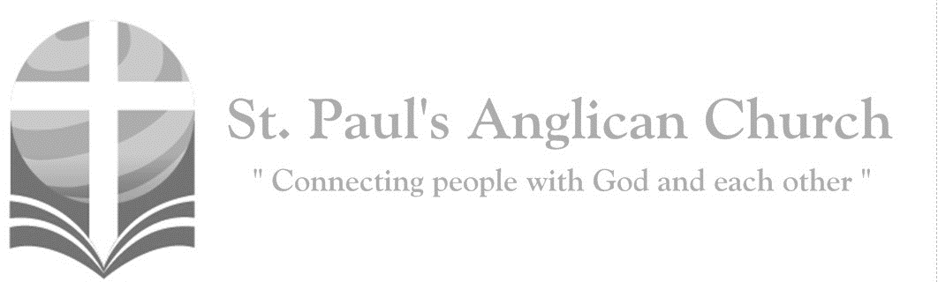

Sunday, September 22, 2019: 15th Sunday After Pentecost

*You know the grace of our Lord Jesus Christ, that though he was rich, yet for your sake became poor, so that by his poverty you might become rich. (2 Corinthians 8:9)*

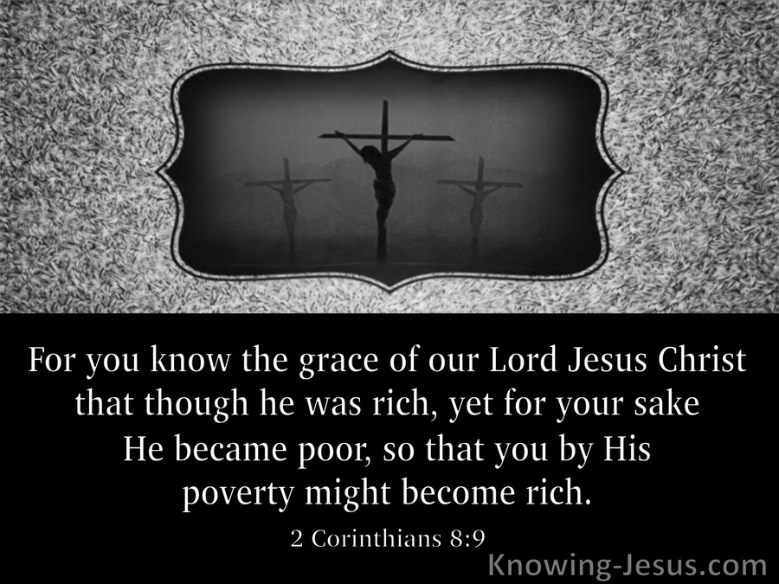

SUNDAYS AT ST. PAUL’S

**REGULAR SERVICES**

* Weekly services held Sundays at 10:00AM
* Interface services - Art based services throughout the year
* Sermons available on our website

**SUNDAY PRAYER**

* Prayer for the service at 9:30AM in the Luke Room
* Individual Prayer in the Chapel during the Sunday service

**SERVING AT ST. PAUL’S**

* Join a Ministry Team (Sunday service team, music team, children’s ministry, Altar guild, or many others)
* Regular or One-Time Giving (cash, cheque, automatic debit, and credit options available)

**LARGE PRINT MATERIALS** Large print Bibles and   
 Books of Alternative   
 Services (BAS) are availableat each Sanctuary door.

Page numbers will not be the same as those listed in the bulletin.

**VISITING TODAY?**

We want to get to know   
 you! Please join us for

in the Hall for coffee and

fellowship following the service. The greeters are also available to help if you have any questions.

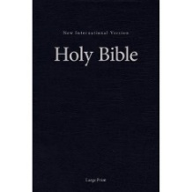



**Assisted listening**

**is available. Please**

**ask a greeter**

**for assistance.**



CONNECT

**St. Paul’s CHILDREN’S MINISTRY**

**KIDS** Pre-School-Grade 2 in the hall / Grade 3-5 in the Matthew Room

Sunday School teaching is weekly during the 10:00AM service.

**St. Paul’s YOUTH MINISTRY**

**YOUTH** Youth Grades 6-12 meet weekly during the 10:00AM service.

Youth also meetbi-weekly for fun events and devotionals.

**St. Paul’s ADULT MINISTRY**

**ADULTS** St. Paul’s has a number of small groups where you can connect with others through Christ. If you are interested in joining a small   
group or starting a small group of your own, please speak with Pat Stretch.

**Opening Song: *Holy is Our God***

Lift up His Name within the sanctuary  
Lift up His Name

Among the people who are gathered  
Here to sing His praise  
Who are gathered h

Here to sing His praise

(*Chorus*) Holy is our God  
Holy is Your Name  
Mighty are Your works and deeds  
And wondrous are Your ways  
All that You have made  
Shall return and give You glory, Lord

The earth, the sky

The sea and all within them  
This universe beyond

The sight of mortal men  
All subject to His reign  
All creation subject to His reign   
(*To Chorus*)

The great I Am

No end and no beginning  
You were and are

And evermore You shall be  
All my days are in Your hands  
All my days are in Your hands

(*To Chorus*)

**The Gathering of the Community**

Celebrant: *(BAS pg. 185)* The grace of our Lord Jesus Christ, and the love of God, and the fellowship of the Holy Spirit, be with you all.

**People: And also with you.**

Celebrant:Almighty God,

**All:to you all hearts are open, all desires known, and from you no secrets are hidden. Cleanse the thoughts of our hearts by the inspiration of your Holy Spirit that we may perfectly love you, and worthily magnify your holy name; through Christ our Lord. Amen.**

Celebrant: *(pg. 381)* Almighty God, you have created the heavens and the earth, and ourselves in your image. Teach us to discern your hands in all your works and to serve you with reverence and thanksgiving; through Jesus Christ our Lord, who is alive and reigns with you and the Holy Spirit, one God, now and for ever.

**People:** **Amen**.

**Children Dismissal**

**The Reading of Scripture**

First Reading: Jeremiah 8:18-9:1 (pg. 541 in the red pew Bible)

Reader: The Word of the Lord.

**People:** **Thanks be to God.**

Psalm: Psalm 79:1-9 (pg. 811 in the BAS)

Second Reading: 1 Timothy 2:1-7 (pg. 839 in the red pew Bible)

Reader: The Word of the Lord.

**People:** **Thanks be to God.**

**Worship Through Song**

***Creation Calls***

I have felt the wind blow  
Whispering Your name  
I have seen Your tears fall  
When I watch the rain

(*Chorus*) How could I say there is no God  
When all around creation calls  
A singing bird, a mighty tree  
The vast expanse of open sea

Gazing at a bird in flight  
Soaring through the air  
Lying down beneath the stars  
I feel Your presence there

I love to stand at ocean's shore  
And feel the thundering breakers roar  
To walk through golden fields of grain  
'Neath endless blue horizon's frame

Listening to a river run  
Watering the earth  
The fragrance of a rose in bloom  
A newborn's cry at birth (*To Chorus*)

I believe, I believe, I believe

***Breathe on Me***

Breathe on me Breath of God  
Love and life that makes me free  
Breathe on me Breath of God  
Fan the flame within me

(*Chorus*) Teach my heart, heal my soul  
Speak the mind that in Christ we know  
Take me to Your sanctuary  
Breathe on me

Speak to me voice of God  
Soft and still inside my heart  
Speak to me word to God  
Comfort, heal, restore with love

(*To Chorus*)

**Listening Time**

**The Gospel Reading**

Celebrant: The Lord be with you.

**People: And also with you.**

Celebrant: The Holy Gospel of our Lord Jesus Christ according to St. Luke.

**People: Glory to you, Lord Jesus Christ.**

Gospel Reading: Luke 16:1-13 (pg. 740 in the red pew Bible)

Celebrant: The Gospel of Christ.

**People: Praise to you, Lord Jesus Christ.**

**Sermon Notes:** Sermon by the Reverend Dr. Myron Penner

________________________________________________________________________________________________________________________________________________________________________________________________________________________________________________________________________________________________________________________________________________________________________________________________________________________________________________________________________________________________________________________

________________________________________________________________________________________________________________________________________________________________________________________________________________________

________________________________________________________________________________________________________________________________________________________________________________________________________________________________________________________________________________________________________________________________________________________________________________________________________________________________________________________________________________________________________________________________________________________________________________________________________________________________________________________________________________________________________________________________________________________________________________________________________________________________________________________________________________________________________________________________________________________________________________________________________________________________________________

**Affirmation of Faith – Love**

**All: We believe in God, who is love, whose love is manifest in all Creation, in our lives, and in all people. We follow Christ, who embodied God’s love. In his life and ministry, his death and resurrection, and his granting to us of his Spirit, he filled us with that love as well. We live by the Spirit, the presence of God’s love in us. In that love we participate in the Church, Body of Christ, in loving God by loving our neighbors through our prayers, our presence, our gifts and our service. Love is our faith, and it is a gift from God. We thank God, and ask God’s blessings, that we may love in the name of Christ and the power of the Spirit, to God’s glory. Amen.**

**Prayers of the People**

**Confession of Sin**

Celebrant: *(pg. 191)* Dear friends in Christ, God is steadfast in love and infinite in mercy; he welcomes sinners and invites them to his table. Let us confess our sins, confident in God’s forgiveness.

*Silent Confession*

Celebrant:Most holy and merciful Father,

**All: we confess to you, to one another, and to the whole communion of saints in heaven and on earth, that we have sinned by our own fault, in thought, word, and deed; by what we have done and by what we have left undone. O God, uphold us by your Spirit that we may live and serve you in newness of life to the honour and glory of your name; through Jesus Christ our Lord. Amen.**

Celebrant: Accomplish in us, O God, the work of your salvation,

**All: that we may show forth your glory to the world.**

Celebrant: By the cross and passion of your Son, our Lord,

**All: bring us with all your saints to the joy of His resurrection.**

Celebrant: Almighty God have mercy upon you, pardon and deliver you from all your sins, confirm and strengthen you in all goodness and keep you in eternal life through Jesus Christ our Lord.

**People:Amen.**

**The Peace**

Celebrant: The peace of the Lord be always with you.

**People: And also with you.**

**Offertory Song: *All To Us***

Precious cornerstone, sure foundation  
You are faithful to the end  
We are waiting on You Jesus  
We believe You're all to us

(*Chorus*) Let the glory of Your name  
Be the passion of the Church  
Let the righteousness of God  
Be a holy flame that burns  
Let the saving love of Christ  
Be the measure of our lives  
We believe You're all to us

Only Son of God sent from heaven  
Hope and mercy at the cross  
You are everything  
You're the promise  
Jesus, You are all to us (*To Chorus*)

When this passing world is over  
We will see You face to face  
And forever we will worship  
Jesus, You are all to us  
Jesus, You are all to us (*To Chorus*)

**Prayer Over the Gifts**

Celebrant: *(pg. 382)* God of power,

**All: the glory of your works fills us with wonder and awe. Accept our offering this day, and help us to live in peace and harmony with all your creation, for the sake of Jesus Christ our Lord. Amen.**

Celebrant: *(pg. 193)* The Lord be with you.

**People: And also with you.**

Celebrant: Lift up your hearts.

**People: We lift them to the Lord.**

Celebrant: Let us give thanks to the Lord our God.

**People: It is right to give our thanks and praise.**

Celebrant: *(pg. 193)* It is indeed right that we should praise you, gracious God, for you created all things……. Therefore, with them, and with all your saints who have served you in every age, we give thanks and raise our voices to proclaim the glory of your name.

**All:** ***(Sung)*** **Holy, holy, holy Lord, God of power and might, heaven and earth of Your glory are full. Hosanna, hosanna, hosanna in the highest. Blessed is he who comes in the name of the Lord.   
Blessed is he who comes in the name of the Lord.   
Holy, holy, holy Lord, God of power and might, heaven and earth of Your glory are full. Hosanna, hosanna, hosanna in the highest.**

Celebrant: (pg. 194) Holy God, source of life and goodness, all creation rightly gives you praise……. Therefore, we proclaim the mystery of faith.

**All Christ has died. Christ is risen. Christ will come again.**

Celebrant: (pg. 195) Recalling his death, proclaiming his resurrection……. Through Christ, with Christ, and in Christ, in the unity of the Holy Spirit, all glory is yours, almighty Father, now and for ever.

**All: Amen.**

Celebrant: *(pg. 211)* As our Saviour taught us, let us pray,

**All: *(Sung)* Our Father which art in heaven, hallowed be Thy name. Thy kingdom come, thy will be done on earth as it is in heaven. Give us this day our daily bread and forgive us our debts as we forgive our debtors and lead us not into temptation but deliver us from evil.   
For Thine is the kingdom and the power and the glory forever. Amen. For Thine is the kingdom and the power and the glory forever. Amen.**

Celebrant: *(pg. 212)* We break this bread to share in the body of Christ.

**All: We, being many, are one body, for we all share in the one bread.**

Celebrant: *(pg. 213)* The gifts of God for the People of God.

**People: Thanks be to God.**

**The Communion**

*You are welcome to receive communion or come forward for a blessing. If you prefer to receive a blessing, please fold your arms over your chest. There is de-alcoholized wine available in the centre and gluten-free wafers available upon request.*

**Lamb of God**

*(Sung)* Lamb of God, you take away the sin of the world.

Lamb of God, you take away the sin of the world.

Lord have mercy, Christ have mercy, Lord have mercy on me.

Lord have mercy, Christ have mercy and grant us thy peace.

**Communion Music**

***Humble King***

Oh kneel me down again  
Here at Your feet  
Show me how much You love  
Humility  
O, Spirit be the star  
That leads me to  
The humble heart of love  
I see in You

'Cause You are the God of the broken  
The friend of the weak  
You wash the feet of the weary  
Embrace the ones in need  
I want to be like You Jesus  
To have this heart in me  
You are the God of the humble  
You are the humble King

***Hallelujah to My King***

O how strong the power of Jesus' Name  
It is stronger than any other name  
How sweet the victory

That bore my shame  
Took the burden of my sin away

(*Chorus*) Hallelujah, what a Savior  
I owe everything to Him  
Hallelujah, what a Savior  
Hallelujah to my King

O how great the kindness

Our God has shown  
We were strangers

Now we're called His own  
His grace has welcomed

The sinner home   
Tender mercies lead us to the throne

(*To Chorus*)

Hallelujah, Hallelujah to my King  
Hallelujah, Hallelujah to my King

O what peace the Spirit of Jesus brings  
Through the trials He will carry me  
One day in Heaven our eyes will meet  
Filled with wonder all the saints will sing

(*To Chorus*)

**Prayer After Communion**

Celebrant: *(pg. 382)* Ruler of the universe,

**All: all creation yearns for its fulfilment in your Son. May we who have shared in holy things grow in maturity in him. This we ask in the name of the same Jesus Christ our Lord.** **Amen.**

Celebrant: *(pg. 214)* Glory to God,

**All:whose power, working in us, can do infinitely more than we can ask or imagine. Glory to God from generation to generation, in the Church and in Christ Jesus, for ever and ever. Amen.**

**Blessing**

**Congregational Announcements *(David P.)***

**Closing Song: *The Lord is My Salvation***

The grace of God has reached for me  
And pulled me from the raging sea  
And I am safe on this solid ground  
The Lord is my salvation

I will not fear when darkness falls  
His strength will help me

Scale these walls  
I'll see the dawn of the rising sun  
The Lord is my salvation

(*Chorus*) Who is like the Lord our God  
Strong to save, faithful in love  
My debt is paid and the victory won  
The Lord is my salvation

My hope is hidden in the Lord  
He flowers each promise of His Word  
When winter fades

I know spring will come  
The Lord is my salvation

In times of waiting, times of need  
When I know loss, when I am weak  
I know His grace will renew these days  
The Lord is my salvation (*To Chorus*)

And when I reach the final day  
He will not leave me in the grave  
But I will rise He will call me home  
The Lord is my salvation

Glory be to God the Father  
Glory be to God the Son  
Glory be to God the Spirit  
The Lord is our salvation (*Repeat*)

The Lord is our salvation  
The Lord is our salvation

**The Dismissal**Celebrant: *(pg. 215)* Go forth into the world, rejoicing in the power of the Spirit.

**All: Thanks be to God. Amen.**

*Please join us in the Hall for pizza and salad following the service.*

**Ministry Fair and Rector’s Update – Today in the Hall**  
Please join us for an update from Myron as well as a ministry fair for St. Paul’s today following the service. Pizza and salad will be served for lunch so please plan to stay!!

**Breaking Free – Video Series for Women- Starting Sep. 30**   
All women are invited to join the group starting on Monday, Sep. 30. They will meet every other week in the John Room and be going through *Breaking Free* by Beth Moore. If you would like to attend, please contact Connie P. or the office.

**Myron’s Induction Service–   
Tuesday, September 24 at 7:00PM**   
Please join us for Myron’s Induction Service on Tuesday, Sep. 24 at 7:00PM in the Sanctuary.

**Bible Study/Fellowship Planning**

**Wednesday, Sep. 25 at 7:00PM**  
Anyone interested in a new Bible Study or Fellowship Group is welcome to attend the planning meeting this Wednesday, Sep. 25 at 7:00PM in the Luke Room.

**Community Square Dance and Potluck – Saturday, October 5**   
Please join us, in partnership with Fusion Canada, for a Square Dance and Potluck in the Hall! Potluck begins at 5:30PM with the Square Dance following at 7:00PM. If you want to help, contact Terry Berard.

**St. Paul’s Church-Wide Retreat**

**November 15-17 - Camp Nakamun**

This retreat is for everyone (singles, couples, families, etc.) and will feature a wagon ride, games, swimming, and lots more!! Registrations are due Oct. 27.

**Back to Church Sunday – Sep. 29**

We’re having a “Back to Church Sunday” on September 29!! This is going to a special Sunday designed to be a little more “user-friendly” for folks who don’t normally come to an Anglican church – or any church at all! The emphasis is on inviting someone, not on whether they actually come (although it’s great of they do!). Invitations are available at each door.

**RightNow Media**

If you did not receive your personal RightNow invitation last week, please email the church office at office@stpauls-anglican.ca (as this also means we don’t have your email address).

**The Power of Forgiveness – Sep. 29**

Please join us Sunday, September 29 at 8:45-9:45AM in the John Room for a discussion about the power of forgiveness led by Nancy Whistance-Smith. Come hear Nancy’s story and share your own!

**$5 – 5 Ways – For Buyé -**

**Supporting a Medical Initiative**

Medical cards (covering 80% of medical expenses) for seniors in Buyé cost $5.00 but that is out of reach for many. If we each contribute $5.00 during coffee time each Sunday this month, we can make a difference for many in the Buyé Diocese. There will be a basket in the Hall for your donations. Please join us in supporting this Diocesan initiative!



@StEdmonton

facebook.com/stpachurchedmonton

**St. Paul’s Vestry:**

Peter Jackson, *Rector’s Warden*

Pat Stretch, *People’s Warden*

David Heritage, *Treasurer*

Margot Byer, *Vestry Member*

John Green, *Vestry Member*

Deanna Kalles, *Vestry Member*

David Parker, *Vestry Member*

Carol Rudat, *Vestry Member*

**St. Paul’s Staff:**

*Rector:*

The Reverend Myron Bradley Penner  
*Office Administrator:*

RJ Chambers

*Youth Leader:* Victoria Eeles

**For prayer requests** **email**:

office@stpauls-anglican.ca

**For urgent prayer requests call**

the church office: (780) 455-0771

**For pastoral emergencies call:**

(587) 334-2130

**Office Hours:**

Monday-Thursday: 9:00AM-12:00PM

Closed: Fri/Sat/Sun and Stat Holidays

**St. Paul’s Anglican Church**

10127 145 Street, Edmonton T5N 2X6

Phone: (780) 455-0771; Email: office@stpauls-anglican.ca

Website: www.stpauls-anglican.ca

**This Week’s Readings:**

Jeremiah 8:18-9:1 (pg. 541)

Psalm 79:1-9 (BAS, pg. 811)

1 Timothy 2:1-7 (pg. 839)

Luke 16:1-13 (pg. 740)

**This Week’s Ministry Teams:**

Music/Sound: Andrew’s Team/Jennifer

Service Team: Tilburn Team

Prayers: Deanna K.; Vestry: David P.

Chapel Prayer: Kjeryn A. and Barb M.

Kid’s Ministry: Jodi P. and Abigail P.

**St. Paul’s Cycle of Prayer:**

Scott Morgan, Adele Bossé-Morgan and Jordan, Paige, Jenna, and Kaitlin;

Gordon and Pat Stretch

**Anglican Cycle of Prayer:**

Diocese of Edmonton; the Rt. Rev. Jane Alexander, Bishop. St. Paul, Leduc: Michael Williamson (s. Janet), Interim Priest-in-Charge. Clergy of Buyé diocese in further education: Jean Berchmans Mweningoma, Rev. Dominque CIZA, Rev. Simion KINONO, Theological School of Sewanee, Tennesee: University of the South, America. Ermineskin Cree Nation.

**Next Week’s Ministry Teams**

Music/Sound: Carol’s Team/RJ

Service Team: Jackson Team

Prayers: Gay G.; Vestry: Carol R.

Chapel Prayer: Dudley B. and Pat H-B.

Kid’s Ministry: Renée J. and Carol R.