The Gift of Empowerment – Water in Tanzania (PWRDF website, 2011)

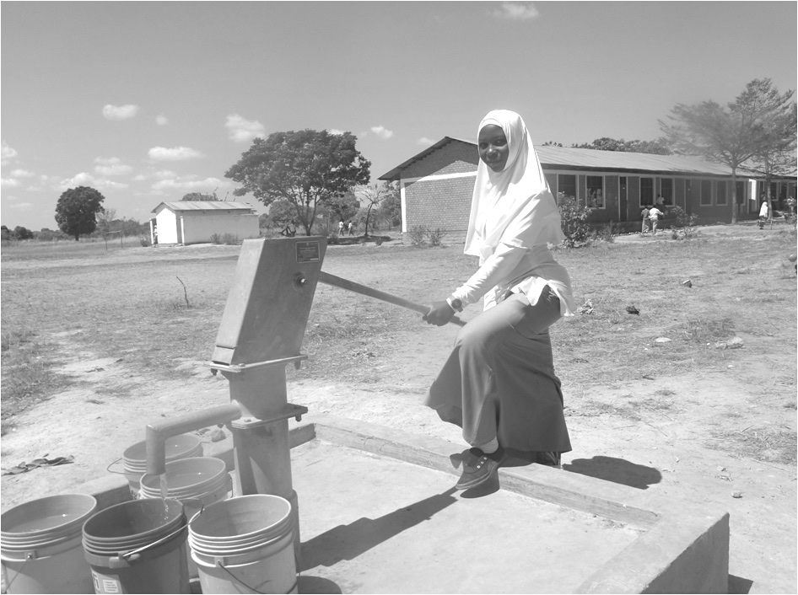
How far do you walk to get water? For most of us, it’s a few steps to the kitchen or washroom sink, the turn of a tap, and out flows clean water. For Habiba Natenda who lives in the village of Mtalikachau in rural Masasi, Tanzania it used to be a 10 km walk – each way – to fill a 20 litre bucket of water. “Traditionally, it is us [women] who fetch or collect the water for domestic use, but because of climate change it is getting more and more difficult to get water,” she explains. As a result, the swamps and shallow wells that Habiba and others were forced to use were often contaminated, and led to outbreaks of cholera, diarrhea, and typhoid. These conditions struck hardest at children.

The Primate’s World Relief and Development Fund (PWRDF) has worked with the Diocese of Masasi and the Department of Foreign Affairs, Trade and Development (DFTAD, formerly CIDA) to bring clean water to Mtalikachau and other villages in rural Masasi. Deep bore holes (wells) have been dug and community water committees have been formed (involving men AND women) so that Habiba and thousands of women and their families have ready access to clean water, experience reduced rates of water-borne diseases, and now have time for other important activities in their lives.

To support the ongoing work of the Diocese of Masasi to bring clean water to rural Tanzanian communities, make your donation payable to PWRDF and earmarked for “Water Projects in Africa.”

Photo: Community well in a schoolyard in rural Masasi, Tanzania.

