CEFC MEETS COVID-19 CHALLENGE
In the first months of 2020, the Centretown Emergency Food Centre served over 1500 clients. Thus, the CEFC Management Committee knows the importance of keeping the Centre open during the COVID-19 lockdown, especially when so many other service organizations have been forced to close.
However, significant challenges had to be overcome. The CEFC facilities are too small to allow adequate social distancing, and many of our volunteers are over 65 and thus at greater risk from the virus.
Yet with an enormous effort and great ingenuity, Kerry Kaiser and her team have managed. Throughout March, along with support from the Ottawa Food Bank, Centre 507 and Somerset West Community Health Centre, CEFC has been able to distribute prepackaged hampers to our clients.
However, as the virus continues to spread in Ottawa, the Management Committee has reluctantly decided to reduce hours of service to clients. For the immediate future, the Centre will be open to serve clients from 12 noon to 1 pm only, Monday and Friday. We will continue to monitor the situation and adjust as necessary.
Financial contributions to help defray unexpected expenses are welcome. Donations can be made via the CCSAC website (www.centretownchurches.org).
Check out our new Facebook link at:
www.facebook.com/CentreTownChurches/

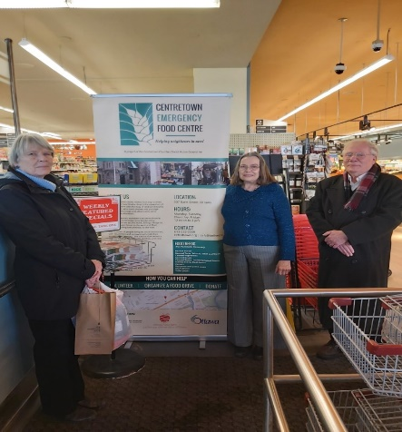
Nancy Lee (left), CCSAC Board Member Elizabeth Kent (centre) and Roger White at the February food drive for the Emergency Food Centre.
FOOD CENTRE HOLDS SUCCESSFUL DRIVE
In February, CCSAC Board members participated in a successful food drive at McKeen Metro in the Glebe. A total of $1,494 was raised in cash donations, and food items valued at $1,380 were received on behalf of the Centretown Emergency Food Centre (CEFC).
CEFC Management Committee Chair Allison Dingle noted, “The money raised will be a great help with our food purchases, especially during these late winter months when we must buy most of the fresh fruits and vegetables we offer our clients. The large amount of food donated will help us fill our storage room and shelves.”
CCSAC MEETS WITH ST. ANDREW’S MEN’S FELLOWSHIP
CCSAC Chair Kristine Burr, accompanied by Martha Musgrove, was recently invited to give a presentation to the Men’s Fellowship group of St. Andrew’s Ottawa.
Kris provided the meeting with an overview of CCSAC, noting our history of identifying and responding to community needs in the core of Ottawa. She then described current projects, including the Centretown Emergency Food Centre (CEFC), an annual prayer breakfast, an annual dinner to thank CEFC volunteers, an Advent service and luncheon and outreach to our church members and the wider community through our website and newsletter.
Martha spoke about how CCSAC’s Outreach Committee has initiated informal consultations with faith and non-faith communities to determine if there are new social needs in our catchment area, and if so, what role CCSAC might play in addressing some of these concerns.
Our presentation was followed by a lively question and answer session during which the Men’s Fellowship members provided their views on key social challenges in the Ottawa core and possible CCSAC responses.
At the conclusion of a stimulating evening, the Men’s Fellowship presented CCSAC with a cheque for $2,000. This support is most appreciated.
Rob Sheffield (left) and Peter Lamont present Kristine Burr with a cheque to further the work of CCSAC.
BRONSON HUB ENGAGES WITH SENIORS
Last September, the Bronson Centre Inc. was awarded a five-year, $2.1 million grant from the New Horizons for Seniors program of Employment and Social Development Canada to develop a unique, location-based initiative. The goals of the new program, Bronson Hub, are “to learn together, build relationships, create projects and work to improve seniors’ inclusion and reduce social isolation.” The Hub’s focus will be intergenerational and cross-cultural.
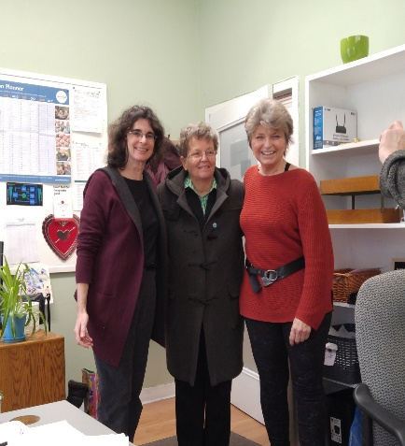
Alicia Borisonik (left), Patricia Marsden-Dole and Pat Kelly at the Bronson Hub
Members of the CCSAC outreach committee met recently with Program Manager Pat Kelly and Arts and Projects Coordinator Alicia Borisonik to learn more about the Hub.
Pat explained that the Bronson Centre has excellent physical resources that could be developed further to offer more services to the surrounding community, especially seniors living in isolation.

