Living Into Our Prayers
Matthew 7:7-12
A Sermon Preached at Lawrence Park Community Church
April 19, 2020
Rev. John Suk, PhD

My brother Art was diagnosed with ALS—Lou Gehrig's Disease—about 12 years ago now. His illness had a huge impact on me, which is probably why it has come up in my preaching more than a few times. Art was only in his mid-40s.

At the time of diagnosis, Art was a dedicated athlete, an onsite manager for massive infrastructure projects like airports, and an active hospital triage and fireman volunteer. He was generous and kind person.

Anyway, after the ALS diagnosis Art began to pray for healing. His church and family prayed too. I also prayed. How could I not?

Occasionally, his church friends would even come to his home to pray. When they did, I heard them claim to have divine visions where Art was healed and running his daily 15k's again. Even as his body shut down, Art continued to pray for his healing, sometimes for hours on end.

Art said he still had talents to share, friends to support, and foreign aid volunteer projects to work on. Art believed that if “thy kingdom” was going to come God needed him, and so God just had to heal him, as his friends prophesied.

In fact, from his hospice bed, unable to lift an arm or walk or talk, communicating by slowly pointing out letters on an alphabet chart, Art actually made financial and nursing arrangements to move out of hospice and back home, because he was so sure God would answer his prayers. Two days later, he died.

We have all struggled with prayer—especially good and reasonable prayers like my brother’s, prayers that would make not only our lives, but the world, a better place; we have all struggled to understand why we did not receive what we humbly requested. And we wonder, in part, because of what Jesus said, in today’s scripture. Jesus said, "Ask and it will be given to you."

What do we make of those words? Or the related idea—a big internet meme—that prayer has some sort of power?

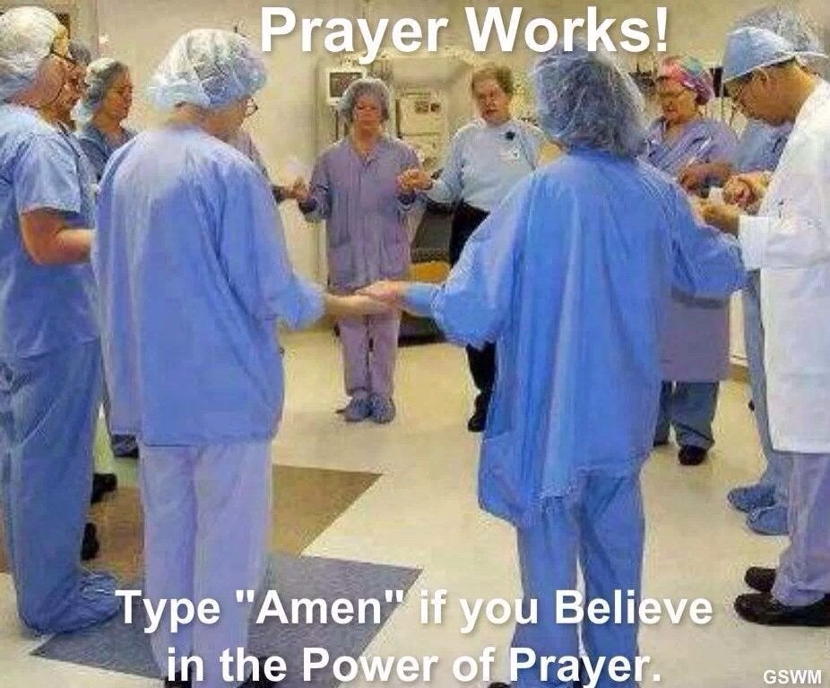
The idea here is that so long as we pray often enough, or with enough faith, or with more and more people, or with the right technique, we can make God do whatever we want, now. Like here, in this FB picture. It says, just type “Amen” if you believe in the power of prayer. The suggestion is that only by this demonstration of faith and enthusiasm will the healing will happen. It is all about technique.

On the other hand, most of us remember that even though Jesus said “ask and it will be given,” not everyone who prayed in the Bible got what he or she wanted. For example, King David—a man after God’s own heart, so we are told—King David prayed that his first son with Bathsheba would live. But his son died, anyway. The great Apostle Paul prayed that his painful thorn in the flesh would be taken away, but it was not. And even Jesus prayed, in Gethsemane, that the cup of his suffering, that his crucifixion, might be cancelled, please. But Jesus died on the cross anyway. God did not give Jesus what Jesus asked for.

We all get this. Like my brother, we have all prayed prayers, deeply felt prayers, for precious things, like life and health, acceptance and belonging, peace and justice—
we have all prayed for such things and then been disappointed that we did not receive.

The truth is, Christians do not live longer than non-Christians. People of faith do not become wealthier, or avoid becoming ill with COVID-19, or have more fun than non-Christians.

People who pray may be calmer, or more centered, or less self-deceptive than those who do not pray—but maybe not, too. Still, my brother, for all his faith, died a young man, disappointed that God had not yet snapped his fingers to make him better. But again, then why did Jesus say, "ask and it will be given to you?"

Well, to understand this saying, we have to make sure we do not take it out of context. These words are spoken near the end of the Sermon on the Mount. In that Sermon, Jesus says: "whoever practices and teaches these commands will be called great in the kingdom of heaven."

No wonder. It does take a great, great person to live up to the suggestions found in Sermon on the Mount.

For example, Jesus says if someone strikes you on the right cheek you should offer your other cheek for a second smack. Jesus says if someone steals your coat, you ought to give him or her the shirt off of your back, too. Jesus says: do not judge, love your enemies, fast from food, don’t store up cash, do not worry, do not stay angry and on and on. No one can do all this. Or even a bit of this! It’s too much.

So, near the end of the sermon, Jesus offers those of us who are not so great some encouragement. "Ask, and it will be given to you. Knock and the door will be opened. Your father in heaven will give you the good gifts you ask for." What gifts?

Well, the gift of actually at least making a start on being a Sermon on the Mount kind of person. God doesn’t give us stuff, but God does invite us to say prayers that put us on the trail of being a Sermon on the Mount kind of person. It’s our decision. Live the prayer one word at a time. Use your prayer as an incentive to your own knocking and searching and acting. That why Jesus ends his sermon by saying, “Whoever hears these words, and acts on them, will be like a wise man who built his house on a rock.” Jesus means, “try. Get started. Use prayer if necessary.”

Soren Kierkegaard said as much too. He said something like, “Prayer does not change God, but changes the person who prays.”

So, prayer is ultimately not about getting from God the nice things or life-events we want. Prayer is, rather, about growing more Christ-like--becoming more and more the people Jesus wanted, hoped, and himself prayed we would become by having us lay out, using words before God, our benchmarks, one at a time.

So, “Ask, and it will be given you; search, and you will find; knock, and the door will be opened for you.” Jesus means when we ask we will also bend our wills to love; when we search, we will find for ourselves the path Jesus showed us, in the Sermon on the Mount. And when we knock, the door that will be opened to us is the door to our own heart, to do the right thing.

So then, pray. Not so much for an end to COVID-19, or to become rich, or to somehow avoid the common lot of all people.

Pray instead that you will become more and more a Sermon on the Mount sort of person. Because as you pray, whether a little or a lot, you will find the main thing has probably already happened.

