Will you help to make a
Happy Holiday Meal
for a family in our community?
Your support means so much and together we CAN and DO
make a difference.

Drive Up and Drop Off Frozen Hams and Turkeys at
The Pierce County Food Pantry every
Monday or Wednesday between 4pm and 6pm
in November and December
at 440 N Maple St. Ellsworth, WI
or call for another drop off time.
715-273-2070
You may also go to hungerpreventioncouncil.com and click on ‘GIVE’ to donate money for our food pantries to purchase needed holiday meal items.

Turkeys and Hams must be frozen and purchased from a retail market.
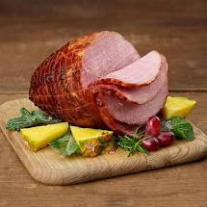
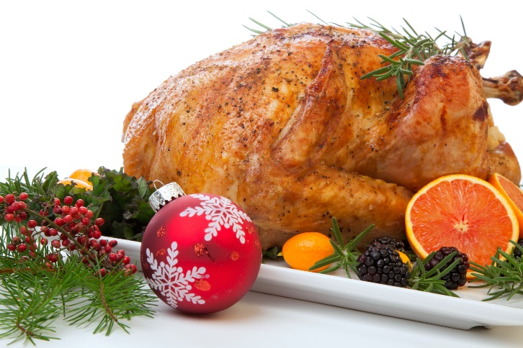
Thank You!

Pierce County Hunger Prevention Council a 501c3

