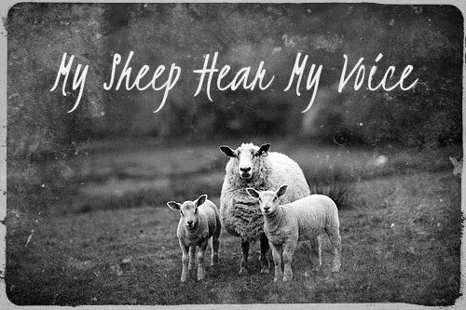
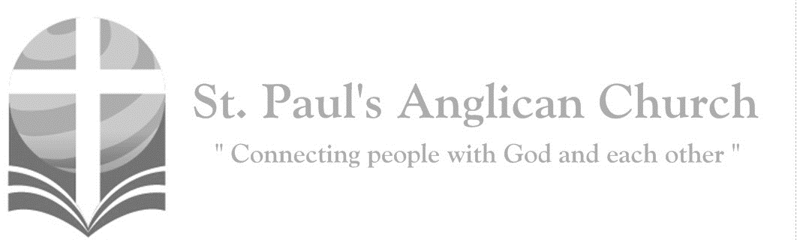
Sunday, August 18, 2019: 10th Sunday After Pentecost

My sheep hear my voice,
says the Lord; I know them and they follow me. (John 10:27)

Opening Songs: Praise God from Whom All Blessings Flow

Praise God from whom all blessings flow
Praise Him all creatures here below
Praise Him above ye heavenly host
Praise Father, Son, and Holy Ghost

Praise God the Father who’s the source
Praise God the Son who is the course
Praise God the Spirit who’s the flow
Praise God our portion here below

Here is Love
Here is love vast as the ocean
Loving kindness as the flood
When the Prince of life our ransom
Shed for us his precious blood
Who his love will not remember
Who can cease to sing his praise
He can never be forgotten
Throughout heaven's eternal days

On the mount of crucifixion
Fountains opened deep and wide
Through the floodgates of God's mercy
Flowed a vast and gracious tide
Grace and love like mighty rivers
Poured incessant from above
And heaven's peace and perfect justice
Kissed a guilty world in love

Morning Prayer
Leader: (BAS pg. 47) Lord, open our lips,
People: And our mouth shall proclaim your praise.
All: Glory to the Father, and to the Son, and to the Holy Spirit: as it was in the beginning, is now, and will be for ever. Amen. Alleluia!
Leader: (pg. 47) God rules over all the earth: O come, let us worship.
(pg. 49) Come, let us sing to the Lord;
People: let us shout for joy to the rock of our salvation.
Leader: Let us come before his presence with thanksgiving
People: and raise a loud shout to him with psalms.
Leader: For the Lord is a great God,
People: and a great king above all gods.
Leader: In his hand are the caverns of the earth,
People: and the heights of the hills are his also.
Leader: The sea is his for he made it,
People: and his hands have moulded the dry land.
Leader: Come, let us bow down, and bend the knee,
People: and kneel before the Lord our maker.
Leader: For he is our God, and we are the people of his pasture and the sheep of his hand.
People: Oh, that today you would hearken to his voice!
Leader: (pg. 47) God rules over all the earth: O come, let us worship.

Children’s Dismissal

The Reading of Scripture
First Reading: Isaiah 5:1-7 (pg. 486 in the red pew Bible)
Reader: The Word of the Lord.
People: Thanks be to God.

Psalm Reading: Psalm 82 (led by Jodi Penner)
Refrain:

God takes his stand in the council of heaven; he gives judgment in the midst of the gods: "How long will you judge unjustly, and show favor to the wicked? Ref.
Save the weak and the orphan; defend the humble and needy; Rescue the weak and the poor; deliver them from the power of the wicked. They do not know, neither do they understand; they go about in darkness; all the foundations of the earth are shaken. Ref.
Now I say to you, 'You are gods, and all of you children of the Most High: Nevertheless, you shall die like mortals, and fall like any prince.'" Arise, O God, and rule the earth, for you shall take all nations for your own. Ref.

Second Reading: Hebrews 11:29-12:2 (pg. 852 in the red pew Bible)
Reader: The Word of the Lord. People: Thanks be to God.

Worship Through Song

Lion and the Lamb
Who is He, who's the mightiest of all
Who is He, creation trembles at His call
Who is He, the lowly sacrifice
Who paid a victim's price
His name is Jesus

(Chorus)
Jesus, from the Father's own right hand
Jesus, Son of God and Son of man
Jesus, who died and rose again
Jesus, He's the Lion and the Lamb

Who is He
With the power none can tame
Who is He
When every foe would fear His name
Who is He, who was humbly led away
To suffer that dark day
His name is Jesus (To Chorus)

Who is He
With the eyes that burn like fire
Who is He, oh the wonder He inspires
Who is He, He bore the guilt and shame
For the ones who'd gone astray
His name is Jesus (To Chorus)

Holy Ground
This is holy ground
We're standing on holy ground
For the Lord is present
And where He is, is holy
This is holy ground
We're standing on holy ground
For the Lord is present
And where He is, is holy

These are holy hands
He's given us holy hands
He works through these hands
And so these hands are holy
These are holy hands
He's given us holy hands
He works through these hands
And so these hands are holy

Broken Vessels
All these pieces broken and scattered
In mercy gathered mended and whole
Empty handed but not forsaken
I've been set free, I've been set free

(Pre-Chorus)
Amazing grace, how sweet the sound
That saved a wretch like me
Oh I once was lost but now I am found
Was blind but now I see

(Chorus) Oh I can see You now
Oh I can see the love in Your eyes
Laying Yourself down
Raising up the broken to life

You take our failure
You take our weakness
You set Your treasure in jars of clay
So take this heart Lord
I'll be Your vessel
The world to see Your life in me
(To Pre-Chorus)

By Faith
By faith we see the hand of God
In the light of creation's grand design
In the lives of those
Who prove His faithfulness
Who walk by faith and not by sight

By faith our fathers roamed the earth
With the power of His promise
In their hearts
Of a holy city built by God's own hand
A place where peace and justice reign

(Chorus)
We will stand as children of the promise
We will fix our eyes on Him
Our soul's reward
Till the race is finished
And the work is done
We'll walk by faith and not by sight

By faith the prophets saw a day
When the longed-for Messiah
Would appear
With the power to break the chains
Of sin and death
And rise triumphant from the grave
By faith the church was called to go
In the power of the Spirit to the lost
To deliver captives
And to preach good news
In every corner of the earth (To Chorus)

By faith the mountain shall be moved
And the power
Of the gospel shall prevail
For we know in Christ
All things are possible
For all who call upon His name
(To Chorus)

Listening Time

The Gospel Reading
Reader: The Lord be with you.
People: And also with you.
Reader: The Holy Gospel of our Lord Jesus Christ according to St. Luke.
People: Glory to you, Lord Jesus Christ.
Gospel Reading: Luke 12:49-56 (pg. 738 in the red pew Bible)
Reader: The Gospel of Christ.
People: Praise to you, Lord Jesus Christ.

Missions Presentation

Affirmation of Faith – The Apostle’s Creed
All: I believe in God, the Father almighty, Creator of heaven and earth. I believe in Jesus Christ, his only Son, our Lord. He was conceived by the power of the Holy Spirit and born of the Virgin Mary. He suffered under Pontius Pilate, was crucified, died and was buried. He descended to the dead. On the third day, he rose again. He ascended into heaven and is seated at the right hand of the Father. He will come again to judge the living and the dead. I believe in the Holy Spirit, the holy catholic Church, the communion of saints, the forgiveness of sins, the resurrection of the body, and the life everlasting. Amen.

Prayers of the People

Collect
Leader: (pg. 374) Almighty God, you have broken the tyranny of sin and sent into our hearts the Spirit of your Son. Give us grace to dedicate our freedom to your service, that all people may know the glorious liberty of the children of God; through Jesus Christ our Lord, who lives and reigns with you and the Holy Spirit, one God, now and for ever.
All: Amen.

The Peace
Leader: The peace of the Lord be always with you.
People: And also with you.
Leader: Let us share God’s peace with one another.
All share the peace with one another.
Offertory Song: We Are Called to be God’s People

We are called to be God's people
Showing by our lives His grace
One in heart and one in spirit
Sign of hope for all the race
Let us show how He has changed us
And remade us as His own
Let us share our life together
As we shall around His throne

We are called to be God's servants
Working in His world today
Taking His own task upon us
All His sacred words obey
Let us rise then to His summons
Dedicate to Him our all
That we may be faithful servants
Quick to answer now His call

We are called to be God's prophets
Speaking for the truth and right
Standing firm for godly justice
Bringing evil things to light
Let us seek the courage needed
Our high calling to fulfill
That we all may know the blessing
Of the doing of God's will

The Lord’s Prayer
Leader: (pg. 54) Gathering our prayers and praises into one, let us pray as our Saviour taught us,
All: (Said) Our Father in heaven, hallowed be your name. Your kingdom come, your will be done, on earth as in heaven. Give us today our daily bread. Forgive us our sins as we forgive those who sin against us. Save us from the time of trial, and deliver us from evil. For the kingdom, the power, and the glory are yours, now and for ever. Amen.

Congregational Announcements (Peter J.)

Closing Song: O, For a Thousand Tongues to Sing

O, for a thousand tongues to sing
My great Redeemer's praise
The glories of my God and King
The triumphs of His grace

My gracious Master and my God
Assist me to proclaim
To spread through all the earth abroad
The honors of Thy name
So come on and sing out
Let our anthem grow loud
There is one great love, Jesus

Jesus the name that charms our fears
That bids our sorrows cease
'Tis music in the sinner's ears
'Tis life and health and peace
(continued on next page)
He breaks the power of canceled sin
He sets the prisoner free
His blood can make the foulest clean
His blood availed for me

(Chorus) So come on and sing out
Let our anthem grow loud
There is one great love, Jesus

He speaks and listening to His voice
New life the dead receive
The mournful broken hearts rejoice
The humble poor believe

Glory to God and praise and love
Be ever, ever given
By saints below and saints above
The church in earth and heaven
(To Chorus)

The Dismissal
Leader: Let us bless the Lord.
All: Thanks be to God.
Leader: The grace of our Lord Jesus Christ, and the love of God, and the fellowship of the Holy Spirit, be with us all evermore.
All: Amen.

Please join us in the Hall for a potluck following the service.
Potluck After Service Today
Please join us following today’s service for a potluck in the Hall!!! Even if you forgot to bring something, stay and join us!!

The Molly Project
Marg Daly has copies of her book, The Molly Project, available for purchase after today’s service. Cost for copies of The Molly Project are $25.00 each.
Sunday School Summer Schedule
August 18: Renée J.
August 25: Gay G.

Office Hours in Myron’s Absence
The church office will be open Tuesdays and Thursdays from 9:30AM-12:30PM while Myron is away. Messages will only be checked at those times as well.

St. Paul’s Hymn Sing and Ice Cream Social – August 21, 7:00PM
Please join us on Wednesday, August 21 at 7:00PM for a hymn sing in the Hall followed by ice cream!! Ice cream will be provided but please bring your favourite topping/s to share.

Altar Flowers Dedicated to
Chandra and Hannah
The flowers on the altar this morning are dedicated to Chandra Singham and Hannah David as they celebrate their 40th Wedding Anniversary (on August 17).

@StEdmonton
facebook.com/stpachurchedmonton
St. Paul’s Vestry:
Peter Jackson, Rector’s Warden
Pat Stretch, People’s Warden
David Heritage, Treasurer
Margot Byer, Vestry Member
John Green, Vestry Member
Deanna Kalles, Vestry Member
David Parker, Vestry Member
Carol Rudat, Vestry Member

St. Paul’s Staff:
Rector:
The Reverend Myron Bradley Penner
Office Administrator:
RJ Chambers
Youth Leader: Victoria Eeles
For prayer requests email:
office@stpauls-anglican.ca
For urgent prayer requests call
the church office: (780) 455-0771
For pastoral emergencies call:
(587) 334-2130

Office Hours:
Monday-Thursday: 9:00AM-12:00PM
Closed: Fri/Sat/Sun and Stat Holidays
St. Paul’s Anglican Church
10127 145 Street, Edmonton T5N 2X6
Phone: (780) 455-0771; Email: office@stpauls-anglican.ca
Website: www.stpauls-anglican.ca
This Week’s Readings:
Isaiah 5:1-7 (pg. 486)
Psalm 82 (in the bulletin)
Hebrews 11:29-12:2 (pg. 852)
Luke 12:49-56 (pg. 738)

This Week’s Ministry Teams:
Music/Sound: Jodi’s Team/RJ C.
Service Team: Jackson Team
Prayers of the People: Gay or Dudley
Chapel Prayer: Wendell and Nora
Vestry on Duty: Peter J.

St. Paul’s Cycle of Prayer:
Nathan and Deanna Kalles;
Frank and Carol Rudat;
Val Tilburn

Anglican Cycle of Prayer:
Diocese of British Columbia; the Rt. Rev. Logan McMenamie, Bishop. Trinity Mar Thoma Church, Edmonton: Anil Abraham Annamma (s. Jomol Anil), Rector. Buyé Diocese,Ven. Audace Kwizera, Youth Coordinator. Métis Nation of Alberta.

Next Week’s Ministry Teams
Music/Sound: Andrew’s Team/Jennifer S.
Service Team: Heritage Team
Prayers of the People: David H.
Chapel Prayer: Kjeryn A. and Barb M.
Vestry on Duty: David H.

