PRAIRIE TABERNACLE
SUNDAYS
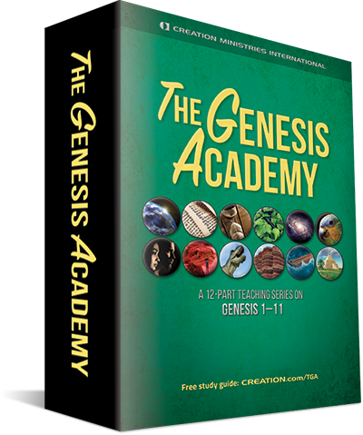
Twelve Sessions
1. Why Does Genesis Matter? Scott Gillis

2. Introduction to Genesis: Author, date, structure, genre Dr Jonathan Sarfati

3. Day 1: The creation of the world Gary Bates

4. Days 2 and 3: The creation of dry land and plants Keaton Halley

5. Day 4: The creation of light-givers Dr Jonathan Sarfati

6. Days 5 and 6: The creation of air, sea, and land creatures Dr Robert Carter

7. Day 6: The creation of mankind Gary Bates

8. The Fall: A cosmic catastrophe Joel Tay

9. The Pre-Flood World Dr Jonathan Sarfati

10. Noah’s Flood and Billions of Years Dr Robert Carter

11. Noah’s Flood and the Ark Keaton Halley

12. The Post-Flood World Dr Robert Carter

Facilitators:
Timothy Bowman tjdbowman@gmail.com
Dr. David Dunn davidldunn.dunn4@gmail.com
John Mills ajohnmills@gmail.com
Raymond Olson rcolson@eastlink.ca

Everyone Welcome
Questions Welcome
Discussion, Inquiry Welcome
May God Bless

