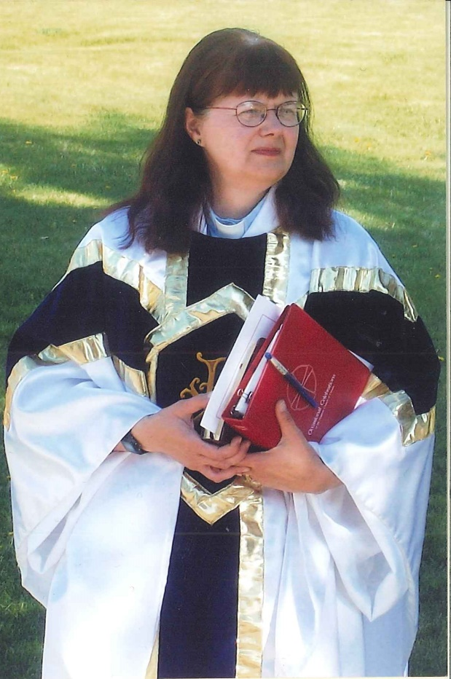

A Celebration of the Ministry of
Captain The Rev Isabel Healy-Morrow

St George’s Anglican Church
Territory of the People

October 21, 2018
The Rt. Rev Barbara Andrews – Presider
Louise Wiens and Choir - Music Ministry

A Celebration of Ministry
The Gathering of the Community

Processional Hymn: CP 575 – “Let Streams of Living Justice”

Celebrant The grace of our Lord Jesus Christ, and the love of God, and the fellowship of the Holy Spirit, be with you all.
People And also with you.

Children’s Time

Celebrant Almighty God,
People to you all hearts are open,
all desires known, and from you no secrets are hidden. Cleanse the thoughts of our hearts by the inspiration of your Holy Spirit,
that we may perfectly love you,
and worthily magnify your holy name;
through Christ our Lord. Amen.

Glory to God sung CP 365

The Collect of the Day
Celebrant Let us pray.
Almighty and everliving God,
increase in us your gift of faith,
that forsaking what lies behind
and reaching out to what is before,
we may run the way of your commandments and win the crown
of everlasting joy;
through Jesus Christ our Lord,
who lives and reigns with you and the Holy Spirit, one God, now and for ever. Amen.

The Proclamation of the Word

First Reading: Isaiah 53:4-12 Cathy Wozlowski

Psalm 104:1-9, 25, 37c Dwight Morrow

Epistle Hebrews 5:1–10 O’Della Grundy

Gradual Hymn: CP 466 “How Clear Is Our Vocation, Lord”

The Gospel Deacon Craig Fairley
All stand for the Gospel.
Reader The Lord be with you.
People And also with you.
Reader The Holy Gospel of our Lord Jesus Christ according to Mark ….(10:35–45)
People Glory to you, Lord Jesus Christ.
At the conclusion of the Gospel, the reader says,
The Gospel of Christ.
People Praise to you, Lord Jesus Christ.

Sermon The Rt. Rev Gordon Light

Anthem “Arise, Come Sing in the Morning”
Liturgy of Thanksgiving for Ministry:

Bishop: For 14 years, Rev. Isabel has served as rector of St. George's. She has offered her gifts, and has worked diligently for the building up of the Church in this place.
By the Grace of God, she has served you well.

Isabel, on June 13, 2004, you were inducted as rector of St. George's – to proclaim God's Word, to baptize new members into the Church, to announce God's forgiveness, and to preside at celebrations of the Eucharist. You have comforted this congregation in times of sickness and trouble, and at the death of their loved ones. Sharing their joys and sorrows, you have ministered to this parish family, sharing together in the Grace of Jesus Christ.

On this day, we celebrate and give thanks for your service. As you begin this new season in your life, your role will change. Today we ask God to pour rich blessings on you and Dwight, and your family.

Wardens at the Lectern:

Brian Mearon: Prior to coming to St. George's, Isabel served congregations at Logan Lake Community Church; The Church of the Redeemer in Barriere; All Saints, Shulus; St. Phillips, Nooaitch; St. Catherine's, Shackan; St. Michael and All Angels, Spences Bridge; and St. Michael's, Merritt. Isabel graduated from the College of Emmanuel & St. Chad in May of 1999. Isabel has also served as Regional Dean for the past twelve years.

Wayne LaGroix: In the Book of Ecclesiastes are written the following verses: “For everything there is a season, and a time for every matter under heaven; a time to be born, and a time to die; a time to plant and a time to pluck up what is planted, a time to kill and a time to heal, a time to break down and a time to build up, a time to weep and a time to laugh, a time to mourn and a time to dance, a time to cast away stones and a time to gather stones together, a time to seek, and a time to lose, a time for war, and a time for peace.”

Shirlee Browett: Isabel, today we mark the time of your service to us and the local community as rector of this parish; as this new season in your life begins, we give thanks for your ministry. It is a time to look back and a time to look forward; a time for joy and a time for sadness. It is a time to give thanks and praise to God for what has been given to us in our life together in this community.
Bishop: Blessed be God.
Congregation: And blessed be God's holy Name.
Bishop: The Lord makes everything beautiful in its time.
Congregation: Whatever God does endures forever.

Bishop: Bless the Lord, O my soul.
Congregation: And forget not all His benefits.
Linda LaGroix – Isabel, in this pulpit, and others in our Territory, you have proclaimed the Gospel of Christ hundreds of times over the past 19 years. You have preached and challenged God's people to live out the Gospel in our daily lives.
Congregation: We thank you for your preaching ministry.
Eloise Welch: Isabel, at this Altar, and others like it, you have presided at the sacrament of Holy Communion, so that young and old alike could be fed with the living presence of Christ.
Congregation: We thank you for presiding at the sacrament of the Eucharist.
Dorothy and Susan Stuart: Isabel, in this sanctuary, you have presided at services where we have given thanks for the lives of those who have died. You walked with us in our time of grief. You proclaimed the Good News of the Resurrection and led us in prayers for comfort and strength.
Congregation: We thank you for your support in our times of loss.

Marco and Barb Faria: Isabel, you have also presided over services of Holy Matrimony. You encouraged couples in their marriage and asked God to bless their union.
Congregation: We thank you for sharing those and other times of great joy.

Keisha Faria: Isabel, not only did you baptize 80 of us, both infants and adults, you have shared children's messages with us, prepared members of this congregation for Confirmation, and shared in youth activities and programs over the years.
Congregation: We thank you for presiding at the sacrament of Holy Baptism, and for supporting our children and youth.

Regional Dean, The Reverend Jo Ann Hinter: Isabel, your ministry here at St George’s has been recognized, and we wish to also give thanks to you for your ministry within the wider church. As Regional Dean you gave support to the clergy and Bishops alike, you mentored those in training, served on the councils of the church and engaged in the ministry of the whole church.
Congregation: We thank you for your ministry in the wider church, and for keeping us informed and involved.

Bishop: Isabel, when you were inducted in 2004, you received various symbols of your new ministry in this place: a Bible, a chalice, a copy of the canons, and a church key. As you return these symbols to the Wardens, we thank you for your kindness and compassion, your careful listening, your prayers, your bridge building with the local community, your ministry of preaching and pastoral care, and all you have done for this congregation to build it up into the Body of Christ.
Dwight, we recognize that you have been the support behind Isabel's ministry for many years. Today, we thank you for your dedication to her and the Church.

Scripture tells us that endings are only new beginnings. Therefore, let us remember to go forth, doing God's will in whatever place we are called.

Witness faithfully in word and deed to the love and salvation known to us in Christ. Isabel, may you give and receive comfort and support in this next chapter of your life and ministry, and continue to be a blessing to others.

May the Love of Christ be always on our hearts and a guiding light to our lives. May you always know God's peace that passes all understanding.

Congregation: Amen.

The Prayers of the People Al Baker
To the statement .... “O Lord my God”…
People How excellent is your greatness!

The Peace

The peace of the Lord be always with you.

People And also with you.

The Celebration of the Eucharist
The Preparation of the Gifts
Offertory Hymn: CP 500 “Sister, Let Me Be Your Servant”
The Prayer over the Gifts
Eternal God, your word inspires our faith.
May we who offer you our praise
trust you in all things.
We ask this in the name of Jesus Christ the Lord. Amen.
The Great Thanksgiving
Celebrant The Lord be with you.
People And also with you.
Celebrant Lift up your hearts.
People We lift them to the Lord.
Celebrant Let us give thanks to the Lord our God.
People It is right to give our thanks and praise.
Celebrant It is right to give you thanks and praise, O Lord, our God, sustainer of the universe, you are worthy of glory and praise.
People Glory to you for ever and ever.
Celebrant At your command all things came to be: the vast expanse of interstellar space, galaxies, suns, the planets in their courses, and this fragile earth, our island home; by your will they were created and have their being.
People Glory to you for ever and ever.
Celebrant From the primal elements you brought forth the human race, and blessed us with memory, reason, and skill; you made us the stewards of creation.
People Glory to you for ever and ever.
Celebrant But we turn against you, and betray your trust; and we turn against one another. Again and again you call us to return. Through the prophets and sages you reveal your righteous law. In the fullness of time you sent your Son, born of a woman, to be our Saviour. He was wounded for our transgressions, and bruised for our iniquities. By his death he opened to us the way of freedom and peace.
People Glory to you for ever and ever.
Celebrant Therefore we praise you, joining with the heavenly chorus, with prophets, apostles, and martyrs, and with those in every generation who have looked to you in hope, to proclaim with them your glory, in their unending hymn:
All Holy, holy, holy Lord,
God of power and might,
heaven and earth are full of your glory.
Hosanna in the highest.
Blessed is he who comes in the name of the Lord. Hosanna in the highest.
Celebrant Blessed are you, Lord our God, for sending us Jesus, the Christ, who on the night he was handed over to suffering and death, took bread, said the blessing, broke the bread, gave it to his friends, and said, “Take this, and eat it: this is my body which is given for you. Do this for the remembrance of me.”
In the same way, after supper, he took the cup of wine; he gave you thanks, and said, “Drink this, all of you: this is my blood of the new covenant, which is shed for you and for many for the forgiveness of sins. Whenever you drink it, do this for the remembrance of me.”
People Glory to you for ever and ever.
Celebrant Gracious God, we recall the death of your Son Jesus Christ, we proclaim his resurrection and ascension, and we look with expectation for his coming as Lord of all the nations. We who have been redeemed by him, and made a new people by water and the Spirit, now bring you these gifts. Send your Holy Spirit upon us and upon this offering of your Church, that we who eat and drink at this holy table may share the divine life of Christ our Lord.
People Glory to you for ever and ever.
Celebrant Pour out your Spirit upon the whole earth and make it your new creation. Gather your Church together from the ends of the earth into your kingdom, where peace and justice are revealed, that we, with all your people, of every language, race, and nation, may share the banquet you have promised; through Christ, with Christ, and in Christ, all honour and glory are yours, creator of all. People Glory to you for ever and ever.
People Amen.
The Lord’s Prayer Sung
Celebrant As our Saviour taught us, let us pray,
All Our Father in heaven,
hallowed be your name,
your kingdom come,
your will be done,
on earth as in heaven.
Give us today our daily bread.
Forgive us our sins
as we forgive those who sin against us.
Save us from the time of trial,
and deliver us from evil.
For the kingdom, the power,
and the glory are yours,
now and for ever.
Amen.

The Breaking of the Bread
Celebrant We break this bread to share in the body of Christ.
All We, being many, are one body, for we all share in the one bread.

The Communion
The gifts of God for the People of God. All are welcome at God’s table.
People Thanks be to God.

Communion Hymns: During Communion sung by choir
The Bread He Took
Long Before the Night
Majesty

Communion Assistants: The Rev Canon Sandra Sugden
The Rev Dan Krausert Theresa Mueller Shirlee Browett

Prayer after Communion
Celebrant Let us pray.
God of peace, you have nourished us in this sacrament
with the body and blood of Christ.
May we who have taken holy things
keep faith in our hearts and lives,
in the name of Jesus Christ the Lord. Amen.

Celebrant Glory to God,
People whose power, working in us,
can do infinitely more than we can ask or imagine.
Glory to God from generation to generation,
in the Church and in Christ Jesus,
for ever and ever. Amen.
Final Blessing: Captain The Rev Isabel C. Healy-Morrow

Go Now in Peace (sung benediction)

Go now in peace, never be afraid
God will go with you each hour of every day
Go now in faith, steadfast, strong and true,
Know He will guide you in all you do.
Go now in love, and show you believe
Reach out to others so all the world can see
God will be there watching from above
Go now in peace, in faith and in love.

Hymn: CP 424 “Sing Praise to God”
Dismissal
Go forth in the name of Christ.
People Thanks be to God.

Announcements:
October 27th – St. Peter’s Monte Creek is hosting a bonfire wiener roast from 11:30 – 1:30pm. Hot Dogs, square, drink. Cost $5.00
November 11th – Bells of Peace 1918-2018: the ringing of bells of all churches in the Territory, across Canada and here at St. George’s. A remembrance of those who served in the First World War.

The flowers on the altar today are given by the Wells family in loving memory of Winona Taverna, aunt and sister.

