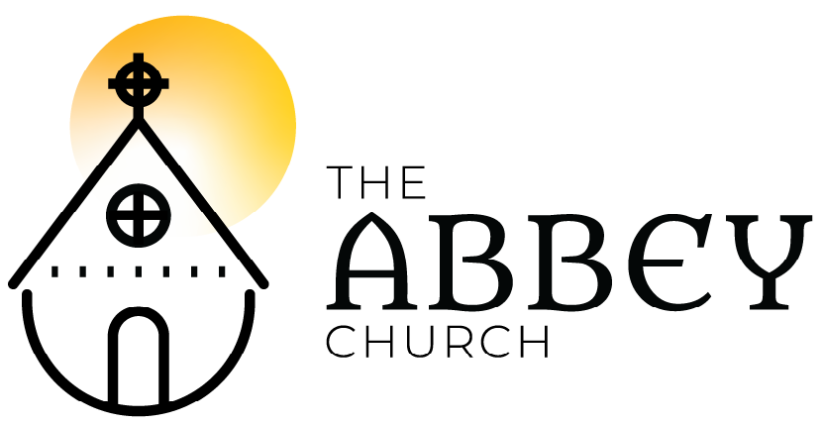

Lent V – March 29, 2020

Please submit your prayer requests in the chat to be included in prayers of people. If chat isn’t working – email roxy.archer@gmail.com who is curating today’s prayer and chat space.

Tolling of the Bells

Welcome

Land Acknowledgment

Opening Words:
The grace of our Lord Jesus Christ, the love of God and the communion of the Holy Spirit be with you. And also with you.

Song: Trisagion
Holy God - Holy and mighty
Holy immortal One
Have mercy - Have mercy - on us
(repeat x3)
Traditional/Fernando Ortega / CCLI with Streaming

Confession:
Let us turn to the light
and confess our sins.
Before God, with the people of God,
We confess our sin; the ways we wound our life, the lives of others and the life of God’s world.

Silence is kept.

Absolution

Song: My Soul Finds Rest
Oh my God hear my cry
From the depths I call out to you
You give your mercy and light
In the dark, in the wilderness

(Chorus)
My soul finds rest in God alone
My salvation comes from You
My soul finds rest, God is my home
I will not be shaken, I will not be shaken.

You are my shield and my strength
Train my feet for this battle
Our God is mighty to save
I will wait, I will wait for him (Chorus)

O my strength, I sing praise to you
O my strength, I sing praise to you
In joy or pain, I sing praise to you
Night or day, I sing praise to you (Chorus)
Sandra McCracken 2015 Drink Your Tea Music / CCLI with streaming, alt. for Lent

Poem: “Mary, sister of Lazarus, at your feet a second time” by Andrea Skevington

Collect + Antiphon

Psalm 130

Reading: Ezekiel 37:1-14

Song: Gospel Acclamation
Lord to whom shall we go?
Lord to whom shall we go?
You are gracious and merciful
Lord to whom shall we go?
Slow to anger and abounding in love
Lord to whom shall we go?
Lord to whom shall we go?
Let us trust in your Word.
Kent Gustafson / Used with Permission

Gospel: John 11:1-45

Repeat acclamation after.

Sermon/Reflection: The Rev. Matt Humphrey

Silence

Affirmation of Faith:
Sh’ma Yira-el! Adonei Eloheinu Adonai Echad.
Hear, O Israel, the Lord our God, the Lord is one. Love the Lord your God with all your heart, with all your soul, with all your mind, and with all your strength.

This is the first and the great commandment. The second is like it: Love your neighbour as yourself. There is no commandment greater than these.

Prayers of the People

Song: Come Ye Sinners
Come Ye Sinners, poor and needy
Weak and wounded, sick and sore.
Jesus ready stands to save you,
Full of pity love and power.

I will arise and go to Jesus
He will embrace me in his arms.
In the arms of my dear Saviour,
Oh there are ten thousand charms.

Come, ye thirsty, come and welcome
God’s free bounty glorified.
True belief and true repentance,
Every grace that brings you nigh.

Let not conscience make you linger,
Not of fitness fondly dream.
All the fitness he requireth
Is to feel your need of him.

I will arise and go to Jesus
He will embrace me in his arms.
In the arms of my dear Saviour,
Oh there are ten thousand charms.
Joseph Hart (1759) / Public

The Holy Eucharist
The Sanctus: Holy, holy, holy Lord
God of power and might!
Heaven and Earth are full of your glory. Hosanna in the highest. +Blessed is the one who comes in the name of the Lord. Hosanna in the highest.
---
The Memorial Acclamation:
Christ has died! Christ is risen!
Christ will come again!
---
The Lord’s Prayer / Prayer of Jesus
… we pray as Jesus taught us:
Our Father who art in heaven, hallowed be Thy name, Thy kingdom come, Thy will be done, on earth as in it is heaven. Give us this day our daily bread. And forgive us our trespasses as we forgive those who trespass against us. And lead us not into temptation but deliver us from evil. For thine is the kingdom, the power, and the glory. Forever and ever. Amen.
---
The gifts of God for the people of God.
Thanks be to God.

Song: Precious Lord, Take my Hand
Precious Lord, take my hand
Lead me on, let me stand
I am tired, I'm weak, I am worn
Through the storm, through the night
Lead me on to the light
Take my ha-and, precious Lord
Lead me home.

When my way grows drear,
Precious Lord, linger near
When my life is almost gone
Hear my cry, hear my call,
hold my hand lest I fall.
Take my hand, precious Lord,
lead me home.

When my darkness appears,
And the night draws near
And the day is past and gone,
At the river I stand, guide my feet
Hold my hand.
Take my hand, precious Lord,
Lead me home.
Thomas A. Dorsey; © 1938; Unichappell Music Inc.

Prayer After Communion

Song: Wings of an Eagle
As we hope in the Lord
We will gain our strength
We will run for miles
We will stand up straight
We will not grow weary
We will not grow faint
On the wings of an eagle we will rise

(Chorus)
On the wings of an eagle we will rise
On the wings of an eagle we will rise
For our hope is found
In the power of God
On the wings of an eagle we will rise
On the wings of an eagle we will rise

For the Lord who is God
Takes God’s people home
Not to be afraid
As we journey the road
Hand in hand we’ll be walking
With the Lord our God
On the wings of an eagle we will rise
(Chorus)
Music and Lyrics by Steve Bell / Signpost Music / CCLI

Blessing: Sung together
The Lord bless you and keep you.
The Lord make his face shine upon you
and be gracious unto you.
The Lord lift up his countenance upon you
and give you peace….

Song: Stay With Me
Stay with me. Remain here with me.
Watch and pray. Watch and pray.
Ateliers et Presses De Taize / OneLicence (with streaming)

JOIN us next week at 3pm
or for morning prayer via Zoom
email admin@emmauscommunity.ca for links and times.

For personal connection – email above - or call or text Rob 778 977 7562 Tuesday – Sunday (Sabbath Mondays)

