What is Interac e-Transfer?
Interac e-Transfer is a fast, secure and convenient way to send money to anyone in Canada using online banking. The participating bank or credit union transfers the funds using established and secure banking procedures. Transfers are almost instant, but can take up to 30 minutes.
How do I send money via Interac e-Transfer?
First of all, you need to be set up for on-line banking. If you are not, call your financial institution. You will need to provide your bank account information and answer some security questions.
Exact steps to send money via Interac e-Transfer vary by individual bank or credit union, but the process will always be simple. Just log into your online bank account, navigate to the Interac e-Transfer section and follow the instructions or phone your bank for help setting it up. You can choose to send the message through e-mail or text. For All Saints, please use the e-mail address: sonya@allsaintscochrane.org. All Saints has been set up for Autodeposit which an Interac e-Transfer feature that allows users to register to have incoming Interac e–Transfer funds deposited directly into their bank account – no security question and answer needed. I will always reply to say I received the funds so that you know they have arrived safely into All Saints’ bank account.
How much does it cost to send money via Interac e-Transfer?
There may be a fee from your financial institution for using the Interac e-Transfer service. Please check with your bank or credit union directly. Normally personal e-Transfers are free but All Saints will be charged $0.50/transaction since we are a Business.
How secure is it to send money by email or text message through Interac e-Transfer?
Interac e-Transfer is one of the safest digital money transfer services in the world. When you send or request money via Interac e-Transfer, the funds are transferred through established and secure banking procedures that banks and credit unions have used for years. Money never travels by email or text – these are simply used to notify you about the transaction, as well as provide deposit instructions. Security measures have been built into the system, including:
- Encryption technology
- Confidential user IDs and passwords issued by financial institutions
- Secure login process
Do you have to e-mail your bank account number to the recipient?
No, never provide your bank account number to anyone. When I sent an E-transfer from my personal account to All Saints for testing out our ability to receive them, the picture below is the e-mail I received from Interac. As you can see, there is no bank account information and in the “Message” area I put my name. This is also where you can put your envelope number, “Grocery Cards”, or signify other funds that you would like to donate to other than General Funds such as PWRDF, Ben Greenfield, Columbarium, Morley Reconciliation, The Parish House.
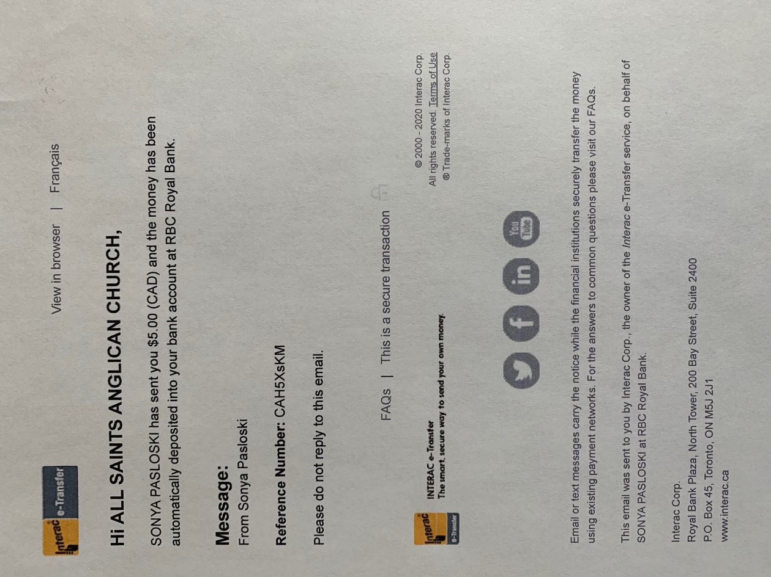
If you have further questions or would like some help getting E-transfer set up, I would be happy to help. Please contact Sonya at sonya@allsaintscochrane.org or PH: 403-932-6556. We appreciate all those who have provided their donations via E-transfer. It has worked really well.

