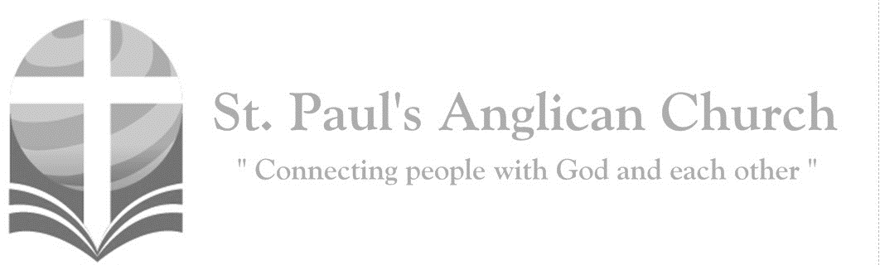
Sunday, August 16, 2020: 11th Sunday After Pentecost

Jesus preached the gospel of the kingdom and healed every infirmity among the people. (Matthew 4:23)

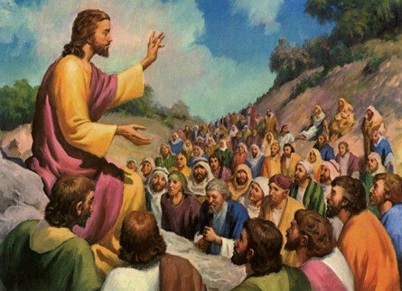

ST. PAUL’S COVID-19 RESPONSE
Welcome!! During this unique time in history, services will look a bit different than normal and will likely be different for quite a while. We want to care for the whole parish during this time and one way to care for one another is keeping each other safe. As such, we ask you to follow these guidelines while worshiping with us:
- Experiencing Cough, Fever, or Other Symptom/s? Go home immediately and please stay home for fourteen days following the end of your symptoms.
- Wear a Mask. All parishioners must wear a mask to all services (as per City of Edmonton bylaw 19408). Exceptions to this include children under the age of two and those with a medical condition where wearing a mask is not possible. Masks may be removed when taking communion but must be replaced immediately following. If you do not have a mask, we have cloth masks available in the foyer.
- Maintain Physical Distance. At all times, please remain a minimum of six feet (three seat spaces) from all other individuals not part of your family unit. You will find tape on the floor six feet apart in multiple locations to help you maintain this distance. Please also maintain physical distance outside.
- Listen to the Ushers. There will be ushers inside and outside to help direct these new procedures. Please heed their direction as they are trying to keep everyone safe and healthy.
- Sign-In Upon Arrival. Please sign-in with the designated usher when you arrive onsite. This will help us track who is in attendance just in case we do have to notify the parish if someone tests Covid positive following a service.
- Sanitize Hands Frequently. Please sanitize your hands upon entry and before taking communion. You may also sanitize as often as you would like during the service. Please also try to refrain from touching surfaces and your face.
- Refrain from Singing. At this time, congregational singing is not allowed by the government of Alberta. Please listen to the lyrics being sung by the leader/s and meditate upon them. You may also hum along to the music as long as your mouth remains closed.
- Recycle Bulletins. Please do not leave bulletins in the pews. A recycle bin is available at the exit door. You may also take the bulletin home.
- Use of Washroom. The only washroom available at this time is located at the back of the Sanctuary (just North of the Main Entry doors). Please wipe down all surfaces (including toilet and handle, counter, and faucet) following use.
- Parts of Building Closed. At this time, the only accessible parts of the building are the Sanctuary, Sanctuary washroom, and alley foyer. All other rooms are closed for use including the main washrooms, hall, basement, and chapel. Please do not access any closed section of the building without permission.

Opening Song: Arise
For You are good
Your love endures forever
And we rejoice in Your unfailing love
Consume our praise
With fire down from heaven
And fill us with Your power from above

(Chorus) Arise, Arise
Arise, oh Lord, our God
Arise

Arise, oh Lord, within our midst
As we declare Your righteousness
Lift up the name that we confess
As we proclaim Your holiness
(To Chorus)
Salvation comes from You alone
Oh Lamb of God, the chosen One
That we might be Your resting place
We worship You we seek Your face
(To Chorus)

For You are good
Your love endures forever
And we rejoice in Your unfailing love
Consume our praise
With fire down from heaven
And fill us with Your power from above
(To Chorus)

Penitential Rite
Leader: Dear friends in Christ, as we prepare to worship almighty God, let us with penitent and obedient hearts confess our sins, that we may obtain forgiveness by his infinite goodness and mercy.
Silence is Kept
All: Most merciful God, we confess that we have sinned against you in thought, word, and deed, by what we have done and by what we have left undone. We have not loved you with our whole heart; we have not loved our neighbours as ourselves. We are truly sorry and we humbly repent. For the sake of your Son Jesus Christ, have mercy on us and forgive us, that we may delight in your will, and walk in your ways, to the glory of your name. Amen.
Leader: Almighty God have mercy upon you, pardon and deliver you from all your sins, confirm and strengthen you in all goodness, and keep you in eternal life; through Jesus Christ our Lord.
All: Amen.

Morning Prayer
Leader: The Lord is in his holy temple: O come, let us worship.
All: Be joyful in the Lord, all you lands; serve the Lord with gladness and come before his presence with a song. Know this: The Lord himself is God; he himself has made us, and we are his; we are his people and the sheep of his pasture. Enter his gates with thanksgiving; go into his courts with praise; give thanks to him and call upon his name. For the Lord is good; his mercy is everlasting; and his faithfulness endures from age to age.

The Reading of Scripture
First Reading: Genesis 45:1-15
Then Joseph could no longer control himself before all those who stood by him, and he cried out, "Send everyone away from me." So no one stayed with him when Joseph made himself known to his brothers. And he wept so loudly that the Egyptians heard it, and the household of Pharaoh heard it. Joseph said to his brothers, "I am Joseph. Is my father still alive?" But his brothers could not answer him, so dismayed were they at his presence. Then Joseph said to his brothers, "Come closer to me." And they came closer. He said, "I am your brother, Joseph, whom you sold into Egypt. And now do not be distressed, or angry with yourselves, because you sold me here; for God sent me before you to preserve life. For the famine has been in the land these two years; and there are five more years in which there will be neither plowing nor harvest. God sent me before you to preserve for you a remnant on earth, and to keep alive for you many survivors. So it was not you who sent me here, but God; he has made me a father to Pharaoh, and lord of all his house and ruler over all the land of Egypt. Hurry and go up to my father and say to him, 'Thus says your son Joseph, God has made me lord of all Egypt; come down to me, do not delay. You shall settle in the land of Goshen, and you shall be near me, you and your children and your children's children, as well as your flocks, your herds, and all that you have. I will provide for you there--since there are five more years of famine to come--so that you and your household, and all that you have, will not come to poverty. And now your eyes and the eyes of my brother Benjamin see that it is my own mouth that speaks to you. You must tell my father how greatly I am honored in Egypt, and all that you have seen. Hurry and bring my father down here." Then he fell upon his brother Benjamin's neck and wept, while Benjamin wept upon his neck. And he kissed all his brothers and wept upon them; and after that his brothers talked with him.

Reader: The Word of the Lord.
People: Thanks be to God.

Canticle: Psalm 133 (spoken together)
How very good and pleasant it is when kindred live together in unity! It is like the precious oil on the head, running down upon the beard, on the beard of Aaron, running down over the collar of his robes. It is like the dew of Hermon, which falls on the mountains of Zion. For there the LORD ordained his blessing, life forevermore.

Second Reading: Romans 11:1-2a, 29-32
I ask, then, has God rejected his people? By no means! I myself am an Israelite, a descendant of Abraham, a member of the tribe of Benjamin. God has not rejected his people whom he foreknew. For the gifts and the calling of God are irrevocable. Just as you were once disobedient to God but have now received mercy because of their disobedience, so they have now been disobedient in order that, by the mercy shown to you, they too may now receive mercy. For God has imprisoned all in disobedience so that he may be merciful to all.
Reader: The Word of the Lord.
People: Thanks be to God.

Processional Chorus – Hallelujah to My King

Hallelujah, what a Savior
I owe everything to Him
Hallelujah, what a Savior
Hallelujah to my King

The Gospel Reading
Leader: The Lord be with you.
People: And also with you.
Leader: The Holy Gospel of our Lord Jesus Christ according to St. Matthew.
People: Glory to you, Lord Jesus Christ.
Gospel Reading: Matthew 15:10-28
Then he called the crowd to him and said to them, "Listen and understand: it is not what goes into the mouth that defiles a person, but it is what comes out of the mouth that defiles." Then the disciples approached and said to him, "Do you know that the Pharisees took offense when they heard what you said?" He answered, "Every plant that my heavenly Father has not planted will be uprooted. Let them alone; they are blind guides of the blind. And if one blind person guides another, both will fall into a pit." But Peter said to him, "Explain this parable to us." Then he said, "Are you also still without understanding? Do you not see that whatever goes into the mouth enters the stomach, and goes out into the sewer? But what comes out of the mouth proceeds from the heart, and this is what defiles. For out of the heart come evil intentions, murder, adultery, fornication, theft, false witness, slander. These are what defile a person, but to eat with unwashed hands does not defile." Jesus left that place and went away to the district of Tyre and Sidon. Just then a Canaanite woman from that region came out and started shouting, "Have mercy on me, Lord, Son of David; my daughter is tormented by a demon." But he did not answer her at all. And his disciples came and urged him, saying, "Send her away, for she keeps shouting after us." He answered, "I was sent only to the lost sheep of the house of Israel." But she came and knelt before him, saying, "Lord, help me." He answered, "It is not fair to take the children's food and throw it to the dogs." She said, "Yes, Lord, yet even the dogs eat the crumbs that fall from their masters' table." Then Jesus answered her, "Woman, great is your faith! Let it be done for you as you wish." And her daughter was healed instantly.
Leader: The Gospel of Christ.
People: Praise to you, Lord Jesus Christ.

Worship Through Song

Hallelujah to My King
O how strong the power of Jesus' Name
It is stronger than any other name
How sweet the victory
That bore my shame
Took the burden of my sin away

(Chorus) Hallelujah, what a Savior
I owe everything to Him
Hallelujah, what a Savior
Hallelujah to my King

O how great the kindness
Our God has shown
We were strangers
Now we're called His own
His grace has welcomed
The sinner home
Tender mercies lead us to the throne
(To Chorus)

Hallelujah, Hallelujah to my King
Hallelujah, Hallelujah to my King

O what peace the Spirit of Jesus brings
Through the trials He will carry me
One day in Heaven our eyes will meet
Filled with wonder all the saints will sing
(To Chorus)

I Will Praise Him Still
When the morning falls
On the farthest hill
I will sing His name, I will praise Him still

When dark trials come
And my heart is filled
With the weight of doubt
I will praise Him still

(Chorus) For the Lord our God
He is strong to save
From the arms of death
From the deepest grave

And He gave us life in His perfect will
And by His good grace
I will praise Him still (To Chorus)

And He gave us life in His perfect will
And by His good grace
I will praise Him still

Listening Time

Sermon by David Heritage – Sermon Notes:
________________________________________________________________________________________________________________________________________________________________________________________________________________________________________________________________________________________________________________________________________________________________________________________________________________________________________________________________________________________________________________________
________________________________________________________________________________________________________________________________________________
________________________________________________________________________________________________________________________________________________
________________________________________________________________________________________________________________________________________________
________________________________________________________________________
________________________________________________________________________________________________________________________________________________
________________________________________________________________________
________________________________________________________________________________________________________________________________________________

Affirmation of Faith – Love
All: We believe in God, who is love, whose love is manifest in all Creation, in our lives, and in all people. We follow Christ, who embodied God’s love. In his life and ministry, his death and resurrection, and his granting to us of his Spirit, he filled us with that love as well. We live by the Spirit, the presence of God’s love in us. In that love we participate in the Church, Body of Christ, in loving God by loving our neighbors through our prayers, our presence, our gifts and our service. Love is our faith, and it is a gift from God. We thank God, and ask God’s blessings, that we may love in the name of Christ and the power of the Spirit, to God’s glory. Amen.

Prayers of the People
Leader: Let us pray to the Lord, saying, “Lord, hear our prayer.” Let us pray for those in the St. Paul’s Cycle of Prayer: Andrew, Nancy, Greg, Tim, and Emily Whistance-Smith; David and Heather Mackintosh; Patti Nicholl; and Margaret Ushko; as well as all of those in the Anglican Cycle of Prayer: the Lord keep them in his love and grace.
All: Lord, hear our prayer.
Leader: Let us pray for the peace of the world: the Lord grant that we may live together in justice and faith.
All: Lord, hear our prayer.
Leader: Let us pray for this country, and especially for Queen Elizabeth, the Governor General, the Prime Minister, and all in authority: the Lord help them to serve this people according to his holy will.
All: Lord, hear our prayer.
Leader: Let us pray for children and young people: the Lord guide their growth and development.
All: Lord, hear our prayer.
Leader: Let us pray for the sick: the Lord deliver them and keep them in his love.
All: Lord, hear our prayer.
Leader: Let us pray for all who are condemned to exile, prison, harsh treatment, or hard labour, for the sake of justice and truth: the Lord support them and keep them steadfast.
All: Lord, hear our prayer.
Leader: We remember the prophets, apostles, martyrs, and all who have borne witness to the gospel: the Lord direct our lives in the same spirit of service and sacrifice.
All: Lord, hear our prayer. Amen.

The Collect
Leader: Almighty God, you have broken the tyranny of sin and sent into our hearts the Spirit of your Son. Give us grace to dedicate our freedom to your service, that all people may know the glorious liberty of the children of God; through Jesus Christ our Lord, who lives and reigns with you and the Holy Spirit, one God, now and for ever.
All: Amen.

The Lord’s Prayer
Leader: And now, as our Saviour Christ has taught us, we are bold to say,
All: Our Father, who art in heaven, hallowed be thy name, thy kingdom come, thy will be done, on earth as it is in heaven. Give us this day our daily bread. And forgive us our trespasses, as we forgive those who trespass against us. And lead us not into temptation, but deliver us from evil. For thine is the kingdom, the power, and the glory, for ever and ever. Amen.

Closing Song: The Lord is My Salvation
The grace of God has reached for me
And pulled me from the raging sea
And I am safe on this solid ground
The Lord is my salvation

I will not fear when darkness falls
His strength will help me
Scale these walls
I'll see the dawn of the rising sun
The Lord is my salvation

(Chorus) Who is like the Lord our God
Strong to save, faithful in love
My debt is paid and the victory won
The Lord is my salvation

My hope is hidden in the Lord
He flowers each promise of His Word
When winter fades
I know spring will come
The Lord is my salvation

In times of waiting, times of need
When I know loss, when I am weak
I know His grace will renew these days
The Lord is my salvation
(continued on next page)
(Chorus) Who is like the Lord our God
Strong to save, faithful in love
My debt is paid and the victory won
The Lord is my salvation
And when I reach the final day
He will not leave me in the grave
But I will rise, He will call me home
The Lord is my salvation (To Chorus)

The Dismissal
Celebrant: Go forth into the world, rejoicing in the power of the Spirit.
All: Thanks be to God. Amen.

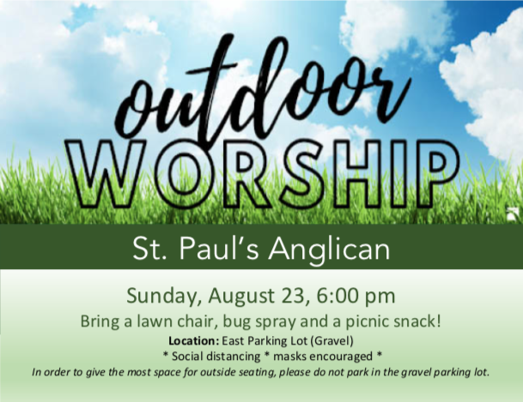

Anglican Cycle of Prayer:
Diocese of Rupert’s Land; the Rt. Rev. Geoffrey Woodcroft, Bishop. Holy Trinity, Edmonton: Interim Ministry; Danielle Lepine, Associate Priest; Allan Bonertz (s. Marg), Penny Bruce and Robin Walker (s. Joanne), Honorary Assistants; Eileen Edwards, Children and Families Coordinator; RJ Chambers, Arts Administrator; Janette Chambers (s. RJ), Office Administrator. Buyé Diocese, Kirima Parish: Etienne Kajekaremerwa, Rector. Frog Lake First Nation.

This Week’s Ministry Teams:
Music: Andrew and Team
Service Team: Parker and Heritage
Reader/Prayers: Rick and Barb M.

St. Paul’s Cycle of Prayer:
Andrew, Nancy, Greg, Tim, and Emily Whistance-Smith;
David and Heather Mackintosh;
Patti Nicholl; Margaret Ushko

Next Week’s Ministry Teams:
Music: Jodi and Team
Service Team: B and Jackson Teams
Reader/Prayers: Renée J.
St. Paul’s Staff:
Rector: The Rev. Myron B. Penner
Office Administrator: RJ Chambers
Youth Leader: Victoria Eeles

For Care/Concern Team
or other prayer requests, email:
office@stpauls-anglican.ca
For urgent prayer requests call
the church office: (780) 455-0771
For pastoral emergencies call:
(587) 334-2130

@StEdmonton
facebook.com/stpachurchedmonton
St. Paul’s Vestry:
Peter Jackson, Rector’s Warden
Margot Byer, People’s Warden
David Heritage, Treasurer
Barb Dixon, Vestry Member
John Green, Vestry Member
Deanna Kalles, Vestry Member
David Parker, Vestry Member
Carol Rudat, Vestry Member

Office Hours:
Monday-Thursday: 9:00AM-12:00PM
Closed: Fri/Sat/Sun and Stat Holidays
St. Paul’s Anglican Church
10127 145 Street, Edmonton T5N 2X6
Phone: (780) 455-0771; Email: office@stpauls-anglican.ca
Website: www.stpauls-anglican.ca

