Spring AWANA Update

Important Dates:

• **Rainbow Loom Day – March 20 10AM-12PM**

**• Spring Break NO AWANA -   
March 20&27**

**• AWANA Grand Prix – April 12 12:30-4PM**

* **AWANA Store –   
  April 17**

**• Potluck and Awards -   
April 24**

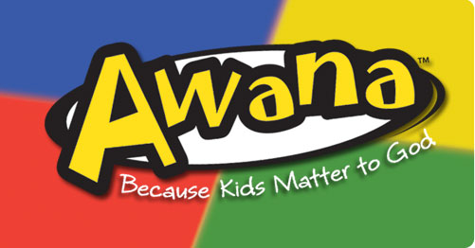

Greetings AWANA Families!

Please let me know if you can:

1. Donate to the AWANA store
2. Volunteer at the Grand Prix

What an amazing year we have had at AWANA! I feel so incredibly privileged to have had the opportunity to minister to your kids this year. I pray that all of our clubbers have hidden God’s word in their hearts and have grown closer to Jesus!

Since January we have been learning about more “Holy Habits”, including study, service, stewardship, and Sabbath. We held a pajama night with a special council time led by our TWU team, and we hosted a special puppet presentation. We also celebrated the victories of our Bible Quiz teams!

We are entering the last few weeks of AWANA, so I want to make you aware of some important upcoming dates. Please take note of the following announcements and write important dates on your calendar.

Announcements/Dates to Note

* There will be **NO AWANA** during Spring Break (March 20th and 27th)
* Our church is hosting a special “**Rainbow Loom Meetup**” on **March 20th** from 10AM-12PM. Please see the graphic on the next page for details.
* The **AWANA Grand Prix** will take place on **April 12th** from 12:30-4PM. Please make sure that your child’s car is ready by that time and watch for more details in the coming weeks. If you are able to volunteer on the day of the event with the concession, set-up or take-down, please let me know.
* The **AWANA store** will be held on **April 17th**. If you have any small toys, books or other appropriate items you would like to donate, please drop them off at the church beginning on April 1st. Remind your clubbers to keep track of their AWANA bucks and bring them on this night!
* Our year-end **Potluck and Awards night** (and last night of club) is on **April 24th.** Parents, siblings and family are welcome to attend this event as we honor the achievements of our clubbers throughout the year. Please bring a **dish to share**. Also please encourage your clubbers to **finish their handbook** if they are close to completing it, as this entitles them to certain awards on this night.
* If you have any questions, contact me any time!



Emily Reesor

Awana Administrator

[awana@flefc.org](mailto:awana@flefc.org)

778-246-0194

