I Pet 2:10 Now A People Nov 18/18 CFBC
A/ Intro: A Special People (Recall 2:9)

B/ In Hosea’s Day 2:10 cf Hos 1:9,10; 2:23
- The setting

- The verdict

- But also restoration

- God is… and God is…

C/ Paul’s Explanation 2:10 cf Rom 9:25-26
- The context
Rom 9:6
Rom 11:16-26 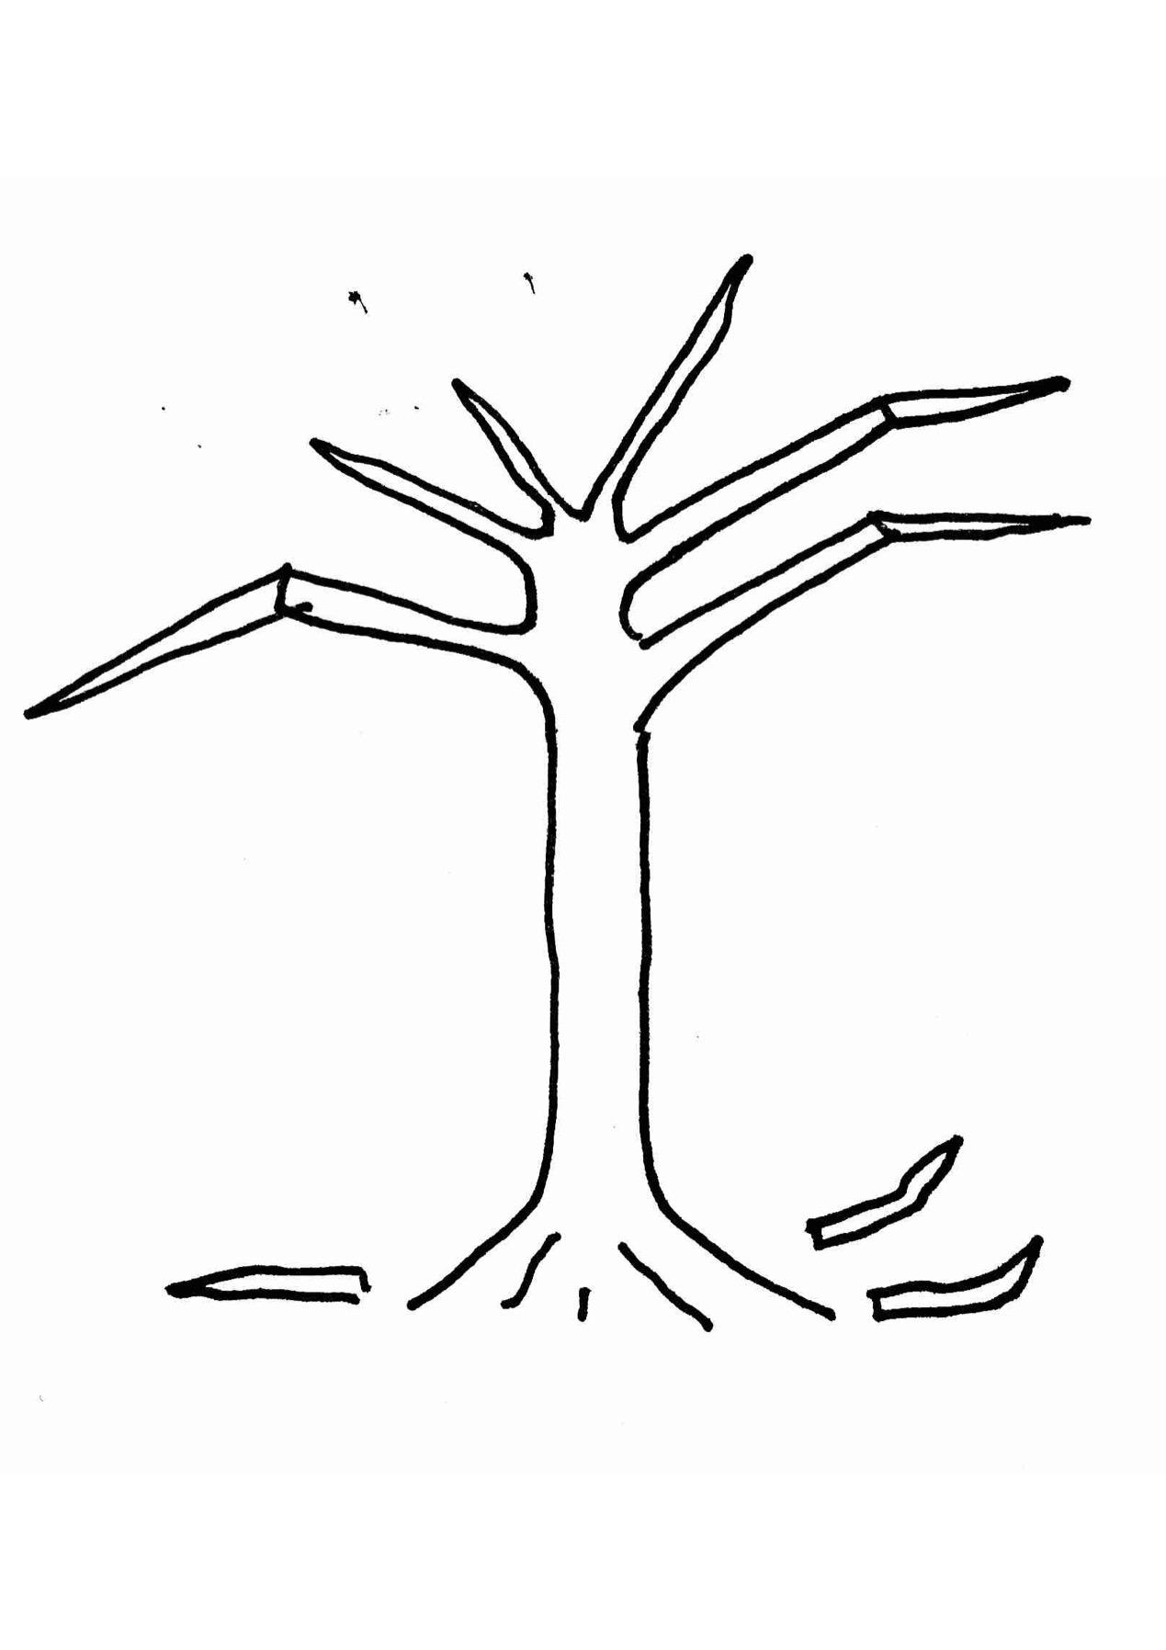

- The purposes of God

D/ God’s People/God’s Mercy 2:10

E/ Conclusion: Advancing Through Mercy

