The Sunnybrook Pulpit
Rev. Ross Smillie
April 2, 2017 – Fifth Sunday of Lent
New Life on Dry Bones
I am going to open your graves and bring you up from your graves, O my people;… I will put my spirit within you, and you shall live, and I will place you on your own soil; then you shall know that I, the Lord, have spoken and will act, says the Lord.
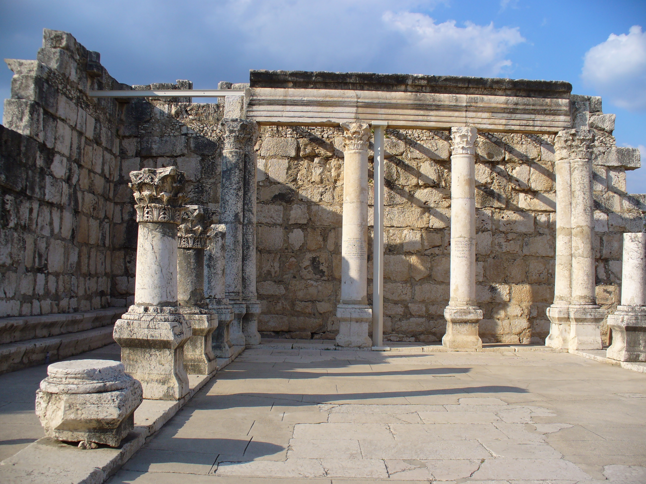– Ezekiel 37:1-14

When we were in Israel a number of years ago, we visited a synagogue in the ancient town of Capernaum. Although Jesus lived in Capernaum and likely attended synagogue there, this building was not the one he attended. It flourished a couple of hundred years after his death, but even so, it is very old. And there isn’t much left. The roof is gone, as are much of the walls. Some walls and pillars still stand and the stone seat where the leader sat to teach, and that’s about it. But the beauty of what is left bears eloquent testimony to the love which people had for it at one time.

I found myself wondering what that place was like in its heyday. Not the building, but the congregation. This old ruin once rang with the laughter of children, I imagine. And their parents gathered to discuss together the affairs of the day, to support each other in their struggles and to help each other discern the will of God for their lives, just as we do. They worshipped together on the Sabbath: they gathered to sing and to pray and hear the old stories read and a preacher helped them connect the ancient wisdom with their own lives, just as we do. What happened to that congregation? Where did the vibrant congregation that met there go? Were they driven away by war or famine or conquest? Were they converted to Christianity or Islam or driven away by invading armies? Or was the congregation’s vitality sapped by infighting, dissent or a failure to address the changing needs of the people? Perhaps it just withered away over the generations.

Thinking about that old synagogue, abandoned for 1500 years or more, I find myself imagining this building in its place: the roof rotted out and old timbers fallen in, the pews eaten into fragments by ants and rot, shards of stained glass hanging from what might be left of the walls, the pulpit chopped up for firewood, some of the art work taken to a museum as a reminder of an ancient faith no longer practiced in this land. Such a thing is not impossible; that is what I learned from visiting that ancient synagogue in Capernaum.

Such a thing is not impossible. God has entrusted the good news to us humans and to our fallible human institutions. It is a terrible freedom, as one of my colleagues says, “the freedom to lose our voices, to forget where we were going and why.” The church is dependent on each new generation passing forward and finding its own relationship with the good news, but when that fails to happen, “we may find ourselves selling tickets to a museum.”

At one time, the church was among the most powerful institutions in the land. Sunday was a day reserved for worship, because decent people observed the Sabbath and removed temptation from those who didn’t. At school, the day began with the Lord’s Prayer, and the Ten Commandments were memorized alongside multiplication tables. But by the time I was in school in the sixties and seventies, the social consensus that this was a Christian nation was starting to crumble. The church has become one option among many others on Sunday mornings, and Christianity has become one option among many for those seeking to make sense of their lives.

Since then the church has limped along. Some congregations thrive, but many more struggle to survive, and a major conflict or an unpopular minister can send them into a death spiral from which it seems impossible to recover. In Red Deer Presbytery we have closed at least five congregations in the last two or three years alone. The same thing is happening to churches all across the country, where aging congregations are making heart-wrenching decisions to bring an end to their life together. The buildings are being converted into community halls or arts centres, or are being torn down to make room for offices or condos.

Are you depressed yet? If so, then I am succeeding, because in order to really hear this passage from Ezekiel, we need to identify with their loss of hopes and dreams, their sense that the faith they had built their lives and dreams around had collapsed into a ruin. We cannot hear the word of Ezekiel except through recognizing the dry bones in our own lives and communities. For Ezekiel spoke to a people in exile. Their nation had fallen victim to a powerful empire, and they had been deported to Babylon. “How shall we sing the Lord’s song in a strange land?” one of the psalms from this period asks. Their belief that God would protect them had been shattered, and revealed as an illusion. They said, according to Ezekiel, “Our bones are dried up and our hope is lost; we are cut off completely.”

Do you feel like that sometimes? Like your bones are so dry that you can almost taste the dust in your mouth? Like you have lost all meaning and direction and joy and you rattle around in your life like rats in a maze, wondering where to turn? For some of us, this happens because of personal reasons: depression or illness or family troubles or financial difficulty or the loss of a loved one. For the Israelites, and perhaps for us in the church, it is a shared loss of hope, a collective sense that the ground we thought was solid has shifted and we don’t know where we stand. What does Christian faith mean in a world of many admirable faiths, and even a respectable atheism? The church and the faith seem less like a solid rock than a shifting quicksand.

To that dispirited and disillusioned group of Jewish exiles, Ezekiel offers a vision, a vision of new flesh covering dry bones, and new spirit animating lifeless bodies. To that people, the prophet Ezekiel offers this word from God, “I am going to open your graves and bring you up from your graves, O my people;… I will put my spirit within you, and you shall live, and I will place you on your own soil; then you shall know that I, the Lord, have spoken and will act, says the Lord.” (Ezekiel 37:12-14)

The exile was the greatest crisis in the history of Jewish faith. The illusion that the Jewish nation would survive in perpetuity was shattered. What could Jewish faith mean if it was not tied to the temple and the land of Israel? We are asking the same questions today: What can Christian faith mean if it is not tied to an established and respectable church? How do we sing the Lord’s song in our own strange land?

As painful as it can be, it is actually not a bad thing to be disillusioned. Illusions may be comforting for a time, but in the end they are empty. If we are to discover the truth that lies beneath our illusions, we have to move through the painful process of being disillusioned. The illusion that we were a Christian nation masked the painful reality that the church’s alliance with political power contributed to the oppression of aboriginal peoples, LGBTQ people, and others. The illusion of the ancient Jews was that God was tied to the Jewish temple and the Jewish nation, and when those things were destroyed, their illusions were shattered. But in exile they discovered a faith beyond their illusions. In exile they learned that God is still real, and that God is a universal God who could be worshipped and followed anywhere. From the greatest crisis in their history emerged an alternative to the temple, an institution that would sustain Jewish life for the next 25 centuries (so far): the synagogue – a local community of worship and study where the ancient wisdom could be studied and taught, where old songs would be passed from generation to generation and new songs would give voice to the faith of each new generation. A few decades later, the exile was ended, the temple was rebuilt, and eventually Israel regained its independence, but the temple became less and less important, while the synagogue thrived and gave new strength to its people.

In our time too, in the church’s modern exile, I believe that beyond the illusion that God is tied to a powerful and wealthy church, we are discovering that God is still real, and that God is putting new flesh on these old bones. Beyond the illusion of a “Christian nation,” we are discovering a freedom and possibility that is both terrifying and exciting. Beyond the illusion that nothing bad will ever happen to God’s faithful, we are discovering that God is still with us, suffering with us through the tragedies of life. Beyond the illusions of control and power, we are discovering a God whose weakness is stronger than human strength, and a way of being God’s people that allows us to speak from the margins of society with compassion and clarity.

It is not quite clear to us what lies beyond the illusions, but what is clear is that Christian faith, while it is not the only choice available to us, is still a profoundly meaningful one. Every moment of our lives offers us a choice: will we see the events of our lives as blind accidents of fate or opportunities for grace? What appear to be death throes may be the birth pangs of something new. Others may interpret such events as random, but faith discovers in them something of holy meaning and holy purpose.

In the quote I have printed in the bulletin for this week, Barbara Brown Taylor writes:

In this age of a million choices, we are the remnant, the sometimes faithful, sometimes unfaithful family of a difficult and glorious God, called to seek and proclaim God’s presence in a disillusioned world. It is a world that claims to have left us behind, along with dragons and maps of a flat earth, but meanwhile the human heart continues to hunt its true home… Our job is to stand with one foot on earth and one in heaven, with the double vision that is the gift of faith, and to say out of our own experience that reality is not flat but deep, not opaque but transparent, not meaningless but shot full of grace for those with the least willingness to believe it is so.

Just when our bones are dry and our hope is gone, just when our illusions are shattered on the floor like a broken pain of glass, then it may be that the reality of the life-giving Spirit of God may come to us, and put new flesh on our dry bones, and breath new spirit into what seemed dead and lost. Let us sing of that hope and faith, as we sing together, “Now the Green Blade Rises.”

From “A Church in Ruins,” by Barbara Brown Taylor, The Preaching Life, p. 5.
Ob cit, pp. 11-12.

