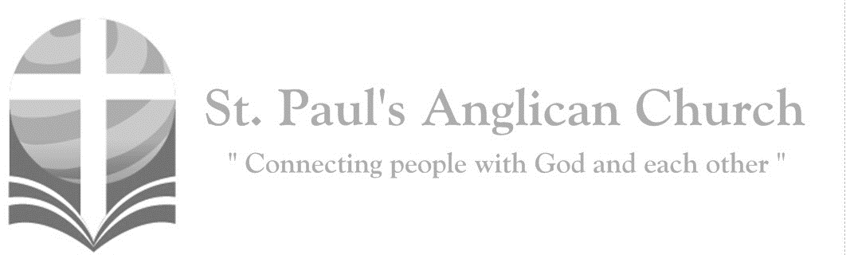

Sunday, January 19, 2020: 2nd Sunday After Epiphany

*The Word of God became flesh and dwelt among us. To all who receive him, he gave the power to become children of God.   
(See John 1)*

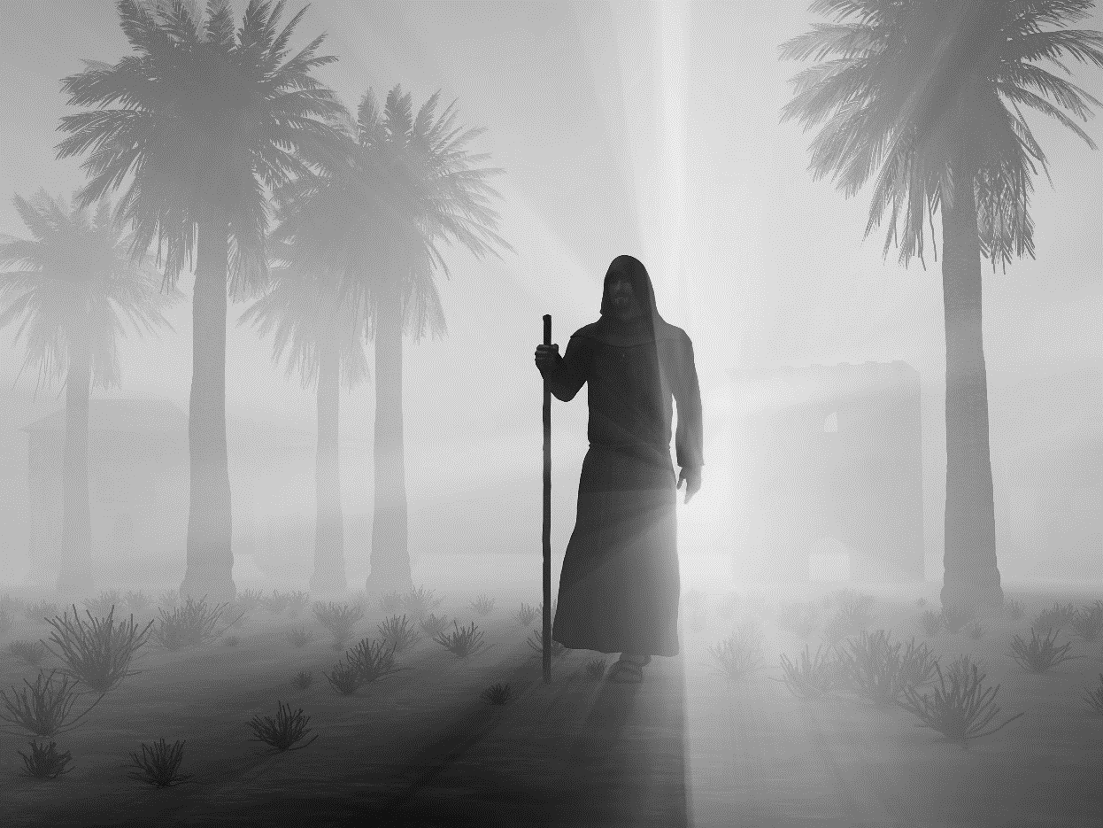

SUNDAYS AT ST. PAUL’S

**REGULAR SERVICES**

* Weekly services held Sundays at 10:00AM
* Interface services - Art based services throughout the year
* Sermons available on our website

**SUNDAY PRAYER**

* Prayer for the service at 9:30AM in the Luke Room
* Individual Prayer in the Chapel during the Sunday service

**SERVING AT ST. PAUL’S**

* Join a Ministry Team (Sunday service team, music team, children’s ministry, Altar guild, or many others)
* Regular or One-Time Giving (cash, cheque, automatic debit, and credit options available)

**LARGE PRINT MATERIALS** Large print Bibles and   
 Books of Alternative   
 Services (BAS) are availableat each Sanctuary door.

Page numbers will not be the same as those listed in the bulletin.

**VISITING TODAY?**

We want to get to know   
 you! Please join us for

in the Hall for coffee and

fellowship following the service. The greeters are also available to help if you have any questions.

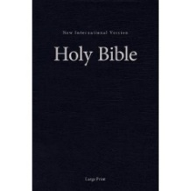



**Assisted listening**

**is available. Please**

**ask a greeter**

**for assistance.**



CONNECT

**St. Paul’s CHILDREN’S MINISTRY**

**KIDS** Pre-School-Grade 2 in the hall / Grade 3-5 in the Matthew Room

Sunday School teaching is weekly during the 10:00AM service.

**St. Paul’s YOUTH MINISTRY**

**YOUTH** Youth Grades 6-12 meet weekly during the 10:00AM service.

Youth also meetbi-weekly for fun events and devotionals.

**St. Paul’s ADULT MINISTRY**

**ADULTS** St. Paul’s has a number of small groups where you can connect with others through Christ. If you are interested in joining a small   
group or starting a small group of your own, please speak with Pat Stretch.

**Opening Song: *Holy Is Our God***

Lift up His Name within the sanctuary  
Lift up His Name among the people

Who are gathered here

To sing His praise  
Who are gathered here

To sing His praise

(*Chorus*) Holy is our God  
Holy is Your Name  
Mighty are Your works and deeds  
And wondrous are Your ways  
All that You have made  
Shall return and give You glory (Lord)

The earth, the sky, the sea

And all within them  
This universe beyond

The sight of mortal men  
All subject to His reign  
All creation subject to His reign

(*To Chorus*)

The great I Am, no end and no beginning  
You were and are

And evermore You shall be  
All my days are in Your hands  
All my days are in Your hands

(*To Chorus*)

**The Gathering of the Community**

Celebrant: *(BAS pg. 185)* The grace of our Lord Jesus Christ, and the love of God, and the fellowship of the Holy Spirit, be with you all.

**People: And also with you.**

Celebrant:Almighty God,

**All:to you all hearts are open, all desires known, and from you no secrets are hidden. Cleanse the thoughts of our hearts by the inspiration of your Holy Spirit that we may perfectly love you, and worthily magnify your holy name; through Christ our Lord. Amen.**

Celebrant: *(pg. 349)* Almighty God, your Son our Saviour Jesus Christ is the light of the world. May your people, illumined by your word and sacraments, shine with the radiance of his glory, that he may be known, worshipped, and obeyed to the ends of the earth; who lives and reigns with you and the Holy Spirit, one God, now and for ever.

**People:** **Amen**.

**Children’s Dismissal**

**The Reading of Scripture**

First Reading: Isaiah 49:1-7 (pg. 520 in the red pew Bible)

Reader: The Word of the Lord.

**People:** **Thanks be to God.**

Canticle: Psalm 40:1-12 (see below)

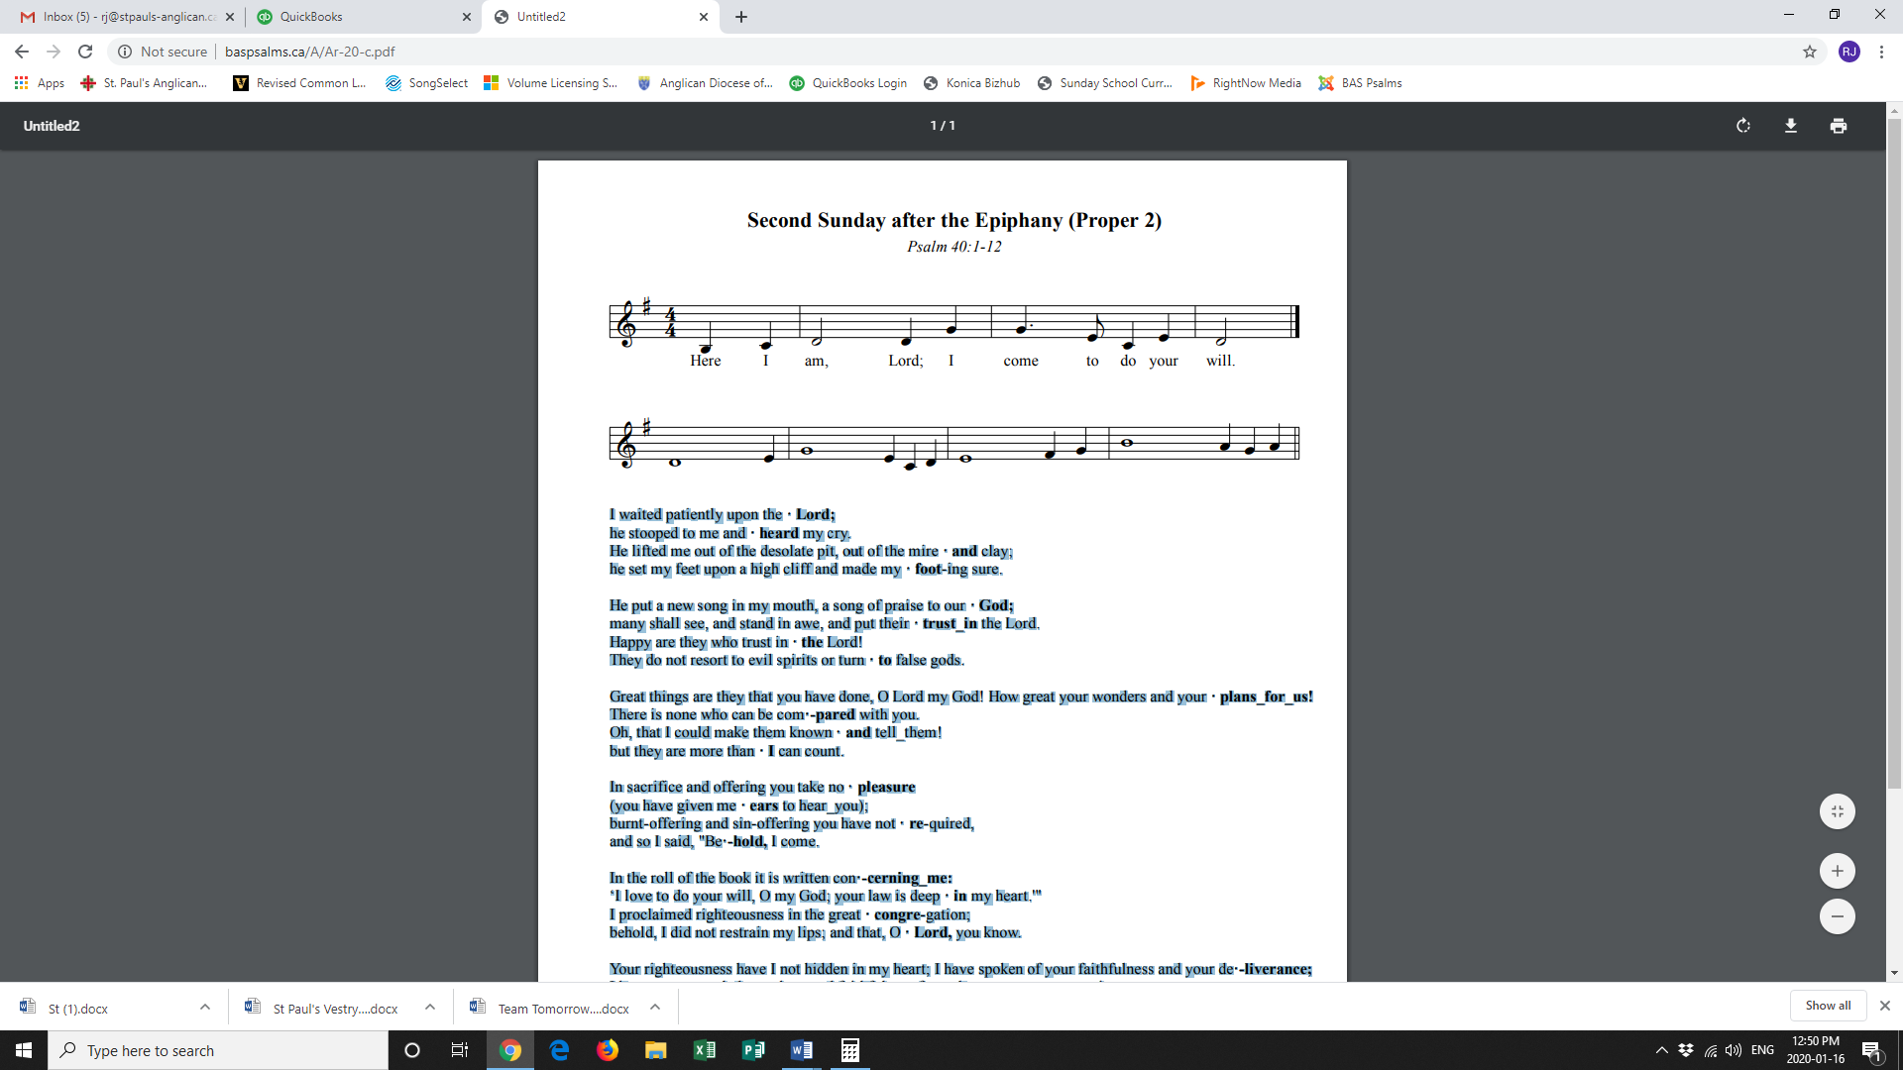

**Refrain:**

I waited patiently upon the Lord; he stooped to me and heard my cry. He lifted me out of the desolate pit, out of the mire and clay; he set my feet upon a high cliff and made my footing sure. **Refrain**

He put a new song in my mouth, a song of praise to our God; many shall see, and stand in awe, and put their trust in the Lord. Happy are they who trust in the Lord! They do not resort to evil spirits or turn to false gods. **Refrain**

Great things are they that you have done, O Lord my God! How great your wonders and your plans for us! There is none who can be compared with you. Oh, that I could make them known and tell them! But they are more than I can count. **Refrain**

In sacrifice and offering you take no pleasure (you have given me ears to hear you); burnt-offering and sin-offering you have not required, and so I said, "Behold, I come. **Ref**

In the roll of the book it is written concerning me: ‘I love to do your will, O my God; your law is deep in my heart.'" I proclaimed righteousness in the great congregation; behold, I did not restrain my lips; and that, O Lord, you know. **Refrain**

Your righteousness have I not hidden in my heart; I have spoken of your faithfulness and your deliverance; I have not concealed your love and faithfulness from the great congregation. You are the Lord; do not withhold your compassion from me; let your love and your faithfulness keep me safe for ever. **Refrain**

Second Reading: 1 Corinthians 1:1-9 (pg. 806 in the red pew Bible)

Reader: The Word of the Lord.

**People:** **Thanks be to God.**

**Processional Chorus – *All Praise to Thee***

All praise to thee, for thou, O King divine

Didst yield the glory

That of right was thine

That in our darkened hearts

Thy grace might shine

Alleluia, alleluia

**The Gospel Reading**

Reader: The Lord be with you.

**People: And also with you.**

Reader: The Holy Gospel of our Lord Jesus Christ according to St. John.

**People: Glory to you, Lord Jesus Christ.**

Gospel Reading: John 1:29-42 (pg. 750 in the red pew Bible)

Reader: The Gospel of Christ.

**People: Praise to you, Lord Jesus Christ.**

**Worship Through Song**

***The Lord is My Salvation***

The grace of God has reached for me  
And pulled me from the raging sea  
And I am safe on this solid ground  
The Lord is my salvation

I will not fear when darkness falls  
His strength will help me

Scale these walls  
I'll see the dawn of the rising sun  
The Lord is my salvation

(*Chorus*) Who is like the Lord our God  
Strong to save, faithful in love  
My debt is paid and the victory won  
The Lord is my salvation

My hope is hidden in the Lord  
He flowers each promise of His Word  
When winter fades

I know spring will come  
The Lord is my salvation

In times of waiting, times of need  
When I know loss, when I am weak  
I know His grace will renew these days  
The Lord is my salvation (*To Chorus*)

And when I reach the final day  
He will not leave me in the grave  
But I will rise, He will call me home  
The Lord is my salvation (*To Chorus*)

Glory be to God the Father  
Glory be to God the Son  
Glory be to God the Spirit  
The Lord is our salvation (*To Chorus*)

***Majesty***

Here I am humbled by Your majesty  
Covered by Your grace so free  
Here I am knowing I'm a sinful man  
Covered by the blood of the Lamb

Now I've found

The greatest love of all is mine  
Since You laid down Your life  
The greatest sacrifice  
Majesty, majesty  
Your grace has found me just as I am  
Empty handed but alive in Your hands  
 (*continued on next page*)

Here I am

Humbled by the love that You give  
Forgiven so that I can forgive  
Here I stand

Knowing that I'm Your desire  
Sanctified by glory and fire

Now I've found   
The greatest love of all is mine  
Since You laid down Your life  
The greatest sacrifice  
  
Majesty, majesty  
Your grace has found me just as I am  
Empty handed but alive in Your hands  
Majesty, majesty   
Forever I am changed by Your love  
In the presence of Your majesty

**Listening Time**

**Sermon by the Reverend Dr. Myron Penner – Sermon Notes:**

________________________________________________________________________________________________________________________________________________________________________________________________________________________________________________________________________________________________________________________________________________________________________________________________________________________________________________________________________________________________________________________

________________________________________________________________________________________________________________________________________________________________________________________________________________________

________________________________________________________________________________________________________________________________________________________________________________________________________________________________________________________________________________________________

________________________________________________________________________________________________________________________________________________________________________________________________________________________

**Affirmation of Faith – John 14:1-14**

**All: We believe in God, creator of all that is and all that is to come. In God’s house are many rooms, and God prepares a place for us, so that where God is, we may be also. We believe in God; we believe also in Jesus Christ, who is our way, our truth and our life. Through him we have seen God, who lived and worked in him. We believe in the Holy Spirit, who lives and works in us; so that we may do the works that Jesus does, and even greater works; so that the Father may be glorified in the Son. Alleluia.**

**Prayers of the People**

**Confession of Sin**

Celebrant: *(pg. 191)* Dear friends in Christ, God is steadfast in love and infinite in mercy; he welcomes sinners and invites them to his table. Let us confess our sins, confident in God’s forgiveness.

*Silent Confession*

Celebrant:Almighty God, our heavenly Father,

**All: we have gone our own way, not loving you as we ought, nor loving our neighbour as ourselves. We have sinned against you in thought, word, and deed, and in what we have failed to do. We deserve your condemnation. Father, forgive us. Help us to love you and our neighbour, and to live for your honour and glory; through Jesus Christ our Lord. Amen.**

Celebrant: Almighty God have mercy upon you, pardon and deliver you from all your sins, confirm and strengthen you in all goodness and keep you in eternal life through Jesus Christ our Lord.

**People:Amen.**

**The Peace**

Celebrant: The peace of the Lord be always with you.

**People: And also with you.**

**Offertory Song: *Holy Spirit***

Holy Spirit, living Breath of God  
Breathe new life into my willing soul  
Let the presence of the risen Lord  
Come renew my heart

And make me whole  
Cause Your word to come alive in me  
Give me faith for what I cannot see  
Give me passion for Your purity  
Holy Spirit, breathe new life in me

Holy Spirit, come abide within  
May Your joy be seen in all I do  
Love enough to cover every sin  
In each thought and deed and attitude  
 (*continued on next page*)

Kindness to the greatest and the least  
Gentleness that sows the path of peace  
Turn my strivings into works of grace  
Breath of God, show Christ in all I do

Holy Spirit, from creation's birth  
Giving life to all that God has made  
Show Your power once again on earth  
Cause Your church

To hunger for Your ways  
Let the fragrance of our prayers arise  
Lead us on the road of sacrifice  
That in unity the face of Christ  
May be clear for all the world to see

**Prayer Over the Gifts**

Celebrant: *(pg. 350)* Living God,

**All: you have revealed your Son as the Messiah. May we hear his word and follow it, and live as children of light. We ask this in the name of Jesus Christ the Lord. Amen.**

Celebrant: *(pg. 196)* The Lord be with you.

**People: And also with you.**

Celebrant: Lift up your hearts.

**People: We lift them to the Lord.**

Celebrant: Let us give thanks to the Lord our God.

**People: It is right to give our thanks and praise.**

Celebrant: We give you thanks and praise, almighty God……. Now with all creation we raise our voices to proclaim the glory of your name.

**All:** ***(Sung)*** **Holy, holy, holy Lord, God of power and might, heaven and earth of Your glory are full. Hosanna, hosanna, hosanna in the highest. Blessed is he who comes in the name of the Lord.   
Blessed is he who comes in the name of the Lord.   
Holy, holy, holy Lord, God of power and might, heaven and earth of Your glory are full. Hosanna, hosanna, hosanna in the highest.**

Celebrant: *(pg. 197)* Holy and gracious God, accept our praise……. All glory and honour are yours, Father and Son, with the Holy Spirit, in the holy Church, now and for ever.

**All: Amen.**

Celebrant: *(pg. 211)* As our Saviour taught us, let us pray,

**All: *(Sung)* Our Father in heaven, holy is your name. Your kingdom come on earth as in heaven. Our Father in heaven, reveal who you are. Your will be done on earth as in heaven. Feed us today what we need to live. Forgive all our sins as we forgive and keep us safe. The kingdom is yours, the power is yours, and the glory forever. The kingdom is yours, the power is yours, and the glory forever.**

Celebrant: *(pg. 212)* We break this bread to share in the body of Christ.

**All: We, being many, are one body, for we all share in the one bread.**

Celebrant: *(pg. 213)* The gifts of God for the People of God.

**People: Thanks be to God.**

**The Communion**

*You are welcome to receive communion or come forward for a blessing. If you prefer to receive a blessing, please fold your arms over your chest. There is de-alcoholized wine available in the centre and gluten-free wafers available upon request.*

**Lamb of God**

*(Sung)* Lamb of God, you take away the sin of the world, have mercy on us.

Lamb of God, you take away the sin of the world, have mercy on us.

Lamb of God, you take away the sin of the world, grant us your peace.

**Communion Music**

***Jesus Messiah***

He became sin who knew no sin  
That we might become

His righteousness  
He humbled Himself

And carried the cross  
Love so amazing, love so amazing

(*Chorus*) Jesus Messiah

Name above all names  
Blessed Redeemer, Emmanuel  
The Rescue for sinners  
The Ransom from heaven  
Jesus Messiah, Lord of all

His body the bread, His blood the wine  
Broken and poured out all for love  
The whole earth trembled

And the veil was torn  
Love so amazing, love so amazing

(*To Chorus*)

(*continued on next page*)

All our hope is in You  
All our hope is in You  
All the glory to You God  
The Light of the world

Jesus Messiah, name above all names  
Blessed Redeemer, Emmanuel  
The Rescue for sinners  
The Ransom from heaven  
Jesus Messiah, Lord of all

***Once and For All***

God I give You what I can today  
These scattered ashes that I hid away  
I lay it all at Your feet

From the corners of my deepest shame  
The empty places

Where I've worn Your name  
Show me the love I say I believe

Help me to lay it down  
O Lord, I lay it down

(*Chorus*) O let this be where I die  
My Lord with Thee crucified  
Be lifted high as my kingdoms fall  
Once and for all, once and for all

There is victory in my Savior’s loss  
In the crimson flowing from the cross  
Pour over me, pour over me (*To Chorus*)

**Prayer After Communion**

Celebrant: *(pg. 350)* God of glory,

**All: you nourish us with bread from heaven. Fill us with your Holy Spirit, that through us your light may shine in all the world. We ask this in the name of Jesus Christ.** **Amen.**

Celebrant: *(pg. 214)* Glory to God,

**All:whose power, working in us, can do infinitely more than we can ask or imagine. Glory to God from generation to generation, in the Church and in Christ Jesus, for ever and ever. Amen.**

**Blessing**

**Congregational Announcements *(Deanna K.)***

**Closing Song: *I Give Thanks***

You have shown me favour unending  
You have given Your life for me  
And my heart knows of Your goodness  
Your blood has covered me

I will arise and give thanks  
To You Lord my God  
And Your name I will bless  
 (*continued on next page*)  
With my whole heart  
You have shown mercy  
You have shown mercy to me  
I give thanks to You, Lord

You have poured out

Your healing upon us  
You have set the captives free  
And we know it's not what we've done  
But by Your hand alone

We will arise and give thanks  
To You Lord our God  
And Your name we will bless  
With our whole hearts  
You have shown mercy  
You have shown mercy to us  
We give thanks to You, Lord

**The Dismissal**Celebrant: *(pg. 215)* Go forth in the name of Christ.

**All: Thanks be to God. Amen.**

*Please join us in the hall for coffee following the service.*

**Want to Get to Know Others at St. Paul’s? Join a Service Team!!**

Joining a service team is a great way to get to know other parishioners at St. Paul’s. Teams are only scheduled every sixth week. If you would like to join a team, please contact RJ in the office.

**Christ in Cambodia – Jan. 26**

Please join us January 26 at 8:45AM in the John Room as Peter and Renée share with us about the purpose and findings of their recent trip to Cambodia. All are welcome!

**Offering Envelopes in Foyer**

**There are still a few sets of 2020 offering envelopes awaiting pickup in the foyer. They are right outside the office door. If you do not have offering envelopes and would like some, please contact RJ.**

**Chapel Prayer Team Training**

**Chapel Prayer training will be held on Thursday evenings in February. Please contact the office for more information.**

**Interested in Confirmation**

**and/or Baptism?**

**There will be a service of Confirmation on March 1. If you are interested in Confirmation or Baptism, please speak with Rev. Myron or contact the office.**

**AGM and Sandwiches – February 9**

Please join us for the St. Paul’s Annual General Meeting following the service on February 9. We will also be having a Sandwich Sunday that day so please plan to join us for lunch!!

**Games Night – Friday, Jan. 10**

Are you ready to play?! Please join us every 2nd Friday of the month for games in the Hall starting at 6:00PM. Come learn a new game, bring your favourite to teach others, or play a classic with new friends! We also have a Puzzlers Corner for those who want to build puzzles together!



@StEdmonton

facebook.com/stpachurchedmonton

**St. Paul’s Vestry:**

Peter Jackson, *Rector’s Warden*

Pat Stretch, *People’s Warden*

David Heritage, *Treasurer*

Margot Byer, *Vestry Member*

John Green, *Vestry Member*

Deanna Kalles, *Vestry Member*

David Parker, *Vestry Member*

Carol Rudat, *Vestry Member*

**St. Paul’s Staff:**

*Rector:*

The Reverend Myron Bradley Penner  
*Office Administrator:*

RJ Chambers

*Youth Leader:* Victoria Eeles

**For prayer requests** **email**:

office@stpauls-anglican.ca

**For urgent prayer requests call**

the church office: (780) 455-0771

**For pastoral emergencies call:**

(587) 334-2130

**Office Hours:**

Monday-Thursday: 9:00AM-12:00PM

Closed: Fri/Sat/Sun and Stat Holidays

**St. Paul’s Anglican Church**

10127 145 Street, Edmonton T5N 2X6

Phone: (780) 455-0771; Email: office@stpauls-anglican.ca

Website: www.stpauls-anglican.ca

**This Week’s Readings:**

Isaiah 49:1-7 (pg. 520)

Psalm 40:1-12 (in bulletin)

1 Corinthians 1:1-9 (pg. 806)

John 1:29-42 (pg. 750)

**This Week’s Ministry Teams:**

Music/Sound: Andrew’s Team/Jennifer

Service Team: Parker Team

Prayers: Kjeryn A.; Vestry: Deanna K.

Chapel Prayer: Dudley B. and Pat H-B.

Kid’s Ministry: Margot B. and Ryan Y.

**St. Paul’s Cycle of Prayer:**

David Heritage and Rosalie Freund-Heritage and Susan and Ann;   
George and Elizabeth Jakeway

**Anglican Cycle of Prayer:**

The Territory of the People; the Rt. Rev. Barbara Andrews, Bishop, retired December 31, 2019. The episcopal election is scheduled for next Saturday, January 25, 2020. Diocese of Edmonton Environmental Chaplain: Billy Isenor. Buyé Diocese, Kabanga Parish: Lazar Rudende, Rector. Kehewin Cree Nation.

**Next Week’s Ministry Teams**

Music/Sound: RJ’s Team/Cheryl C.

Service Team: Tilburn Team

Prayers: Deanna K.; Vestry: Peter J.

Chapel Prayer: Laurier B. and Pat S.

Kid’s Ministry: Carol G. and Abigail P.