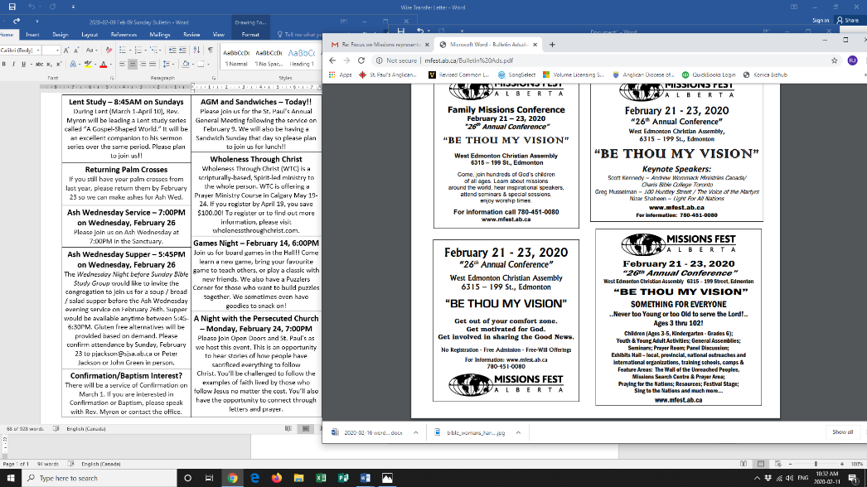

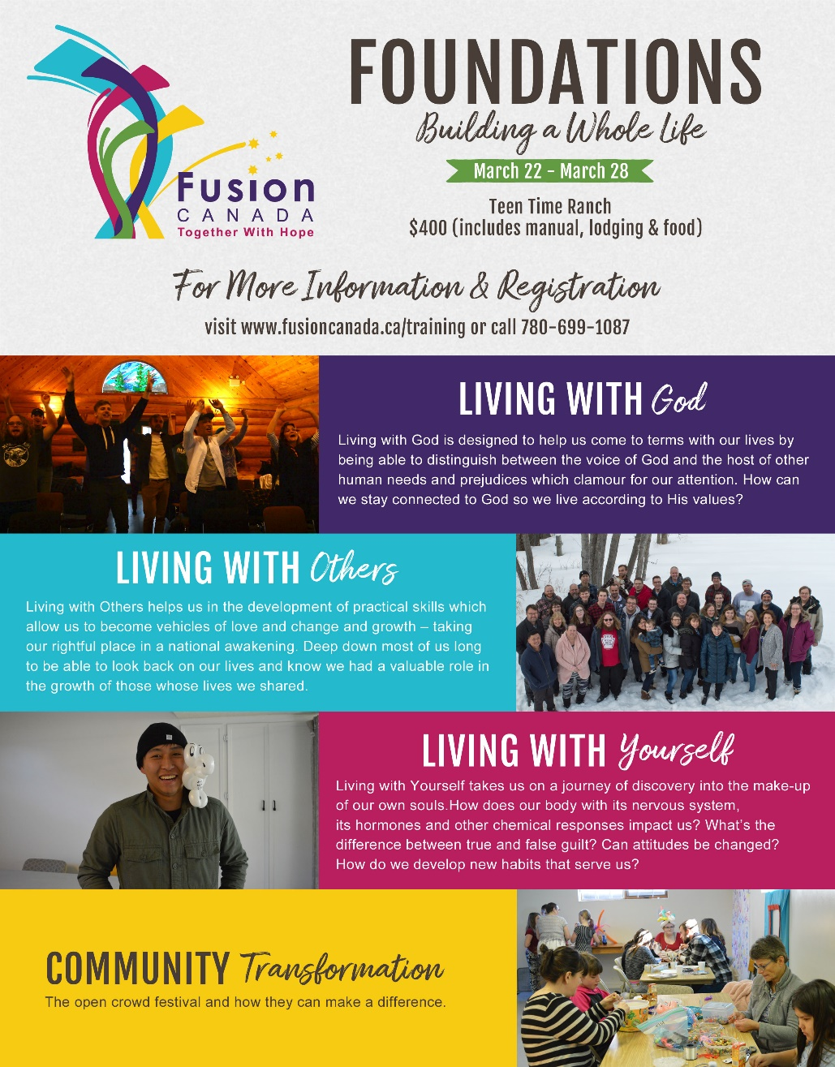

**Confirmation/Baptism Interest?**

**There will be a service of Confirmation on March 1. If you are interested in Confirmation or Baptism, please speak with Rev. Myron or contact the office.**

**For more information about Fusion Canada and the Foundations course (see above), please speak with Terry Berard.**

**Ash Wednesday Service – 7:00PM on Wednesday, February 26**

**Please join us on Ash Wednesday at 7:00PM in the Sanctuary.**

**Ash Wednesday Supper – 5:45PM on Wednesday, February 26**

The *Wednesday Night before Sunday Bible Study Group* would like to invite the congregation to join us for a soup / bread / salad supper before the Ash Wednesday evening service on February 26th. Supper would be available 5:45- 6:30PM. Gluten free alternatives will be provided as requested. Please confirm attendance by Sunday, February 23 to Peter or John in person or Peter at [pjackson@sjsa.ab.ca](mailto:pjackson@sjsa.ab.ca).

**Lent Study – 8:45AM on Sundays in Lent**

During Lent (March 1-April 10), Rev. Myron will be leading a Lent study series called “A Gospel-Shaped World.” It will be an excellent companion to his sermon series at that time. Please plan to join us!!

**Shrove Tuesday Supper – 6:00PM on Tuesday, February 25**

**Please join us for pancakes on Shrove Tuesday!**

**A Night with the Persecuted Church – Monday,   
February 24, 7:00PM**

Please join Open Doors and St. Paul's as we host this event. This is an opportunity to hear stories of how people have sacrificed everything to follow Christ. You’ll be challenged to follow the examples of faith lived by those who follow Jesus no matter the cost. You’ll also have the opportunity to connect through letter writing and prayer.

**Returning Palm Crosses**

**If you still have your palm crosses from last year, please return them by February 23 so we can make ashes for Ash Wednesday.**





**Confirmation/Baptism Interest?**

**There will be a service of Confirmation on March 1. If you are interested in Confirmation or Baptism, please speak with Rev. Myron or contact the office.**

**For more information about Fusion Canada and the Foundations course (see above), please speak with Terry Berard.**

**Ash Wednesday Service – 7:00PM on Wednesday, February 26**

**Please join us on Ash Wednesday at 7:00PM in the Sanctuary.**

**Ash Wednesday Supper – 5:45PM on Wednesday, February 26**

The *Wednesday Night before Sunday Bible Study Group* would like to invite the congregation to join us for a soup / bread / salad supper before the Ash Wednesday evening service on February 26th. Supper would be available 5:45- 6:30PM. Gluten free alternatives will be provided as requested. Please confirm attendance by Sunday, February 23 to Peter or John in person or Peter at [pjackson@sjsa.ab.ca](mailto:pjackson@sjsa.ab.ca).

**Lent Study – 8:45AM on Sundays in Lent**

During Lent (March 1-April 10), Rev. Myron will be leading a Lent study series called “A Gospel-Shaped World.” It will be an excellent companion to his sermon series at that time. Please plan to join us!!

**Shrove Tuesday Supper – 6:00PM on Tuesday, February 25**

**Please join us for pancakes on Shrove Tuesday!**

**A Night with the Persecuted Church – Monday,   
February 24, 7:00PM**

Please join Open Doors and St. Paul's as we host this event. This is an opportunity to hear stories of how people have sacrificed everything to follow Christ. You’ll be challenged to follow the examples of faith lived by those who follow Jesus no matter the cost. You’ll also have the opportunity to connect through letter writing and prayer.

**Returning Palm Crosses**

**If you still have your palm crosses from last year, please return them by February 23 so we can make ashes for Ash Wednesday.**